LTI Linux Product training

Document URL: <https://1drv.ms/w/s!AhlS2A0j9AdLmhZkl3eQ7zwo6ZH5>

Google drive URL: <https://drive.google.com/drive/folders/1KSbZLEOobv9aWkVDvYorSB3ODS7FP_zq?usp=sharing>

Linux OS

* **Opensource** – free to download, free share & change the code.
  + Linux OS
  + URL: <https://www.kernel.org/>
* **Freeware** - free to download, free share
  + UNIX
  + URL: <https://www.oracle.com/solaris/solaris11/downloads/solaris-downloads.html>

UNIX:

* Full form: **Un**iplexed **I**nformation and **C**omputing **S**ervice (UNI*CS*)
* 1969 by Dennis Ritchie & Kemp Thomson

Linux

* By Linus B. Torvalds. Released on 17th sept 1991.
* Derived from UNIX.

Multi-users:

* Virtual terminal / virtual consoles / pseudo terminal.
* Ctrl + atl + <f1, f2…f7> OR chvt <>
* 7 VC

*Linux*: - top 500 super computers

Secure:

* Permissions
* SELinux – security enhanced linux
* Firewall (netfilters, iptables/ip6tables, firewalld)

MBR

* Master Boot Record.
* 4 primary partitions
* HDD: 2TB
* 512 bytes
* 3 sub-divisions
  + 446 bytes 🡪 boot related info
  + 64 bytes 🡪 (16x4)
  + 2 bytes 🡪 magical bytes

GPT

* GUID partition table
* GUID = globally unique identifier
* 128 primary partitions
* HDD: 18 exabyte (approx. 18x10^6 GB)

GRUB

* Grand unified boot loader
* RHEL 6 🡪 GRUB 0.97
* RHEL 7 🡪 GRUB 2.0

1st process

* RHEL 6 🡪 init process (PID 0)
* RHEL 7 🡪 systemd (PID 0)

Runlevel

* Init 0 🡪 runlevel0.target
* Init 1 🡪 runlevel1.target
* Init 2 🡪 runlevel2.target/multi-user.target
* Init 3 🡪 runlevel3.target/multi-user.target
* Init 4 🡪 runlevel4.target/unused till date
* Init 5 🡪 runlevel5.target/graphical.target
* Init 6 🡪 reboot.target

FHS

14 directories (standard), / 🡪 nameless root/root directory

* /bin 🡪 cmd binary for normal users
* /sbin 🡪 cmd binary for super/root users
  + #which useradd
    - /usr/sbin/useradd
  + #which ping
    - /usr/bin/ping
* /etc 🡪 configuration file
* /boot 🡪 boot related info/file
* /kernel 🡪 kernel related file.
* /mnt 🡪 temporary mounts
  + /mnt/abc
  + /mnt/dvd-rom
* /run 🡪 /mnt
* /dev 🡪 device related
  + /dev/sr0 🡪 CD/DVD
  + /dev/sda or /dev/had 🡪 hard disk
* /tmp 🡪 temporary files
* /var 🡪 logs
* /lib or /libx64 🡪 library
* /home 🡪 home directory for normal users
  + /home/Jeetu (~)
  + /home/hulk (~)
* /root 🡪 home directory for root user (~)
* /proc 🡪 running process related info.
  + CPU 🡪 /proc/cpuinfo
  + Memory 🡪 /proc/meminfo
* /usr 🡪 user installed packages/application

File systems in linux:

* Ext, Ext2
* Ext3, Ext4 🡪 RHEL 6
* XFS 🡪 RHEL 7 (back compatible)

Kernel version: “uname -a”

User IDs:

* RHEL 6
  + Root 🡪 0
  + System users 🡪 1-499
  + Normal 🡪 500+
* RHEL 7 (root 🡪 0-999)
  + Root 🡪 0
  + System users 🡪 1-999
  + Normal 🡪 1000+

Installation of RHEL:

1. CD-DVD or ISO.
   1. GUI
   2. Text-based (CLI)
2. Network boot
3. Kickstart

[Task-1: install a new RHEL VM in text mode (CLI).]

Installation destination mount point from 50 GB:

1. / = 35GB
2. /boot = 500mb
3. Swap (1.5xRAM) = 2xRAM = 4GB = virtual memory

File management:

* Create a file / Modify a file
  + Touch
    - Create blank file (1,2,3…n)
    - Update the time stamp of a file.
    - Ex:
      * #touch <file-name>
  + Cat
    - Create
      * #cat > cat1.txt
    - View
      * #cat cat1.txt
    - Append
      * cat >> cat1.txt
    - Overwriting
      * cat > cat1.txt
  + Vi / Vim
    - #vi <file-name>
      * Press ‘i’, to enter into insert mode.
      * …
      * Press “:wq!” To save & quit.
        + W = write / save
        + Q = quit / come out of vi editor
        + ! = forcefully perform the action.
    - #vim <file-name>
      * Press ‘i’, to enter into insert mode.
      * …
      * Press “:wq!” To save & quit.
        + W = write / save
        + Q = quit / come out of vi editor
      * ! = forcefully perform the action
  + Gedit
    - Like notepad in windows
    - #gedit <file-name>
  + Nano
    - #nano <file-name>
* Delete a file
  + #rm <file-name>
  + #rm -f <file-name> //w/o asking Y/N
  + #rm -f *.txt //everything that start with anything & ends with.txt
  + #rm -f f?.txt //delete files with 1 character after ‘f’ &ends with anything.
  + #rm -f f??.txt //delete files with 2 characters after ‘f’ &ends with anything.
* Copy a file
  + #cp <source> <destination>

Path in linux

* Relative path
  + Revolves around the pwd
  + Ex: #cp t1 d1/
* Absolute path
  + Work with from the beginning of the path till the end.
  + Ex: #cp /root/Desktop/t3 /root/Desktop/d1/

File mgmt – conti…

* Move a file
  + #mv <source> <destination>
* Rename
  + #mv <old-name> <new-name>
* Hide
  + #mv <old-name> .<old-name>
* Unhide
  + #mv .<old-name> <old-name>
* Single ‘.’
  + Current directory
* Double “..”
  + Parent directory or 1 step above.

Directories

* Create
  + #mkdir <dir-name>
* Change the location
  + #cd
* delete
  + #rmdir <dir-name> //works with empty directories.
  + #rm -rf <dir-name> //works with empty & non-empty directories.
    - r= recursive
    - f= forcefully (without prompt)

**Permissions**

For file/directory

* read (r) 🡪 4
* write (w) 🡪 2
* execute (x) 🡪 1
* all perms 🡪 7

to view the permissions

#ls -l or #ll

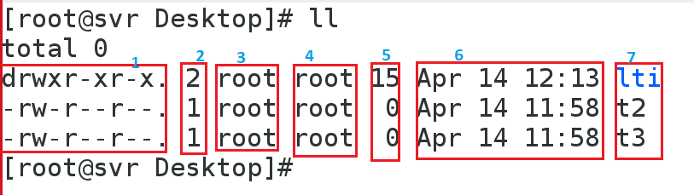

Column1:

* type of file
* and permission allocation to that file/directory

(d/-) 🡪 d= directory, - 🡪 file

(rwxr-xr-x) 🡪 permission to owner, group and others

Owner = rwx, means =>u

* owner can read the f/d
* owner can write into f/d
* owner can execute the f/d

group = r-x, means =>g

* group can read the content of f/d
* group can execute the contents of f/d
* but group cannot write anything in the f/d

other = r-x, means =>o

* other can read the content of f/d
* other can execute the contents of f/d
* but other cannot write anything in the f/d
* Column2: number of links occupied in the memory block.
* Column3: owner of the file/directory 🡪 to change the owner: chown
* Column4: group owner of the file/directory 🡪 chown, chgrp
* Column5: file/directory size in bytes.
* Column6: time stamp of file/directory.
* Column7: name of the file/directory.

To change the file/directory owner & group owner:

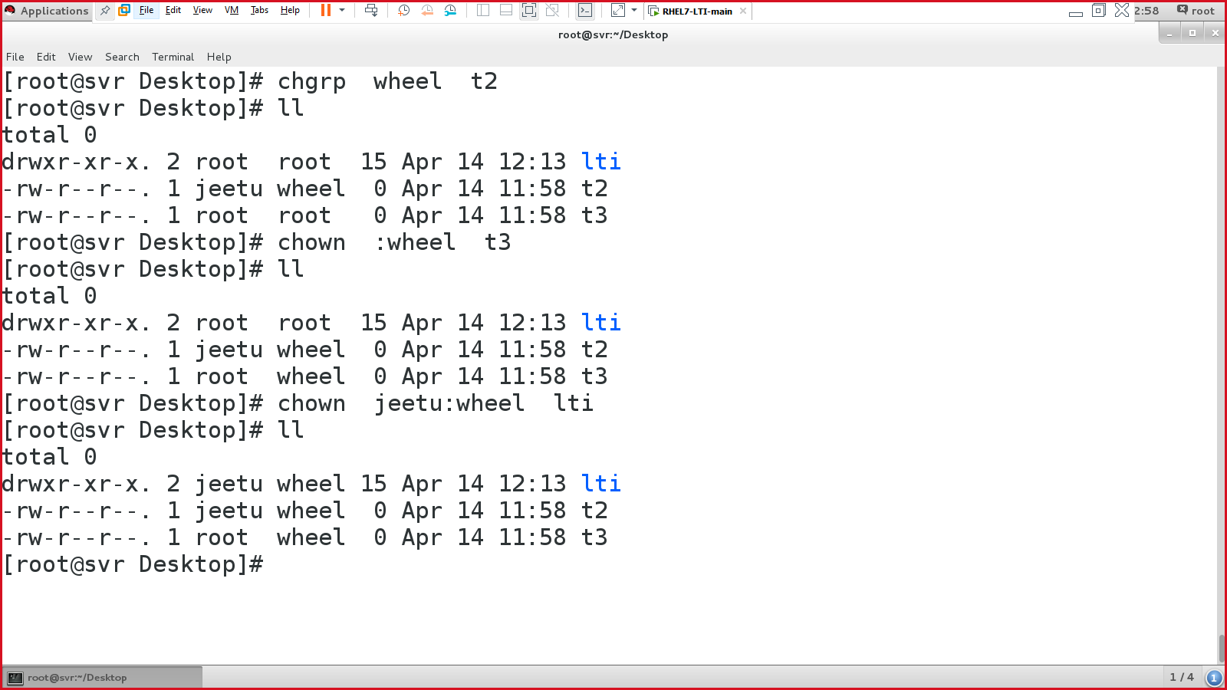

Changing the permissions of a f/d:

1. Changing via numerical method.
   1. #chmod <number> <file-name>
   2. 000
   3. 111
   4. 222
   5. …
   6. 777
2. Changing via symbolic/alphabetical method.
   1. #chmod <user><op><perms> <file-name>
   2. #chmod ugo=x <file-name>
      1. = means assigning new perms
      2. + means save existing perms + add new perms
      3. - means save existing perms + subs new perms
   3. Ex: #chmod u=rwx,g=rx,o=x t2

User management:

Important files in user mgmt:

* /etc/passwd 🡪 holds user related information
* /etc/shadow 🡪 holds users passwd detailed information.

Tasks:

1. create a user
2. modify a user
3. delete a user
4. sudo user 🡪 EDITOR=vim visudo

**/etc/passwd:** (7 columns)

1. login name
2. x 🡪referenced password 🡪 /etc/shadow
3. user id.
4. Group id of the user.
5. Description/full name /GECOS 🡪 “chfn”
6. Default home directory of a user.
7. Default SHELL.

**/etc/shadow**: (9 columns)

1. Login name
2. True encrypted password (MD5 or SHA512)
   1. $6 = SHA512 algo
   2. $1 = MD5 algo
3. Last password change (since 1st Jan 1970 in number of days)
4. Minimum passwd age (0)
5. Maximum passwd age (99999 in days) ~273yrs 🡪 30 days
6. Warning days 🡪 7 days
7. Empty 🡪 inactive
8. Empty 🡪 account expiry
9. Empty 🡪 not used till date / for future purpose.

To check the passwd algo:

# authconfig --test | grep hashing

Creating a user:

1. #useradd <option> <username>
2. Ex: #useradd -u 1024 -s /bin/csh rocky
3. Areas where new user’s entry is gonna create:
   1. /etc/passwd
   2. /etc/shadow
   3. /home/<user-name-dir>
   4. /var/mail/

Modify an existing user:

1. #usermod
2. Ex: #usermod -c "Ittalian Sttalion" rocky

Delete a user:

1. Partial deletion (used for deleting users’ credentials)
   1. #userdel <username>
      1. /etc/passwd
      2. /etc/shadow
2. Full deletion (used for deleting user completely from the Linux system)
   1. #userdel -r <username>
      1. /etc/passwd
      2. /etc/shadow
      3. /home/<user-name-dir>
      4. /var/mail/

To search a specific keyword in a file:

* #grep rocky /etc/passwd OR
* #cat /etc/passwd | grep rocky

To search a file or directory in linux:

* find / -name content.txt // searching a file
* find / -type d -name lti // searching a directory

Groups in Linux:

* File: /etc/group
* Consists of 4 columns
  + Group name
  + X 🡪 referenced passed 🡪 /etc/gshadow
  + Group ID
  + Group members

Sudo users:

* User with limited admin rights.

Sudo user = normal user + limited admin permissions.

* Root user => #
* Normal user => $
* Sudo user => $

File 🡪 /etc/sudoers

Commands 🡪 #visudo or EDITOR=vim visudo

root ALL=(ALL) ALL

* col1: user name
* col2: machine=terminal
* col3: commands given to the user

sudo tasks:

1. create a new sudo user with ALL permission/cmd.
2. create a new sudo user with PREDIFINED cmd.
3. Create a new sudo user with CUSTOM cmd.

Defining the commands:

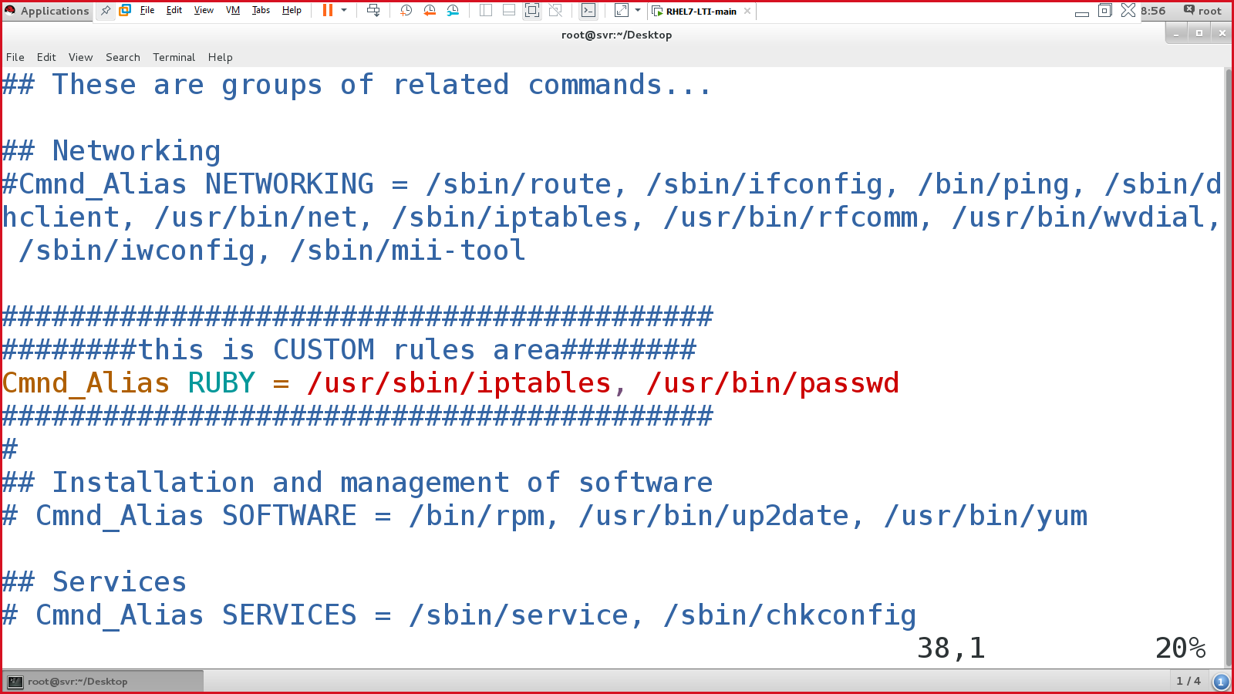

Allocating the commands to the users.

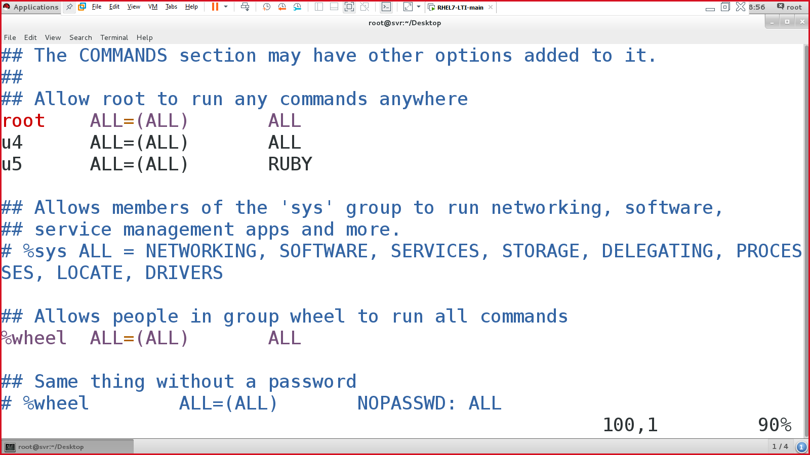

Packages management:

* Installing packages/software on linux machine.
* Local repository (repository = location where all packages are present).
* Internet based repository.

Repo:

* RedHat repo = local (DVD), RedHat satellite server (paid).
* Centos repo = local (DVD), Centos mirror server (free).

Packages managers – responsible for package mgmt (install, remove, update…)

* RPM
  + Redhat package manager
  + **Default method** to manage a package in RHEL/Centos/Fedora…
  + Extension is .rpm
* YUM
  + Yellowdog update manager OR Yellowdog update modifier.
  + A server that WE need to install.
  + To install YUM server, there are 2 methods.
    - **Full** – 8/9 steps, independent of DVD, permanent.
    - **Shortcut** – 1 step, temporary (dependent on DVD)
  + Extension is .rpm
* APT
  + Advanced packaging tool
  + Ubuntu server.
  + Free of cost, no charges to download or install any packages.
  + Extension is .rpm, .deb, .dpkg
* DPKG
  + Debian-based package manager.
  + Extension as .deb, .dpkg
  + Kali, backtrack.
  + Free of cost

Naming convention of a package in Linux: Name-major-version-architecture.rpm

Win 🡪 XShell_5.0-Build-1019.exe

* XShell = name of the software
* _5.0 = versions
* Build-1019 = release/built
* .exe = extension

Linux 🡪 zip-3.0-10.el7.x86_64.rpm

* Zip = name of the package
* ‘3.0’ = major release/version
* 10.el7 = minor release
* X86_64 = architecture of the package
* .rpm = extension.

Architecture of any linux package:

1. 32bit = i686
2. 64bit = x86_64
3. No architecture = noarch = 32bit and 64bit

RPM – Redhat package manager.

* Install
  + #rpm -ivh <package-full-name>.rpm
    - I = install
    - V = verbose
    - H = hashing (###############################)
  + Ex: #rpm -ivh /run/media/root/RHEL-7.0\ Server.x86_64/Packages/dhcp-4.2.5-27.el7.x86_64.rpm OR
  + #rpm -ivh dhcp-4.2.5-27.el7.x86_64.rpm
* Query
  + rpm -q <package-name> 🡪 list single installed package.
  + rpm -qa 🡪 list all installed packages.
* Uninstall/remove
  + #rpm -e <package-name>
* Update
  + #rpm -Uvh <package-name>
    - U = means, update

Problems of RPM:

* *Full name* 🡪 dhcp-4.2.5-27.el7.x86_64.rpm
* *Location* 🡪 /run/media/root/RHEL-7.0\ Server.x86_64/Packages/dhcp-4.2.5-27.el7.x86_64.rpm (absolute path or relative path)
* *Dependency* 
  + #rpm -ivh system-config-kickstart-2.9.2-4.el7.noarch.rpm 🡪 dependency error while installing
  + #rpm -ivh --nodeps system-config-kickstart-2.9.2-4.el7.noarch.rpm 🡪 installation done w/o dependency.

YUM – yellowdog update manager

* Install a YUM server
* It consists of 8/9 steps.

|  |
| --- |
| **Steps to install YUM server:**  **Step 1: check the firewall & SELinux**   * #systemctl status firewalld 🡪 check FW status * #systemctl stop firewalld 🡪 stop FW   SELinux:   * setenforce 0 🡪 will make SELinux permissive * getenforce 🡪 output will permissive.   **Step 2: check the list of packages.**   * rpm -q createrepo deltarpm python-deltarpm vsftpd   **Step 3: create a local repo directory**   * mkdir /var/ftp/pub/yumserver   **Step 4: copy all the packages from DVD to the local repo (created in step 3)**   * cp -var /run/media/root/RHEL-7.0\ Server.x86_64/Packages/* /var/ftp/pub/yumserver/ * v= verbose * a= all (hidden & visible) * r= recursively   **Step 5: create yum/client answer file.**   * To go to /etc/yum.repos.d directory * List the contents of the directory, if any file named package… or Redhat…. Then delete those files. * Create a new file ‘yum.repo’ And write below lines: * [yumserver] * name="Joker SVR" * baseurl=ftp://192.168.10.10/pub/yumserver * gpgcheck=0 * enabled=1   **Step 6: create index for the packages.**   * #createrepo -v /var/ftp/pub/yumserver/     **Step 7: enable, start & check the status of vsftpd service.**   * #systemctl enable vsftpd 🡪 ensure to start vsftpd service at next boot time. * #systemctl start vsftpd 🡪 start the vsftpd service for NOW. * #systemctl status vsftp 🡪 running status of vsftpd   **Step 8: clean, update & verify.**   * #yum clean all * #yum update all * #yum repolist     END OF FULL YUM SERVER |

* Install
  + #yum install -y <package-name>
  + #yum install -y dhcp system-config-kickstart…
* Query
  + #yum info <package-name>
  + #yum info finger
* Uninstall/remove
  + #yum remove <package-name>
* Upgrade/update
  + #yum update <package-name>

**For shortcut YUM method**

Step 1: DVD must be present. Go to /etc/yum.repo.d

Step 2: remove/move all the file.

Step 3: create a new client answer file as yum.repo & write/paste below code:

* [rubyRockss]
* name="Ruby repo"
* baseurl=file:///run/media/root/CentOS\ 7\ x86_64/
* gpgcheck=0
* enabled=1
  + :wq!

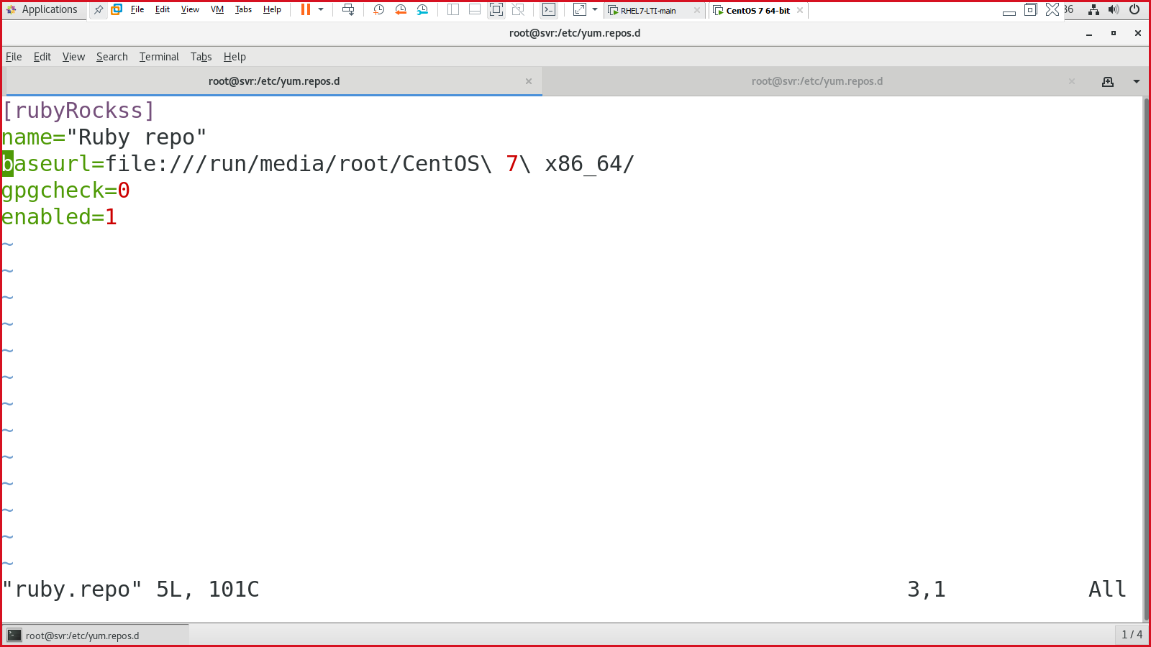

Save & quit

Step 4: run cmd 🡪 #yum repolist

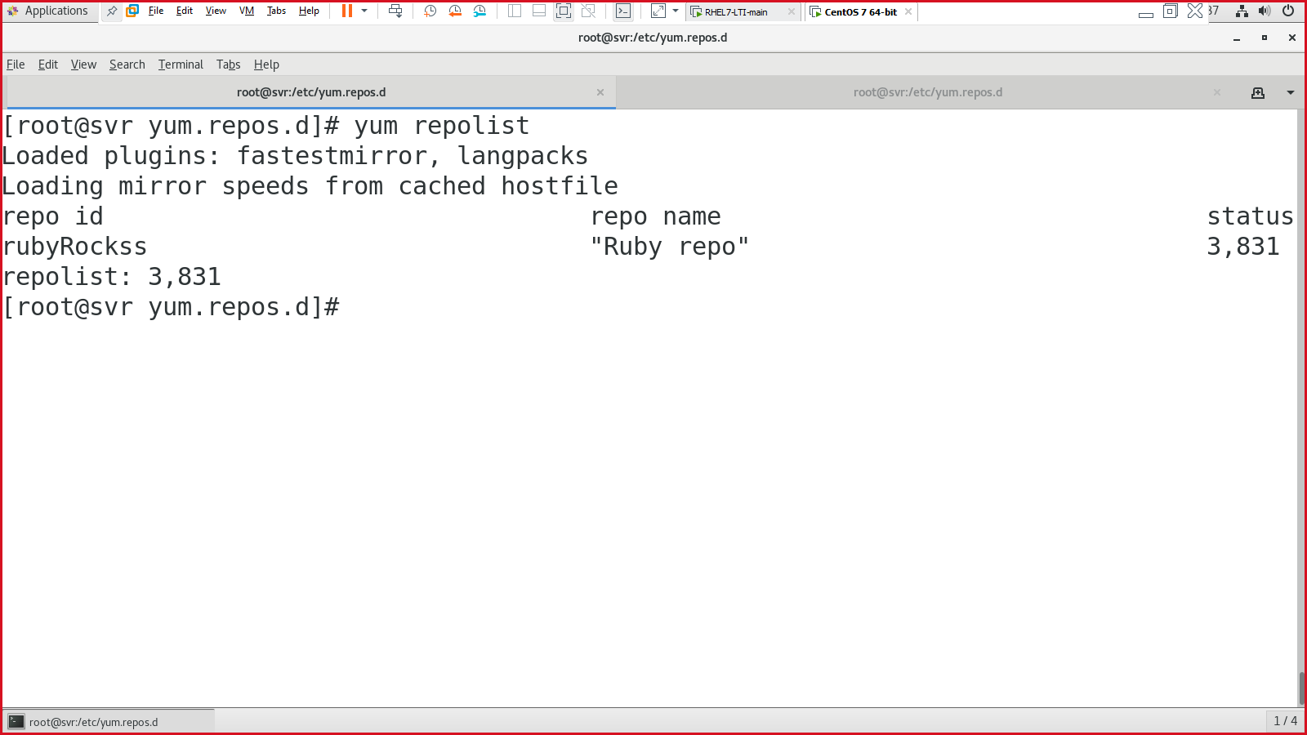

Partitioning:

1. Simple partitioning 🡪 1 blank storage disk
2. Advanced partitioning 🡪 logical volume manager (LVM) 🡪 3 blank storage disks.

Simple partitioning

Before:

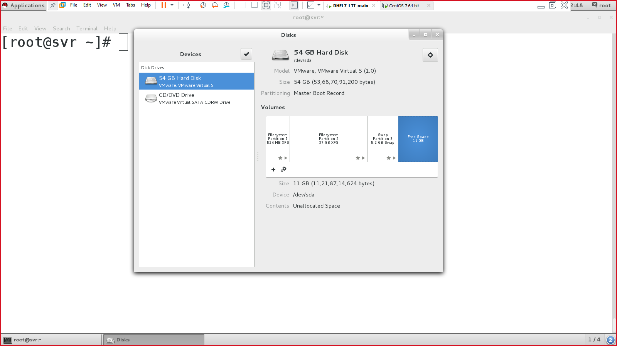

1. Create a partition for the disk 🡪 fdisk
2. Create a file system for the partition (created in step 1) 🡪 mkfs
3. Create a mount point to access the disk. 🡪 mkdir
4. Edit /etc/fstab file 🡪 critical.
5. Mount & verify

Step1: Create a partition for the disk

“fdisk” works on hard disk 🡪 /dev/sda

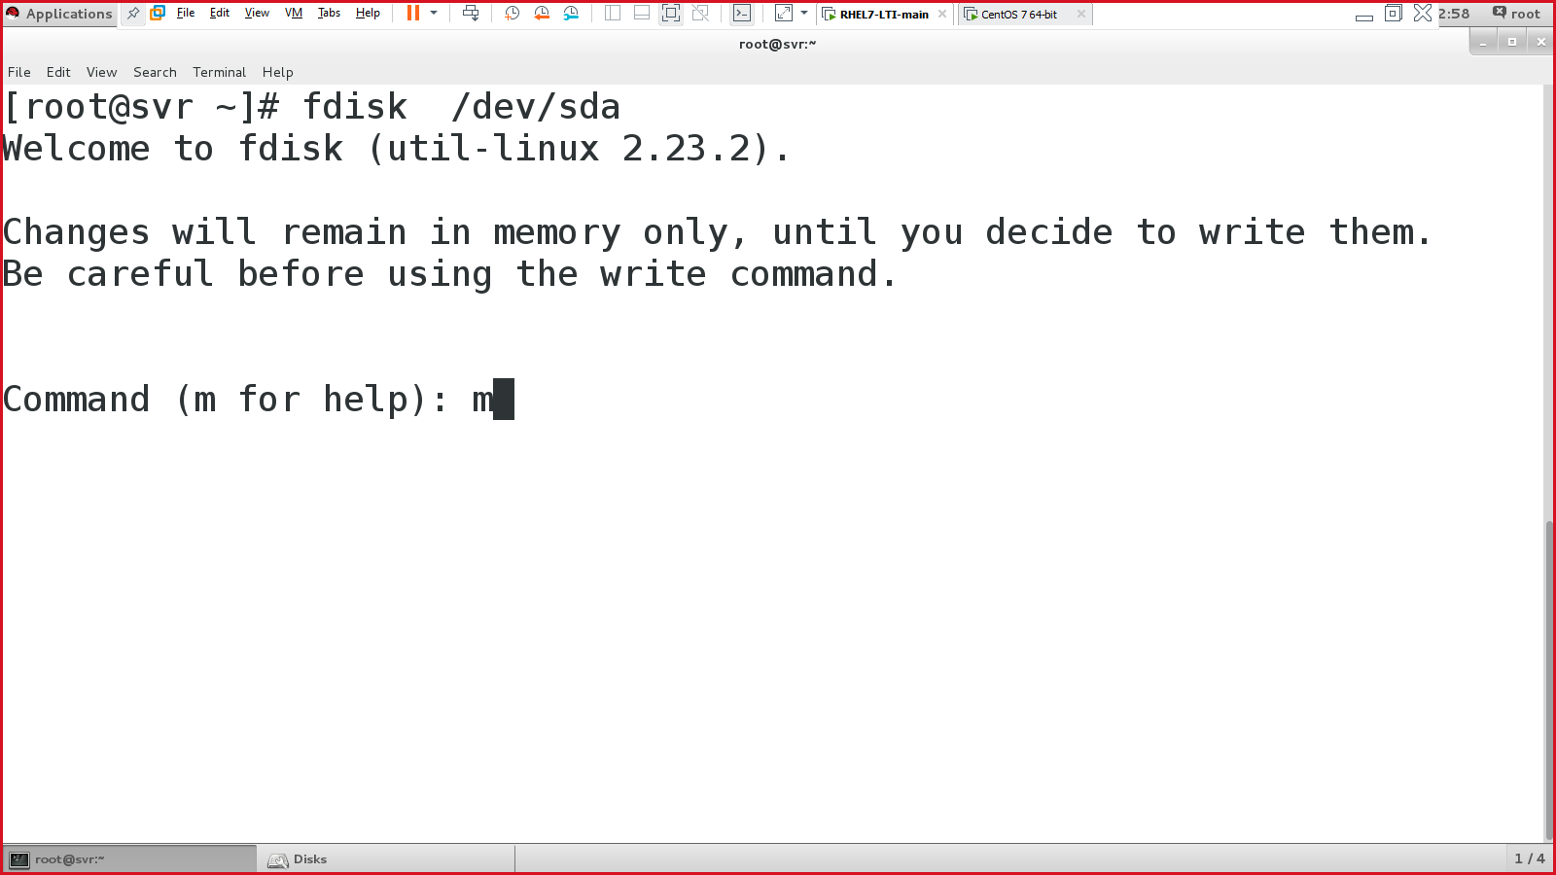

Listing help commands:

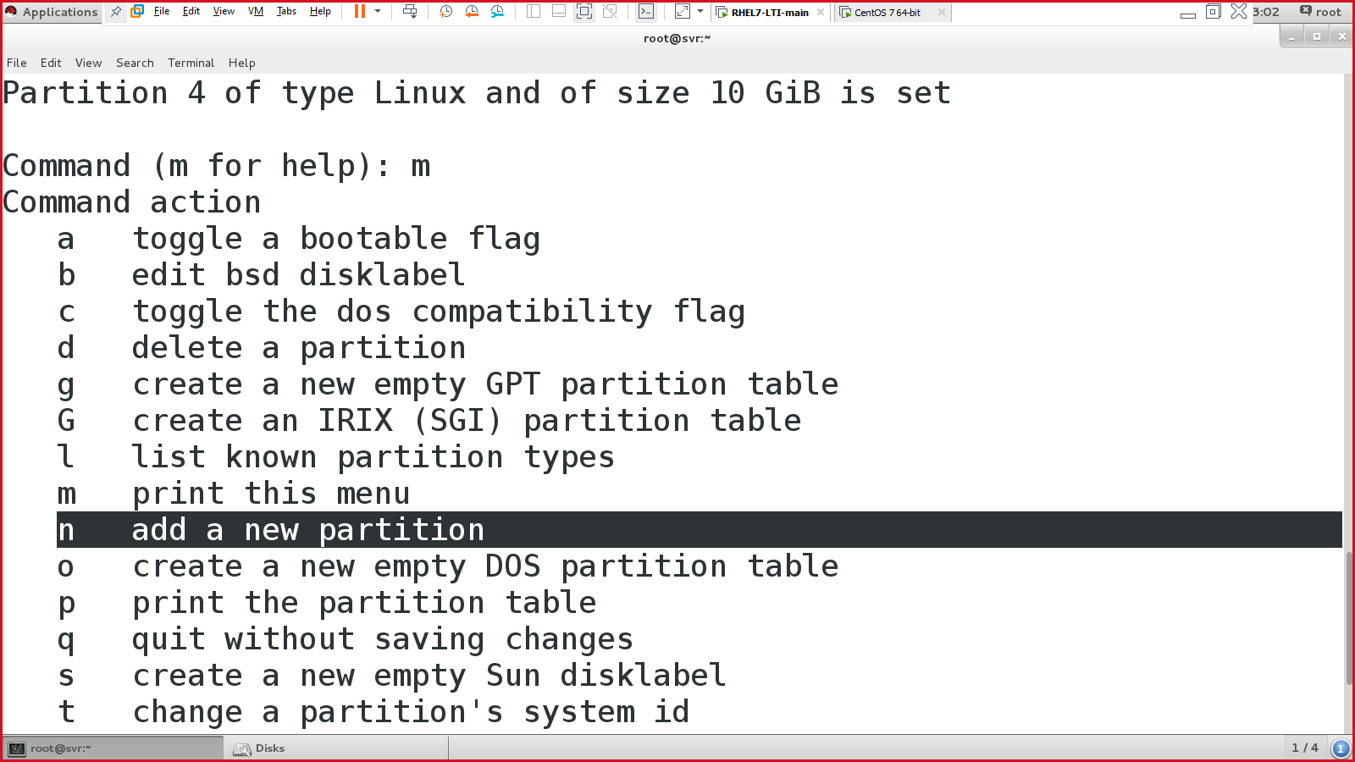

Create primary partition:

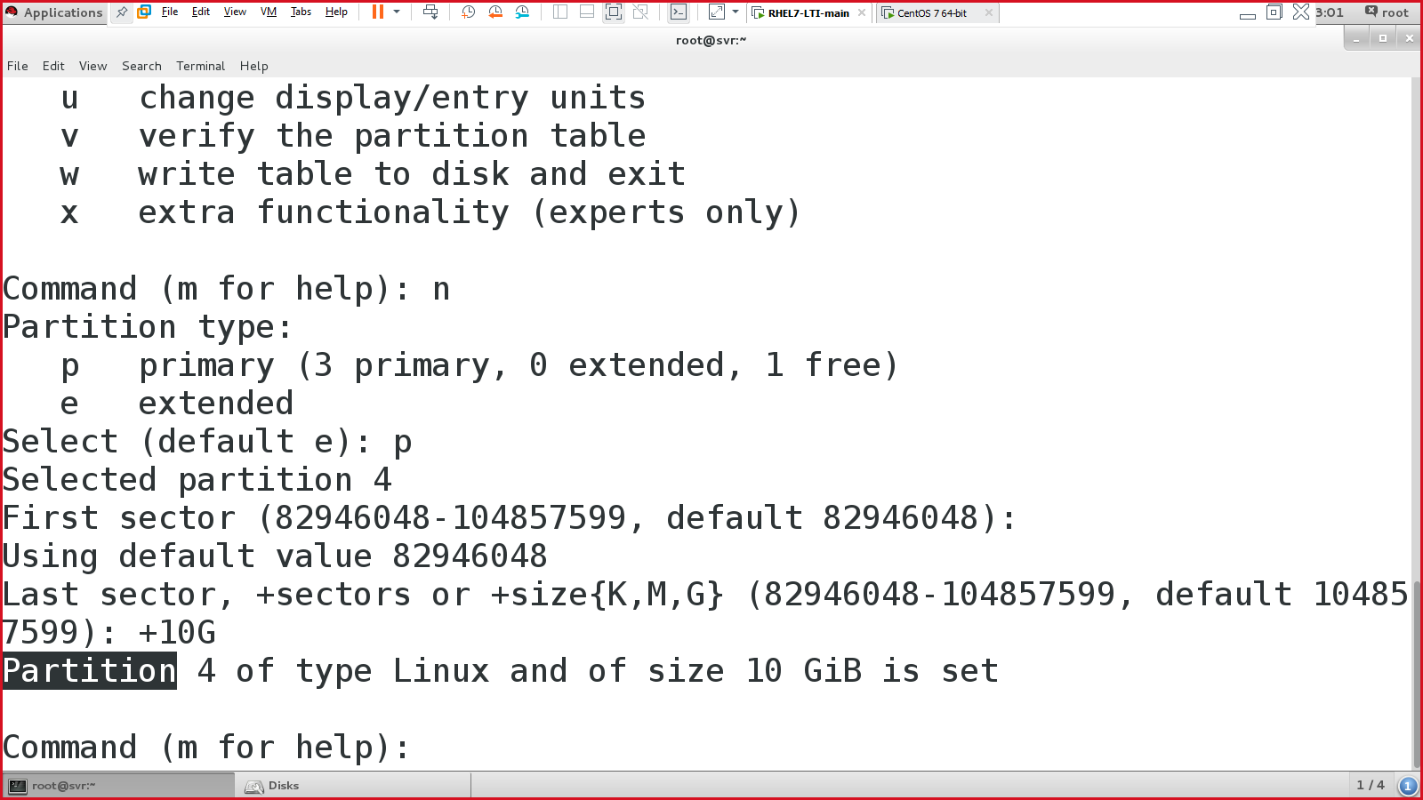

Again press ‘m’ for help & select ‘w’.

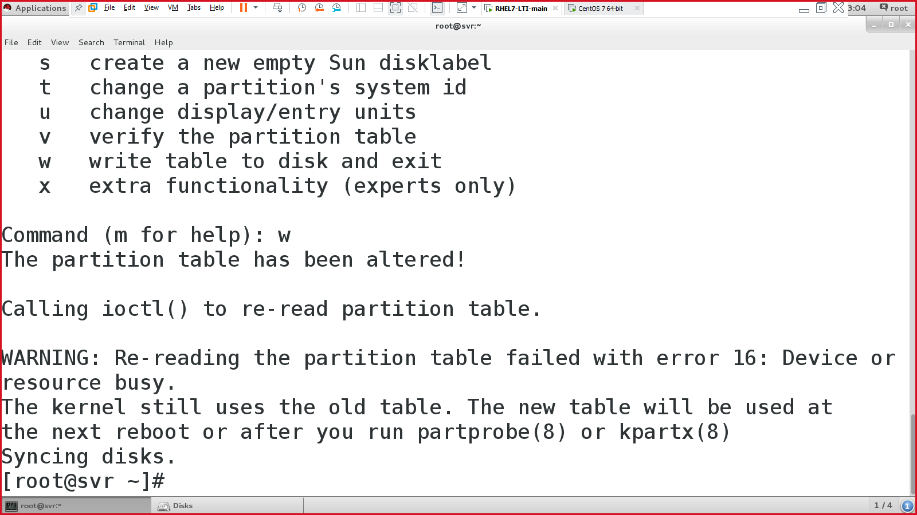

Either reboot your system or execute the command:

* #partprobe /dev/sda

Step2: Create a file system for the partition

“mkfs” works on partition, you created in step 1.

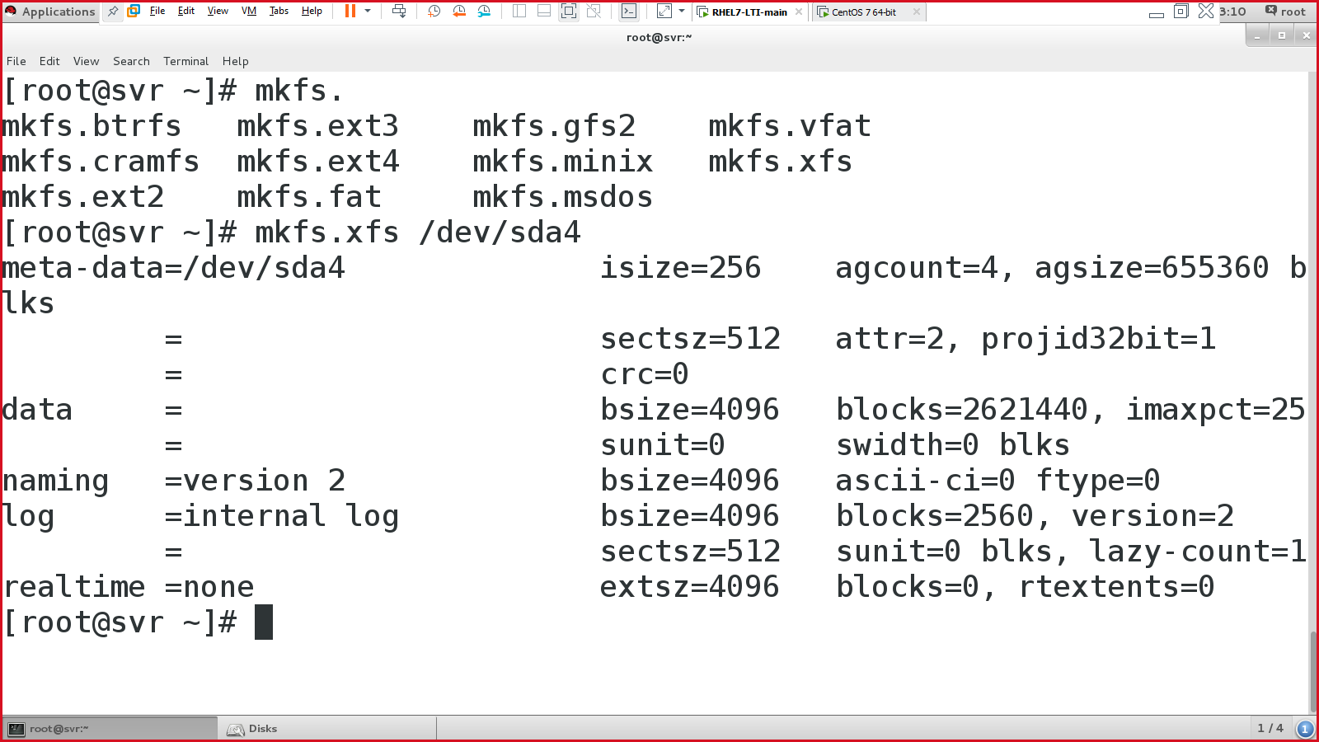

Step 3: Create a mount point to access the disk

* #mkdir /warmachine

Step 4: edit /etc/fstab

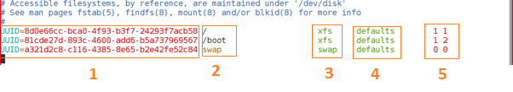

* Col1: what to mount? 🡪 /dev/sda4
* Col2: where to mount 🡪 /warmachine
* Col3: file system of the hard disk 🡪 xfs
* Col4: how to mount/permission 🡪 defaults
* Col5: priority at boot time 🡪 2 2

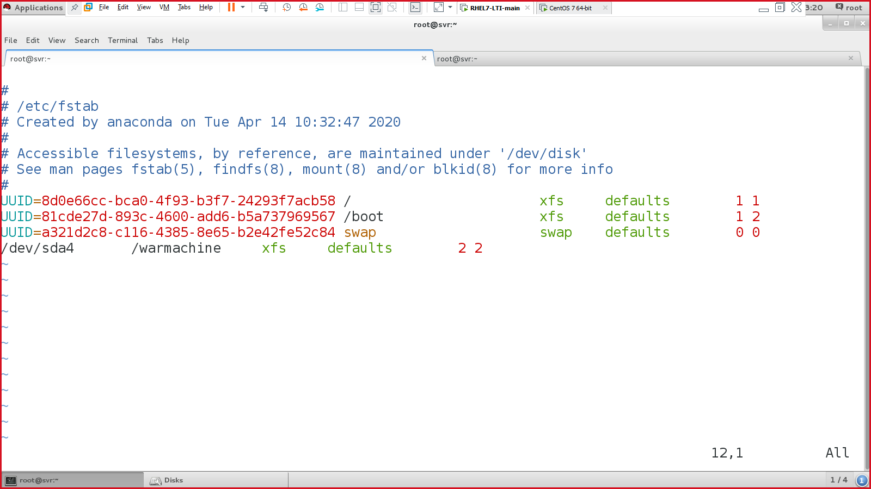

Save & quit

Step 5: Mount & verify

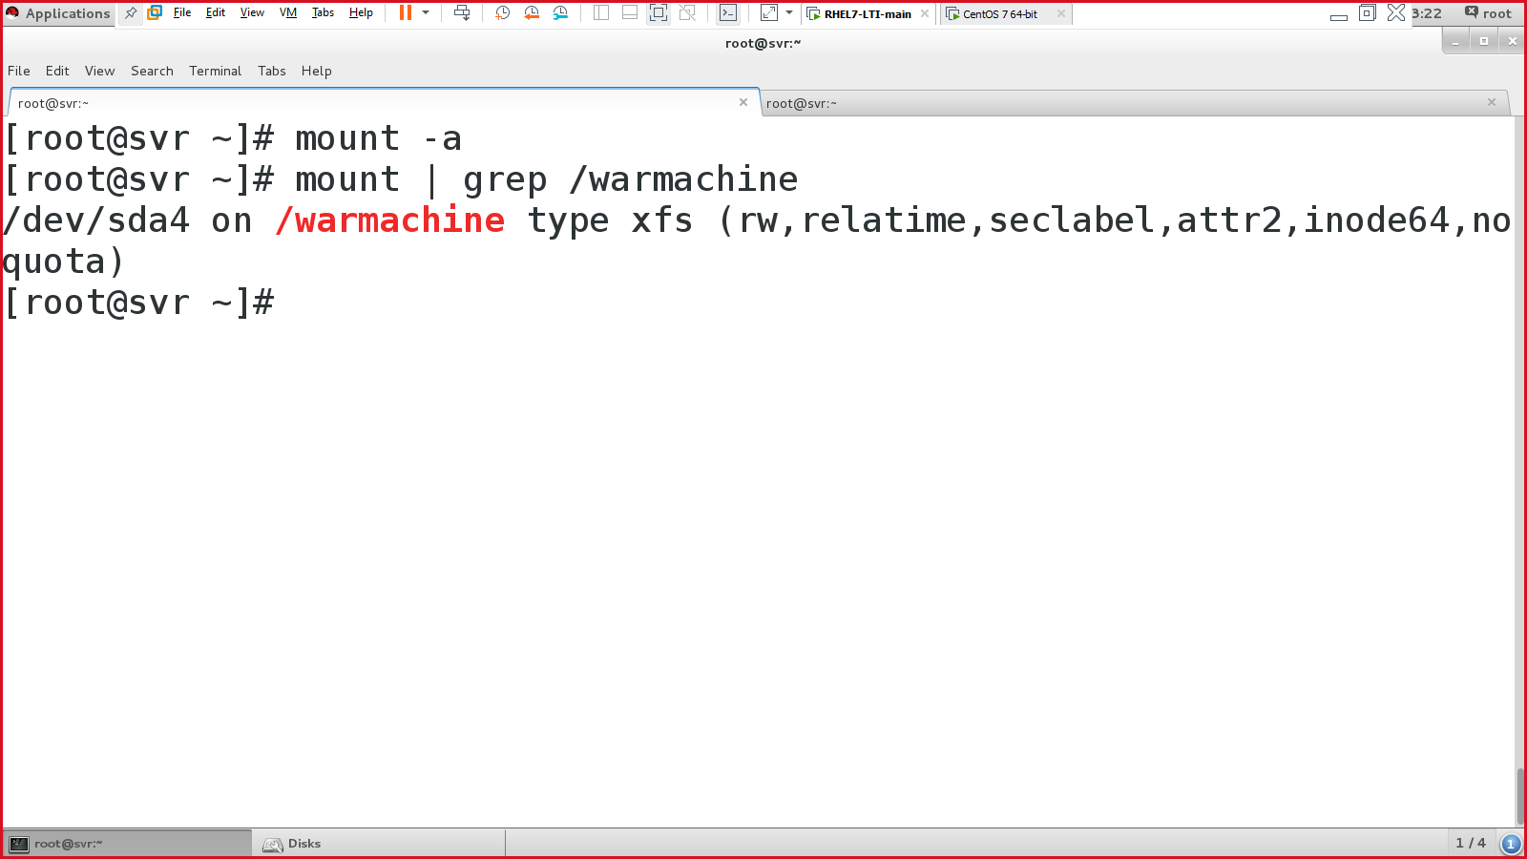

Verify:

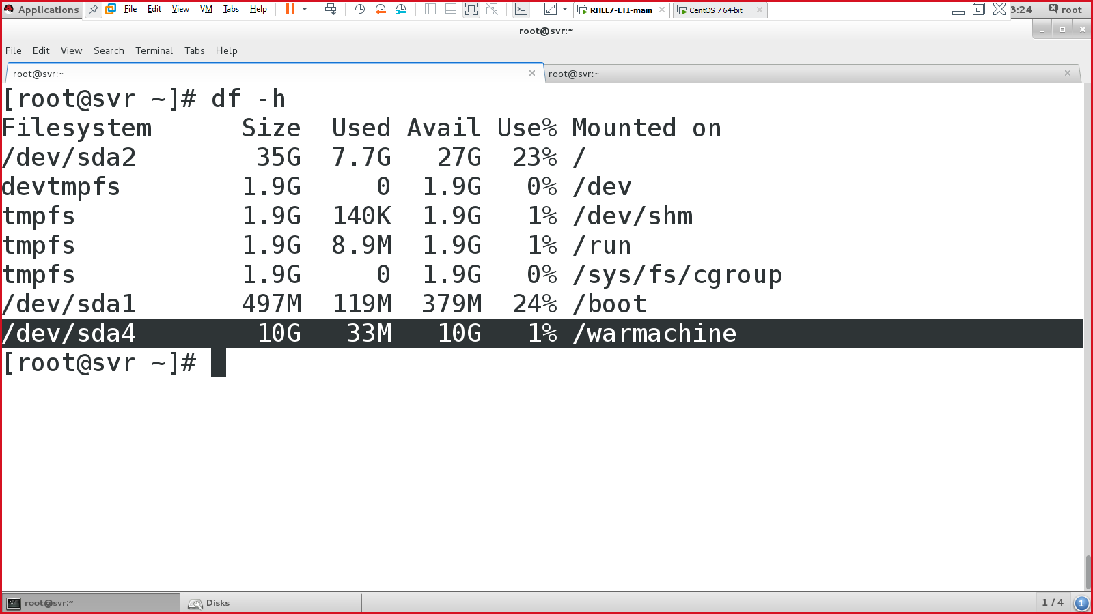

After the partitioning:

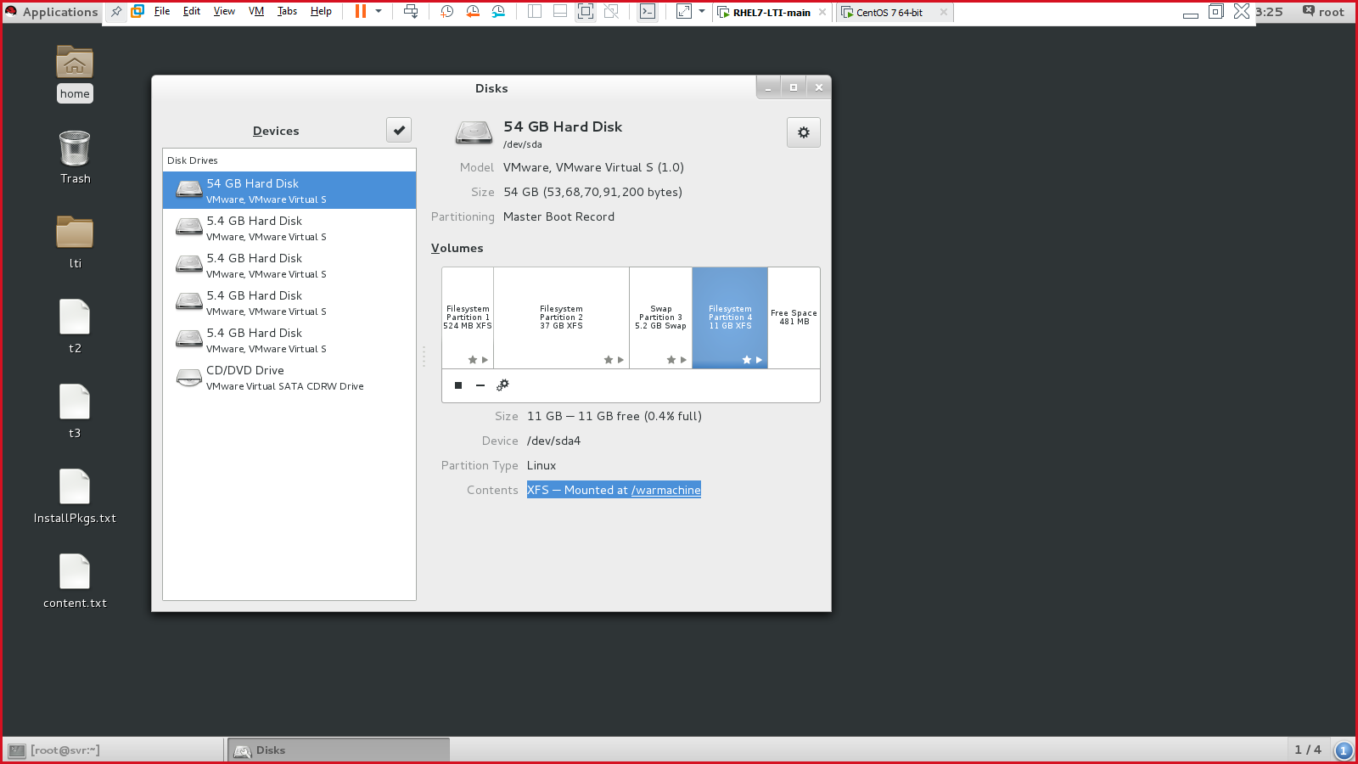

Logical Volume Manager (LVM)

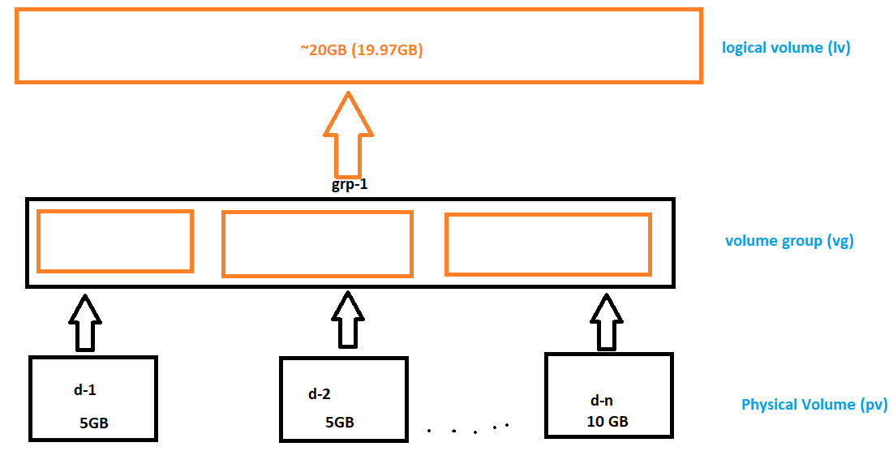

Steps to perform LVM.

* Create a partition for the disk 🡪 fdisk
* pv 🡪 pvcreate, pvdisplay/pvs, pvremove
* vg 🡪 vgcreate, vgdisplay/vgs, vgremove
* lv 🡪 lvcreate, lvdisplay/lvs, lvremove
* Create a file system for the partition (created in step 1) 🡪 mkfs
* Create a mount point to access the disk. 🡪 mkdir
* Edit /etc/fstab file 🡪 critical.
* Mount & verify

Disks for LVM 🡪 /dev/sdb & /dev/sdc

**Step 1: Create a partition for the disk** (use FDISK utility)

#fdisk /dev/sdb

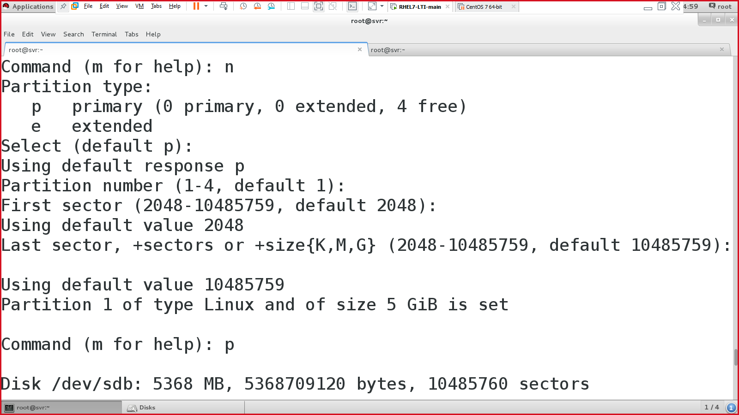

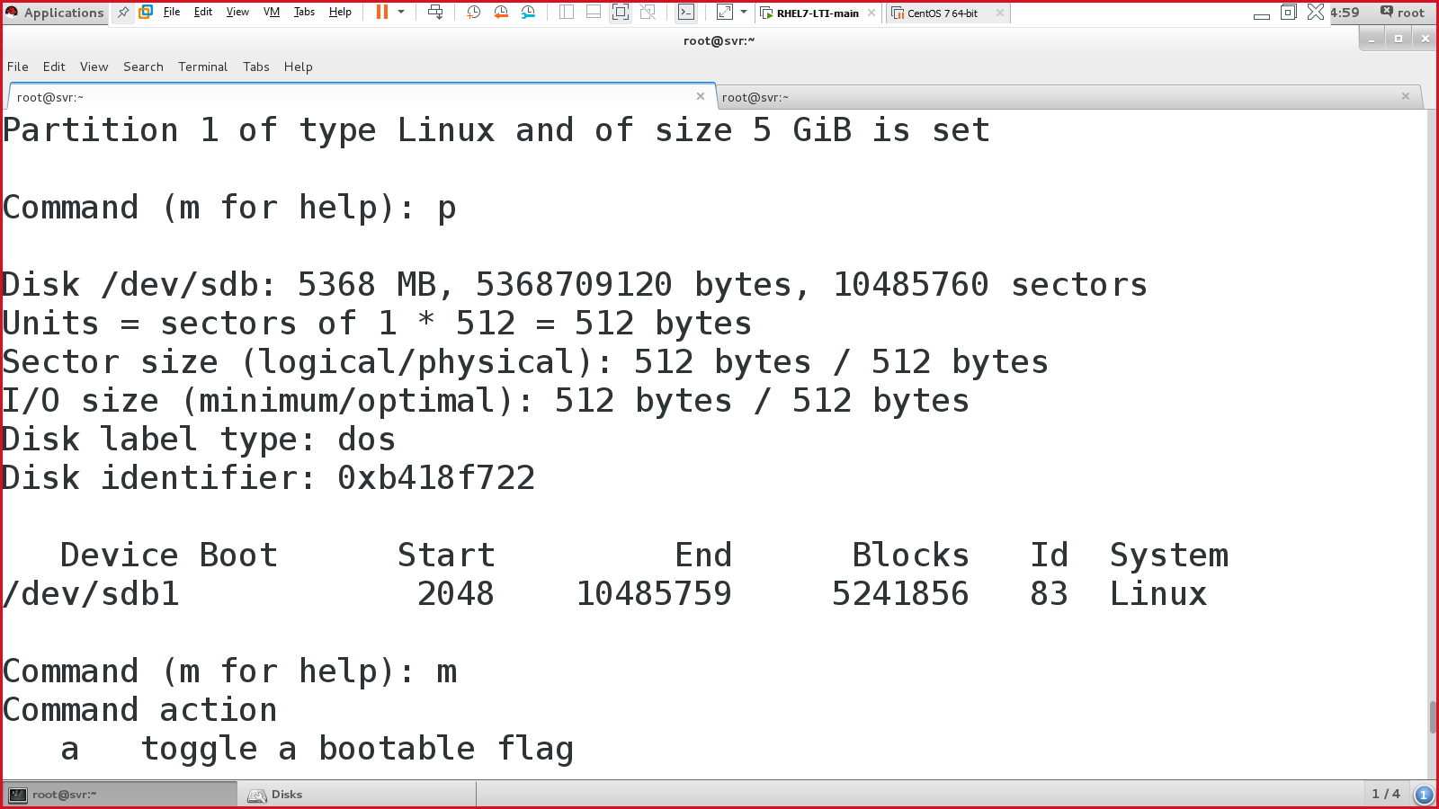

Then select ‘w’ to save & quit the utility

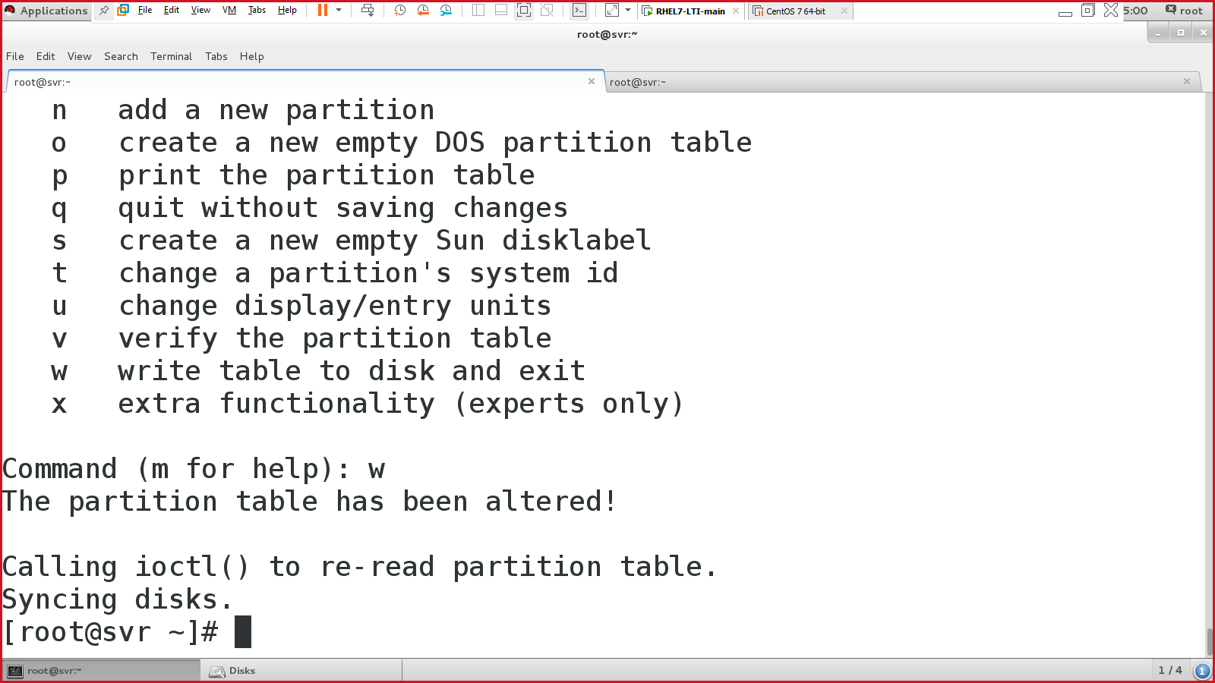

#fdisk /dev/sdc

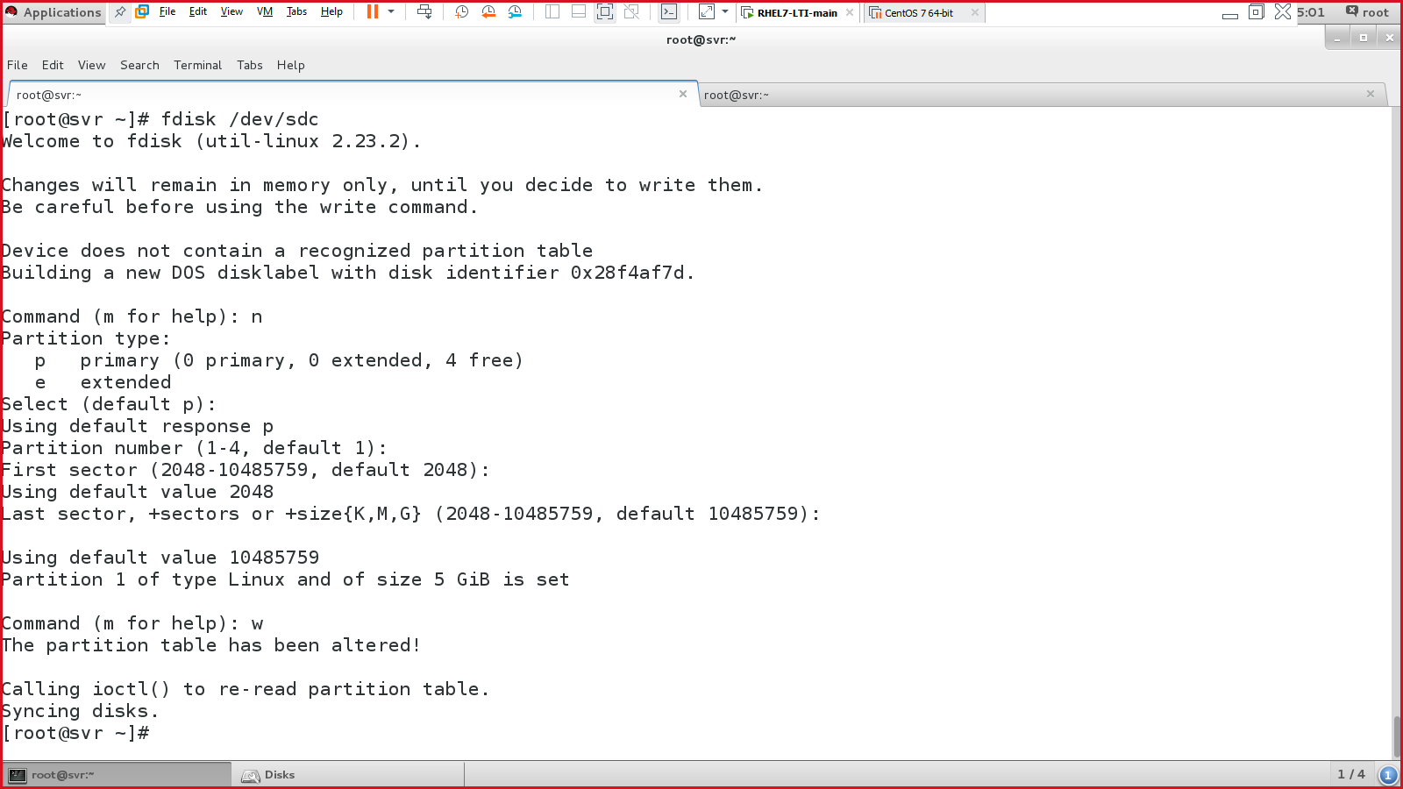

Step 2: create a physical volume (PV)

#pvcreate <disk-1> <disk-2>…

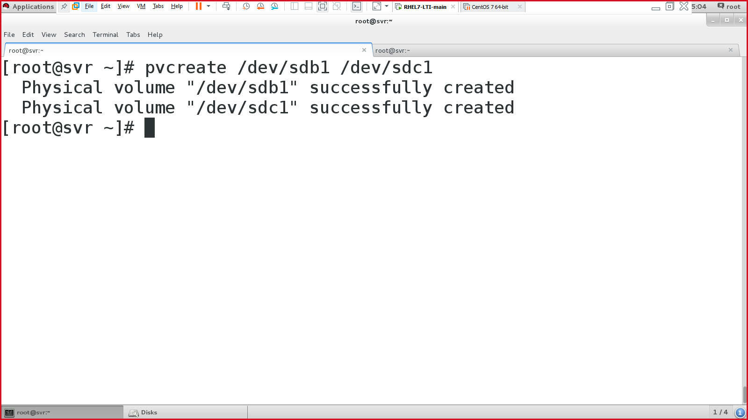

Display the pv:

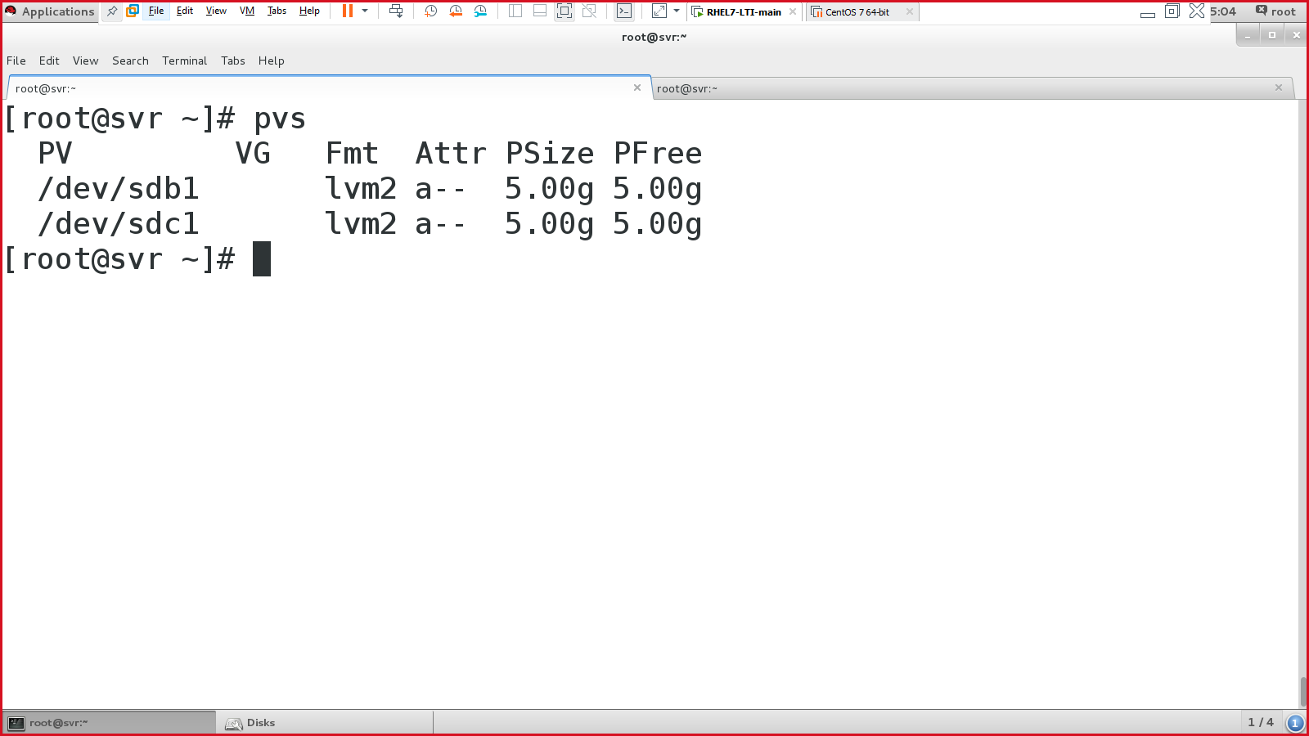

Step 3: create a volume group (vg)

#vgcreate <name-of-the-vg> <pv1> <pv2>…<pvn>

#vgcreate vg /dev/sdb1 /dev/sdc1

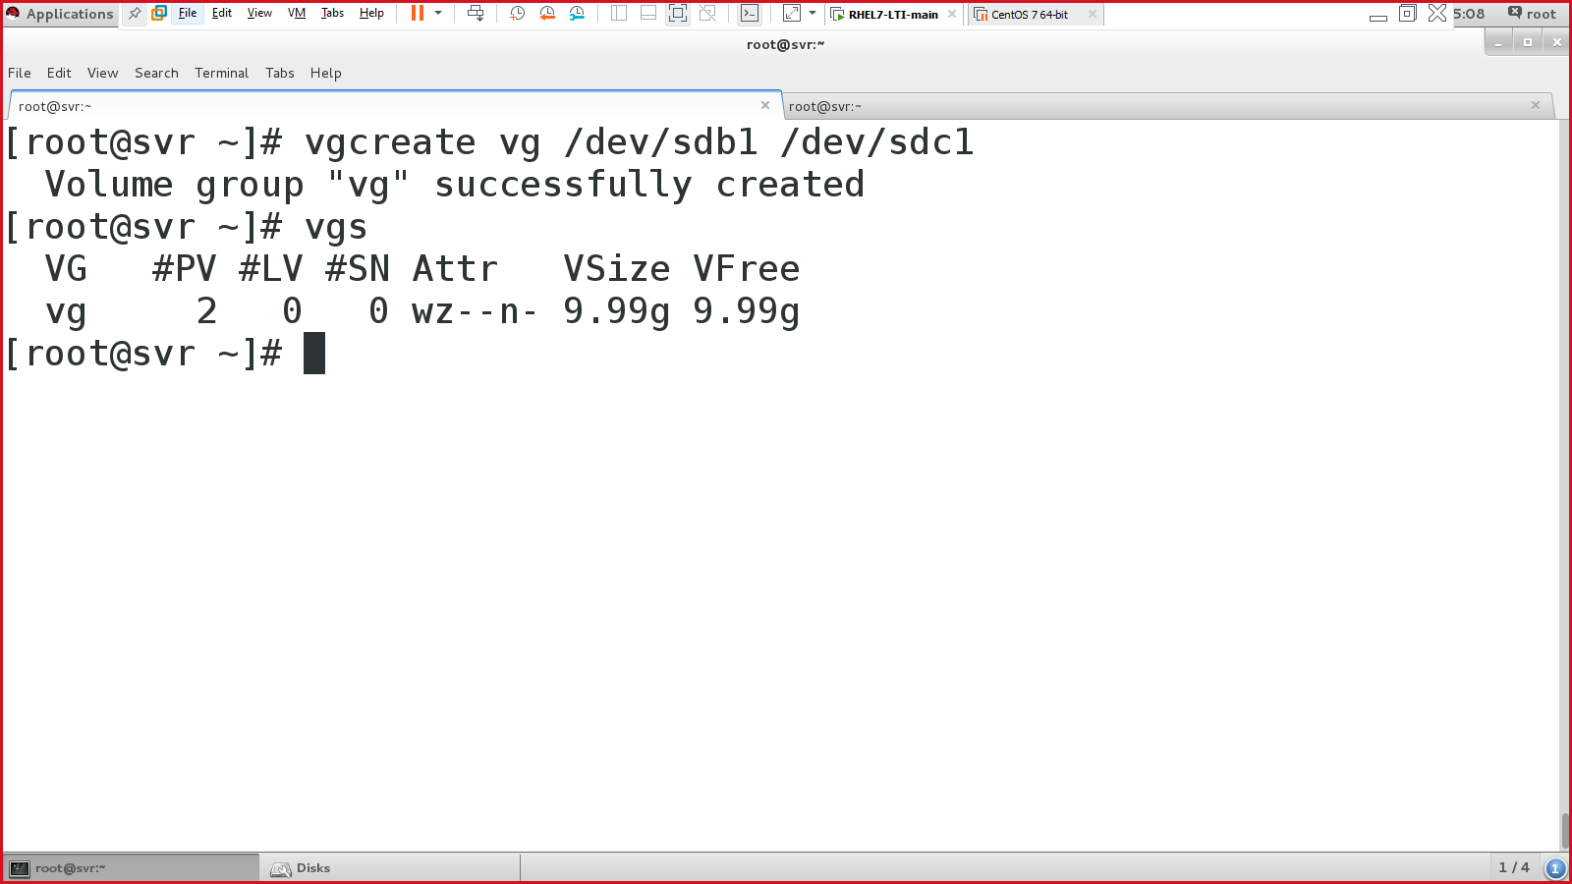

Step 4: create a logical volume (lv)

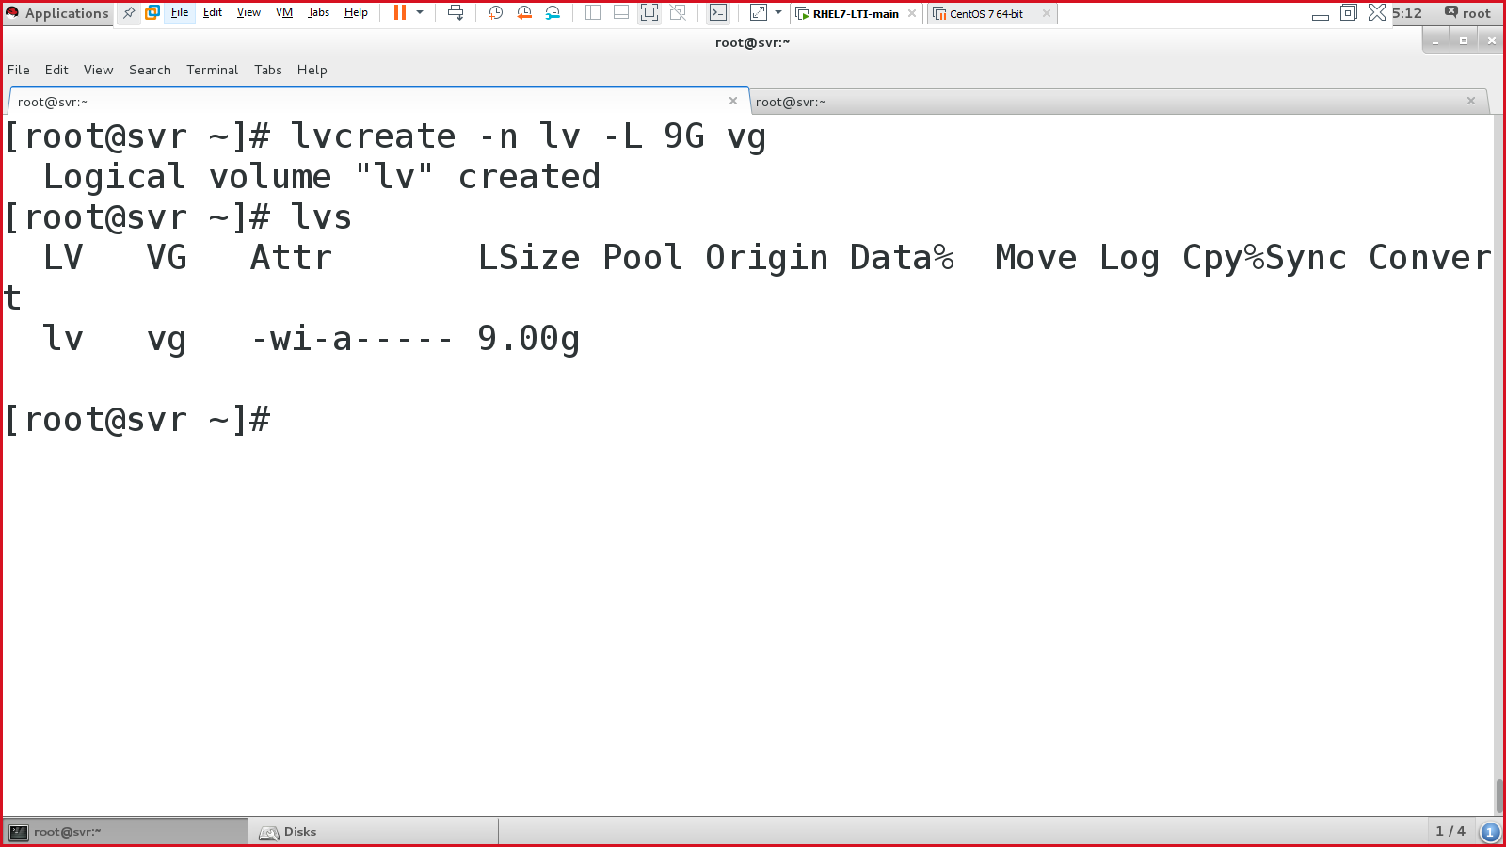

Step 5: create a file system (.ext4)

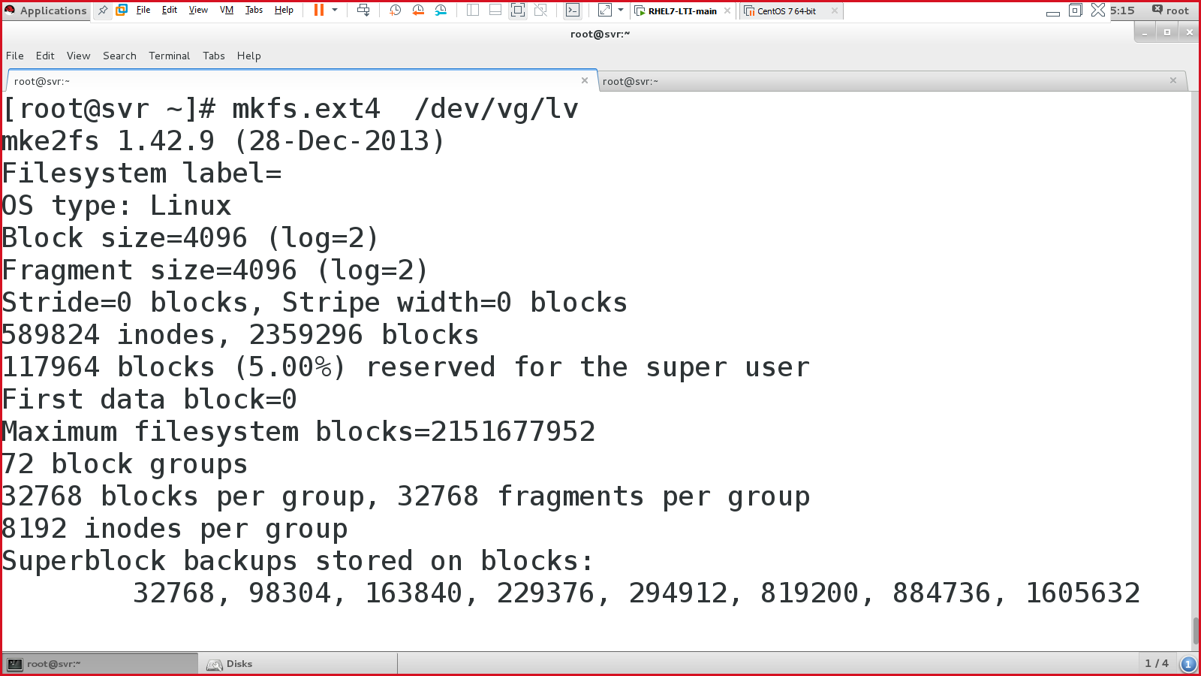

Step 6: create a mount point

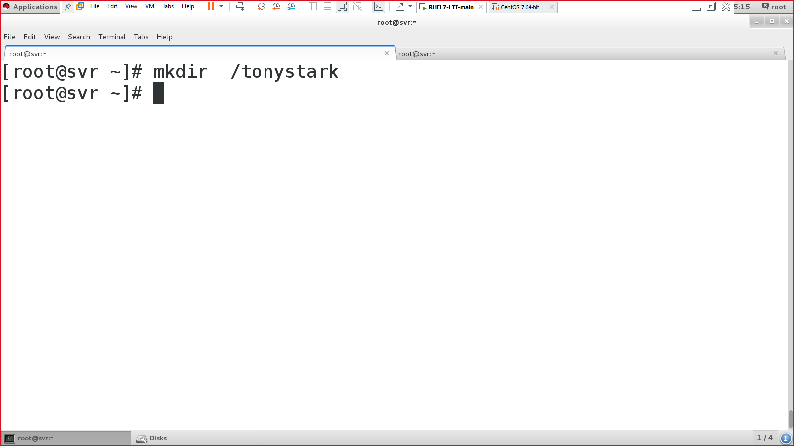

Step 7: mount the hard drive

1. Permanent
   1. Edit /etc/fstab

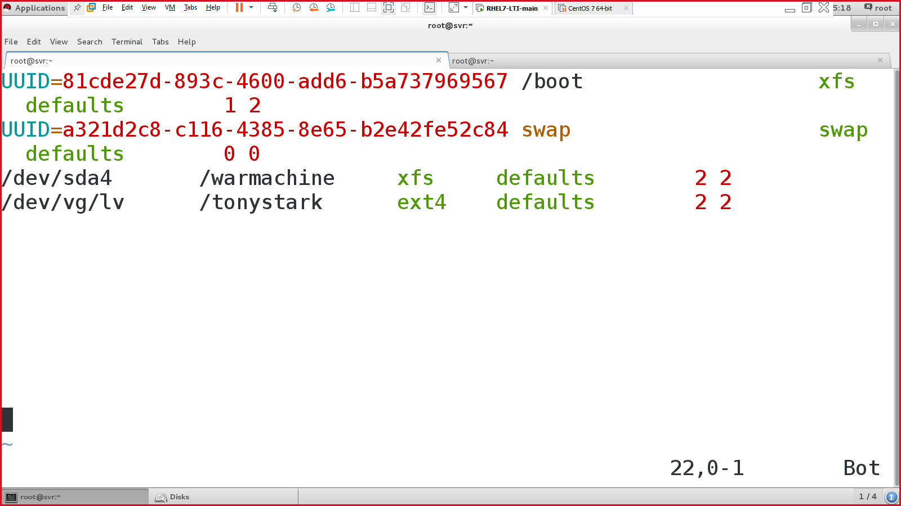

Save & quit

NOTE: EITHER PERFORM PERMANENT MOUNT OR TEMPORARY MOUNT (1 at a time)

1. Temporary
   1. Use mount command.

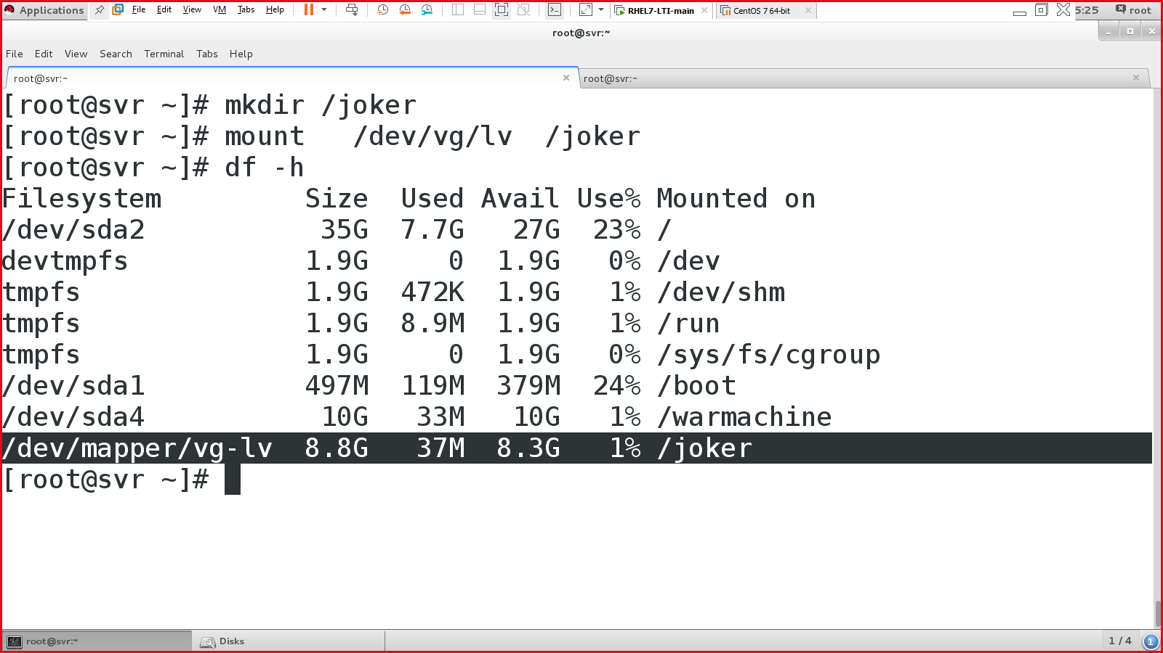

Step 8: mount & verify

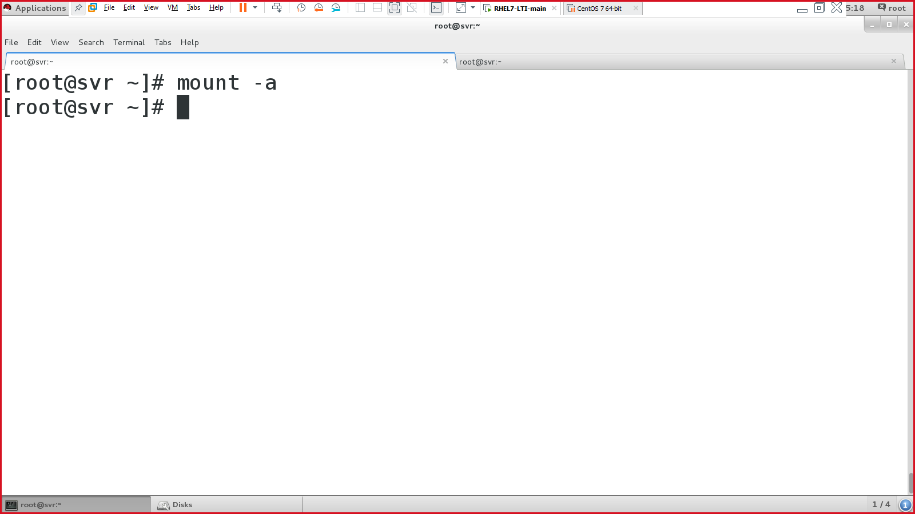

And verify:

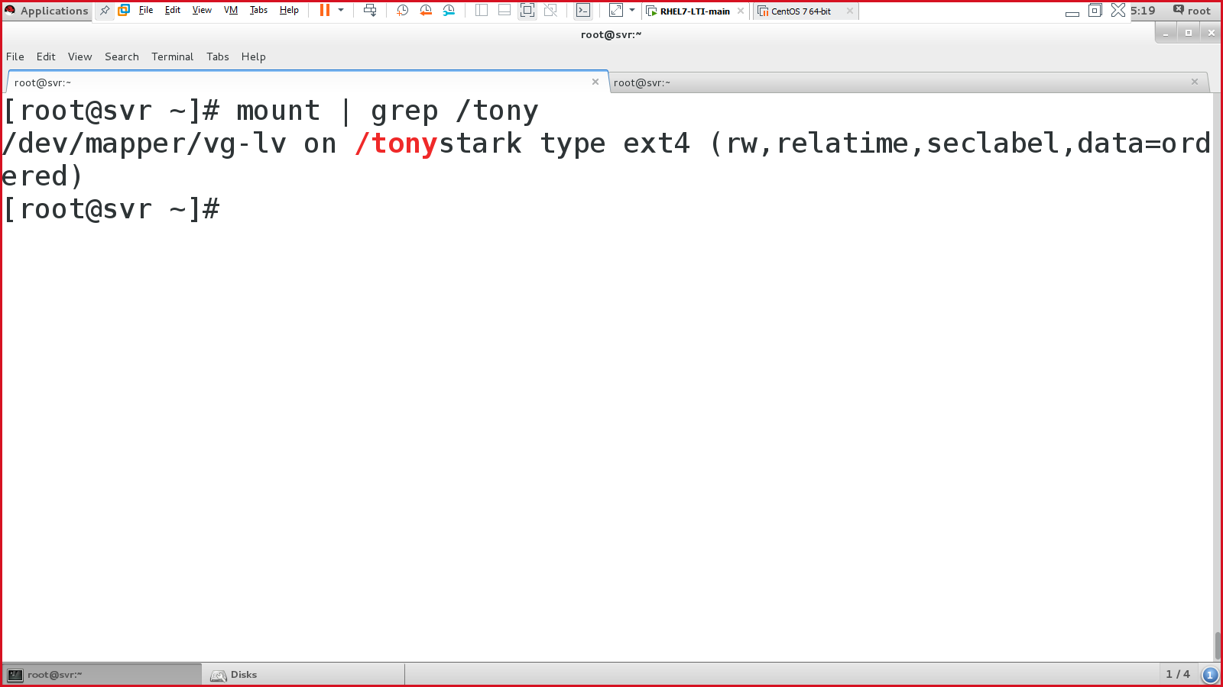

Verify by saving the file in the mounted drive

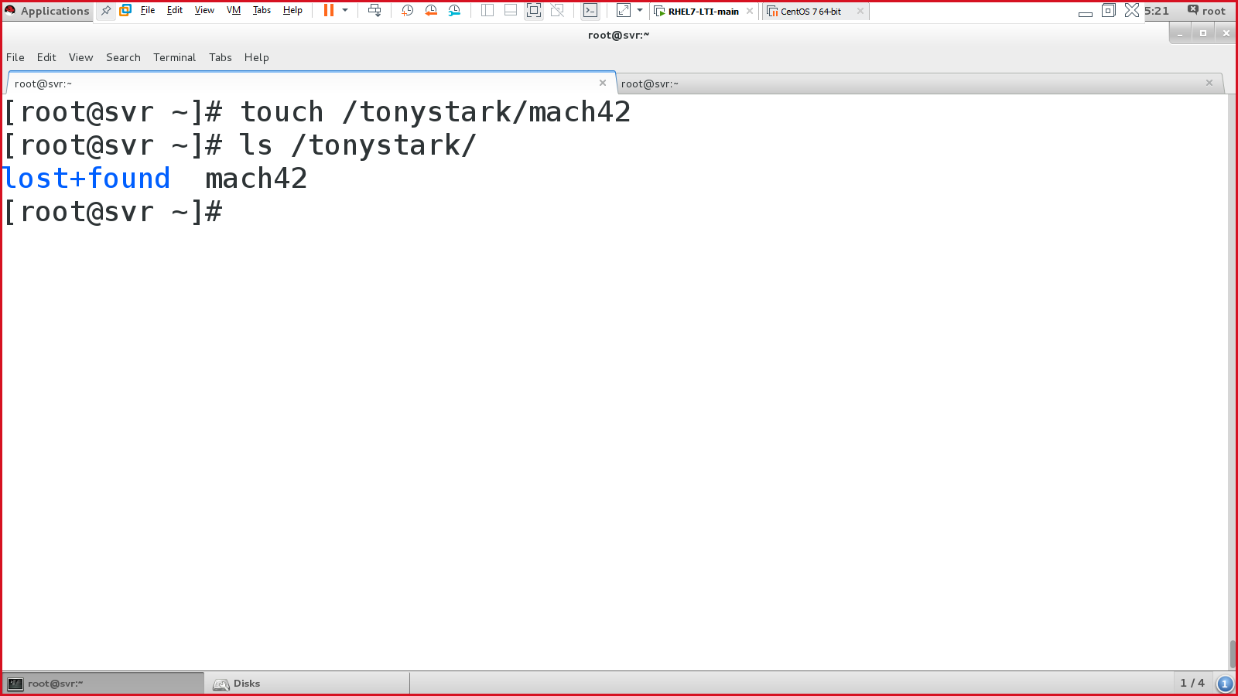

Verify using “df -h”.

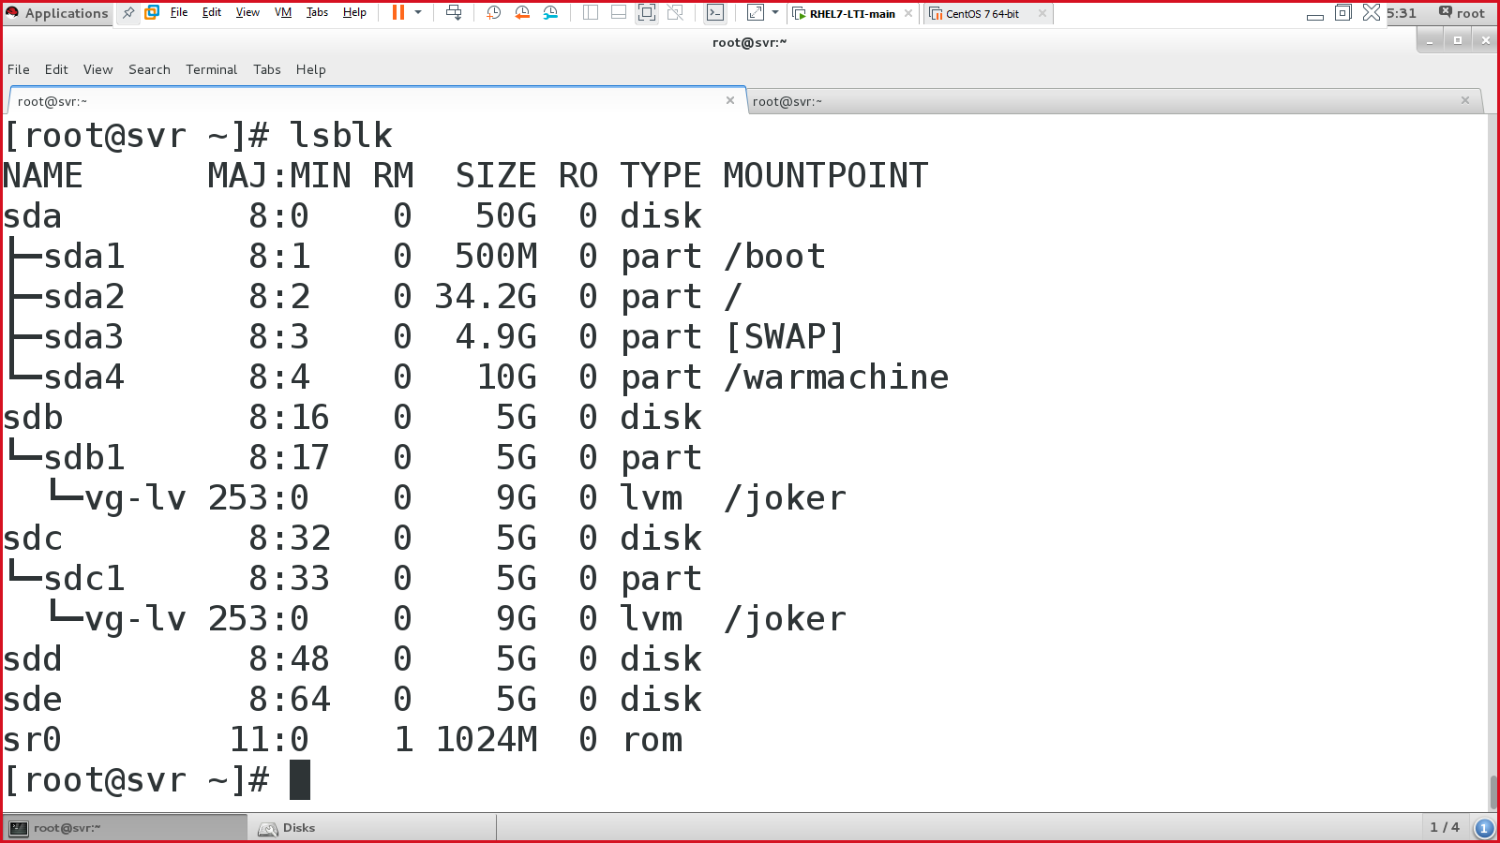

RAID

* redundant array of independent disks or
* redundant array of inexpensive disks.

Types of RAID:

* Raid 0 – striping
* Raid 1 – mirroring
* Raid 5 – striping with parity
* Raid 6 - striping with dual/double parity
* Raid 10 – combining striping with mirroring.

Disks to be in the RAID 0 - /dev/sdd & /dev/sde

Package required for RAID

#yum install -y mdadm

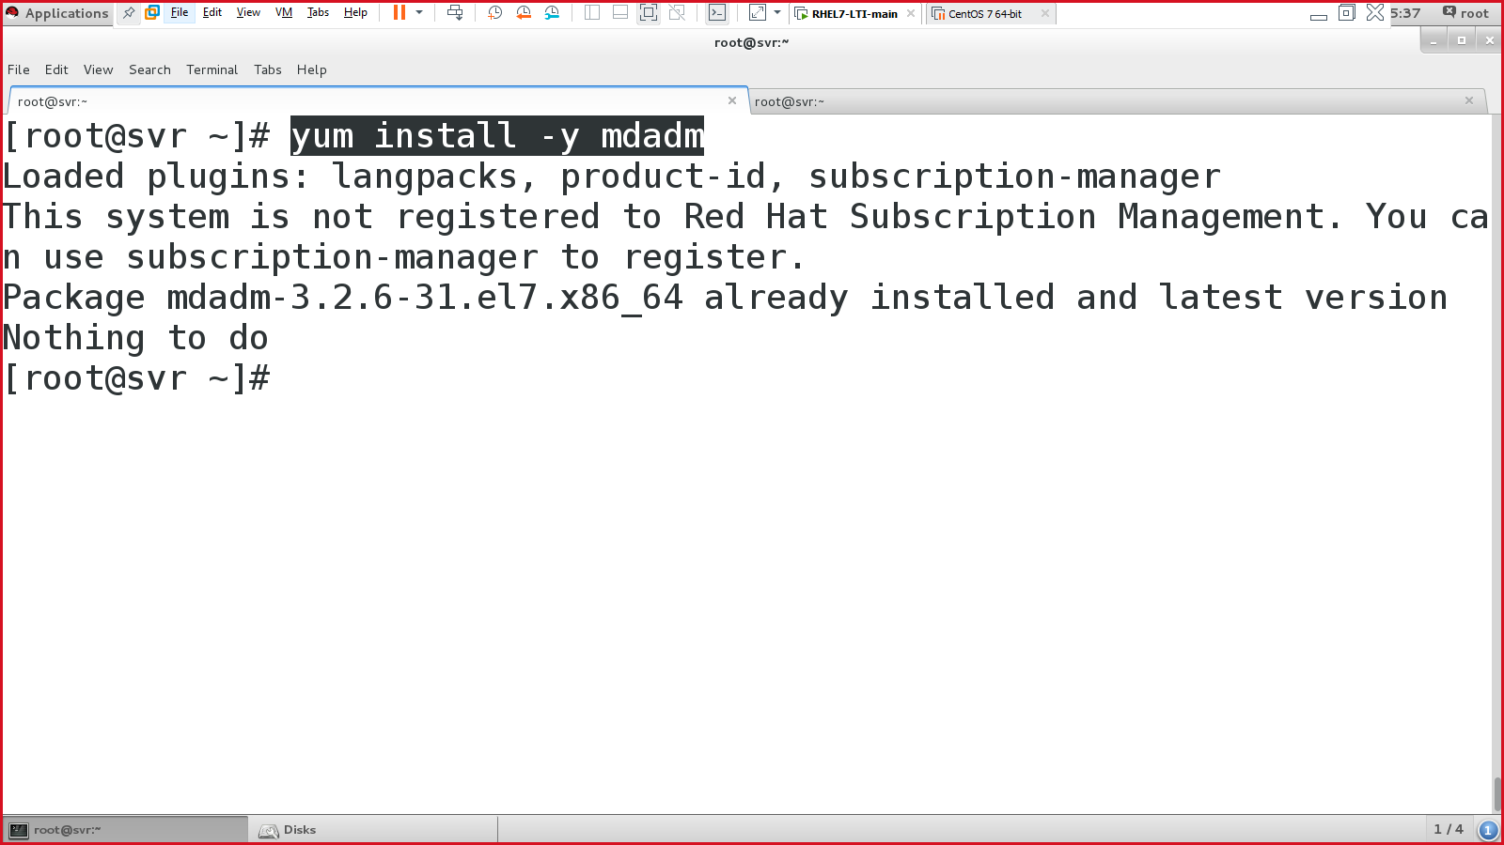

Format the disk in the required raid format.

#fdisk /dev/sdd

* Format the disk in the default setting (done earlier in standard partitioning)
* N = new, p = primary, 1, select 1st sector & last sector.
* Change the partition's system id 🡪 press ‘t’ 🡪 type ‘L’ 🡪 select ‘fd’

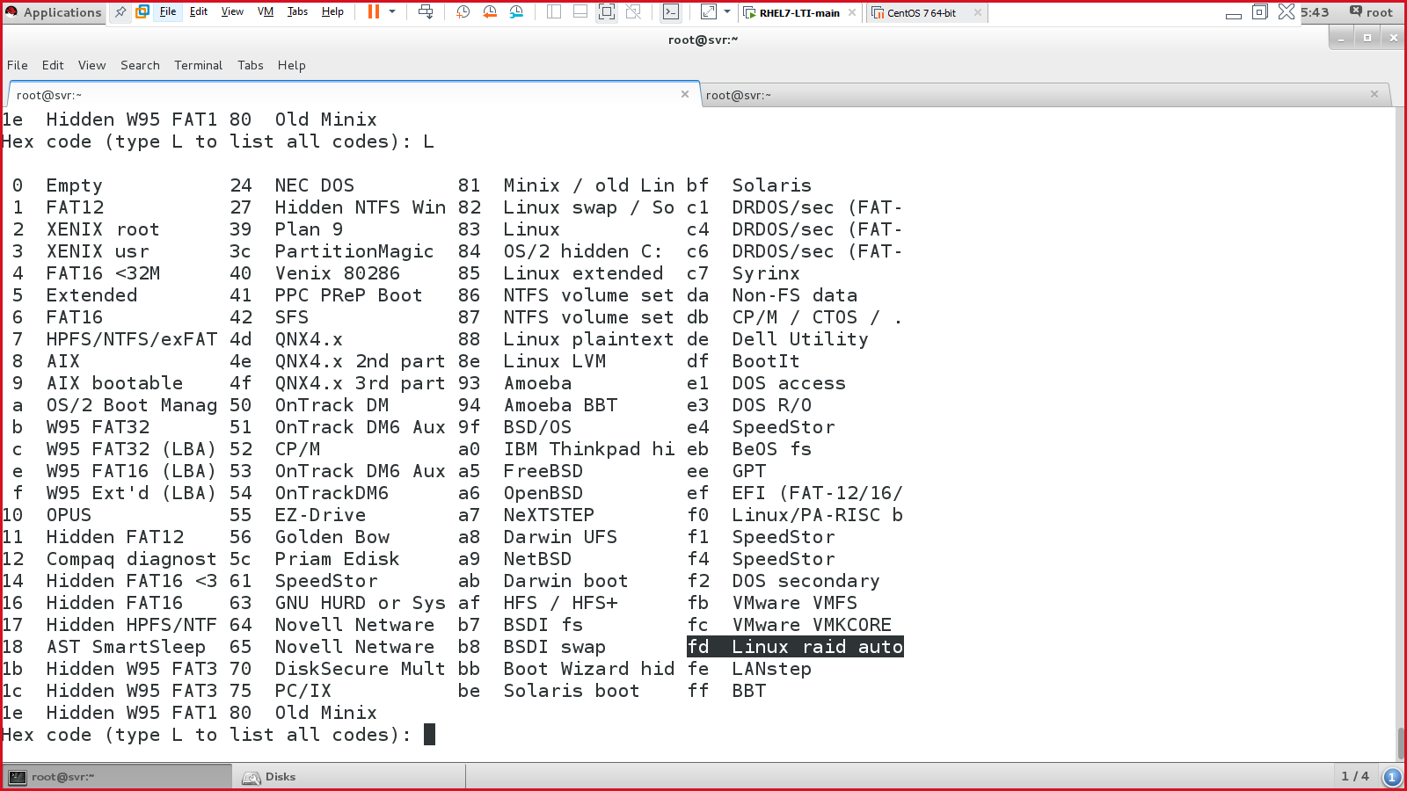

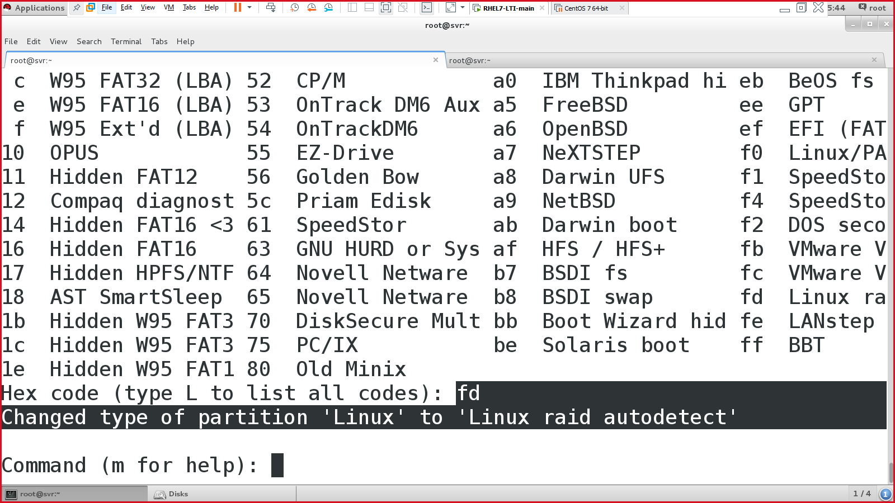

Verify:

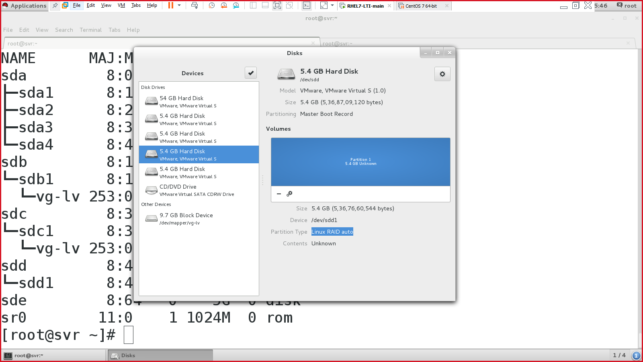

Perform the same for the 2nd disk in RAID:

#fdisk /dev/sde

Execute the below cmd to examine (-E) the disks:

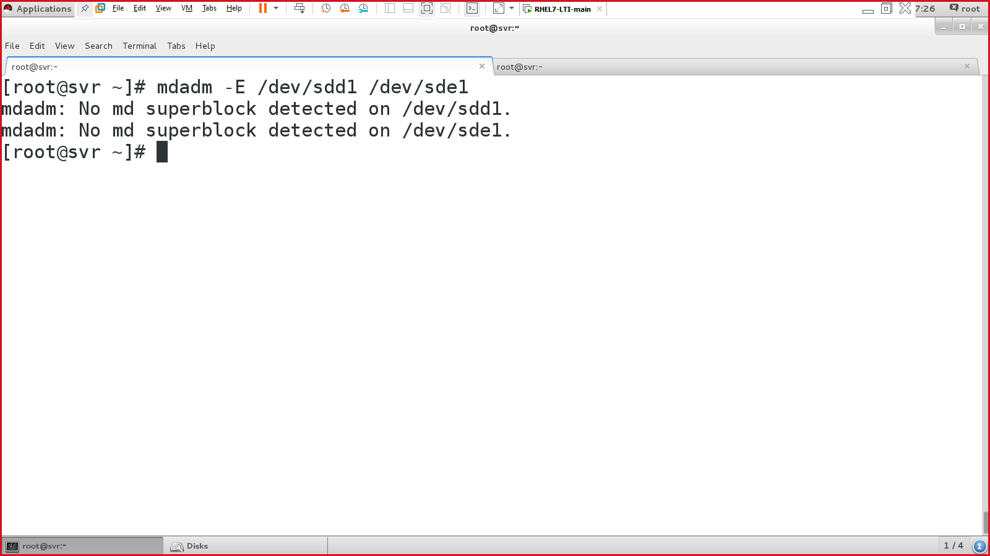

Create raid 0 on /dev/md0

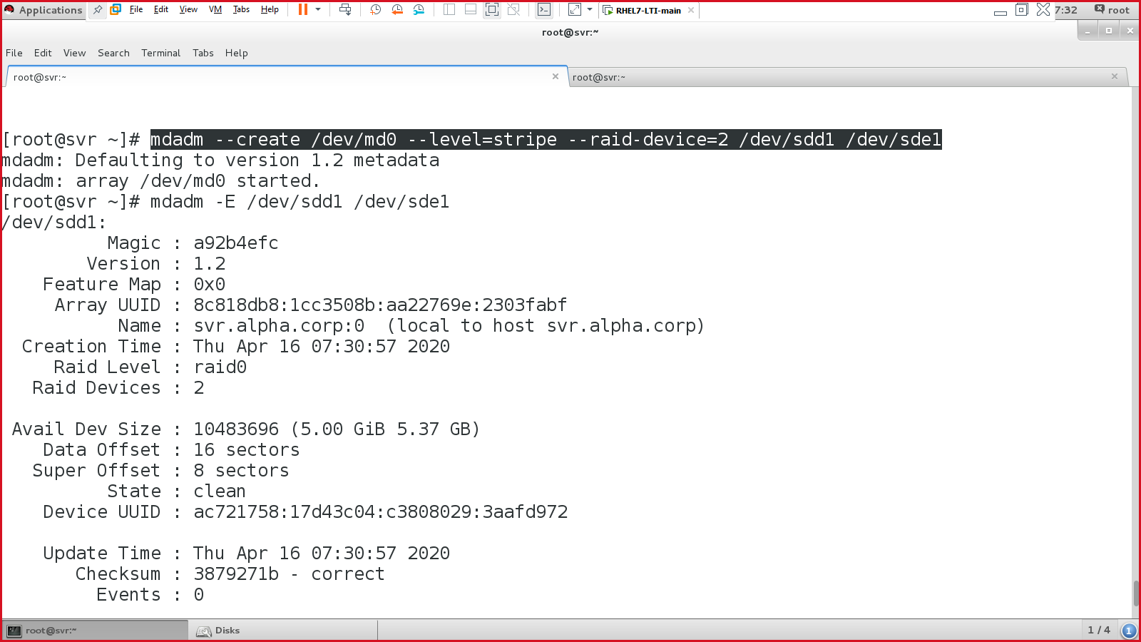

Check the raid status using below command:

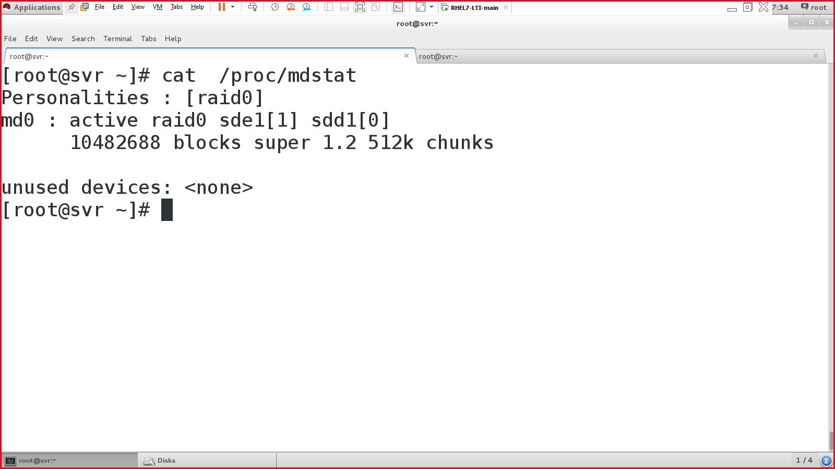

Verify raid status:

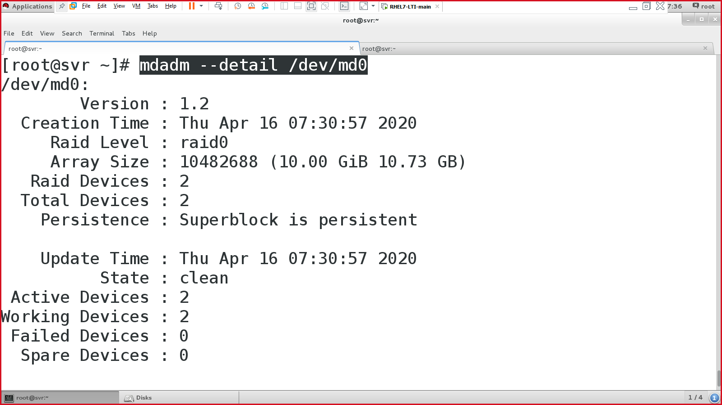

Create a filesystem for RAID (you can use any FS, i.e, xfs, ext3, ext4):

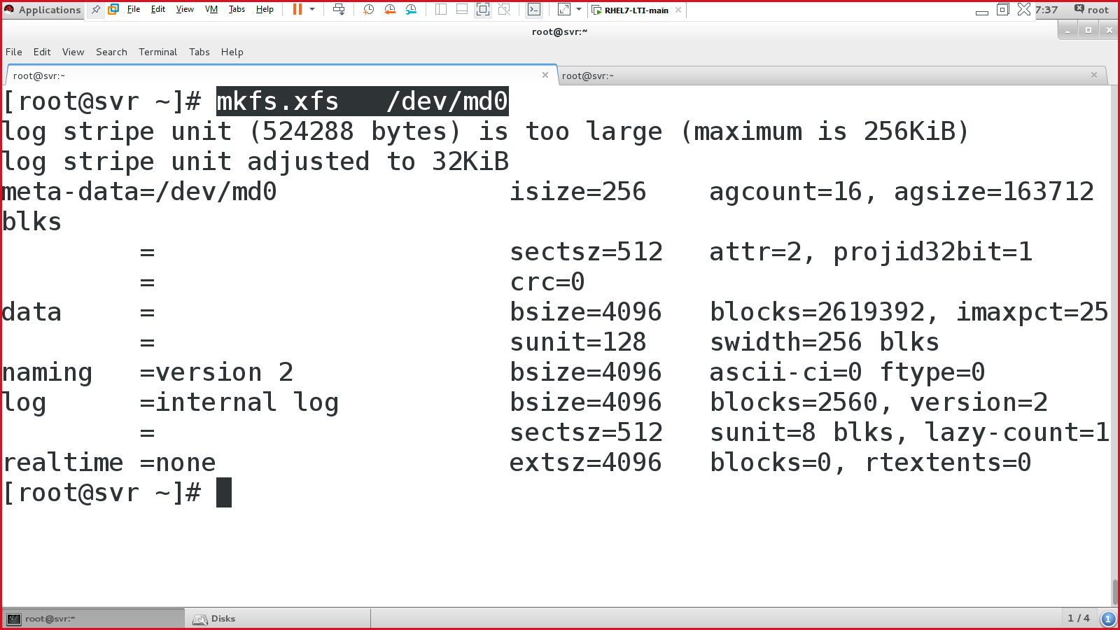

Steps for RAID 0:

* Attach at least 2 disks, and reboot.
* Use FDISK utility to create a new partition & then convert it into the raid format (fd).
* Examine the disk 🡪 #mdadm -E /dev/sdd1 /dev/sde1
* Create a raid 0:

#mdadm --create=/dev/md0 --level=stripe --raid-device=2 /dev/sdd1 /dev/sde1

* Examine the disk again 🡪 #mdadm -E /dev/sdd1 /dev/sde1
* Check the details:
  + #cat /proc/mdstat
  + #mdadm --detail /dev/md0
* Create a file system:
  + #mkfs.xfs /dev/md0
* Edit fstab file:
  + Either you can use /dev/md0

/dev/md0 /raid0 xfs defaults 1 1

* + Or use UUID (extracted from [blkid /dev/md0])

UUID=70acac47-840d-434a-ac6d-baa1a6738f60 /raid0 xfs defaults 1 1

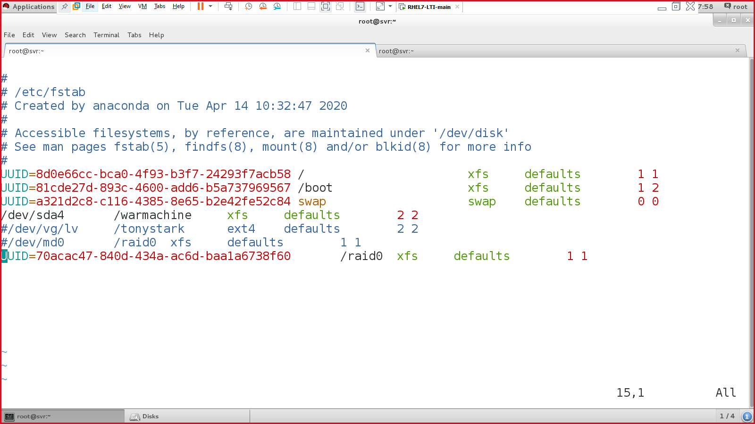

* Mount & verify
  + #mount -a
  + #mount
* Verify: 🡪 df -h

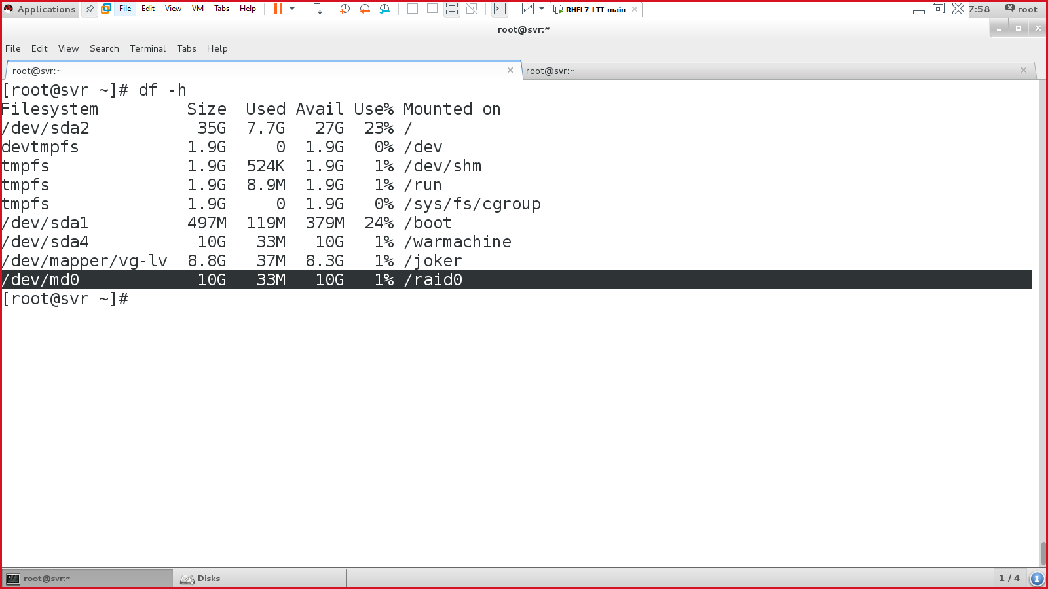

Verify using GUI.

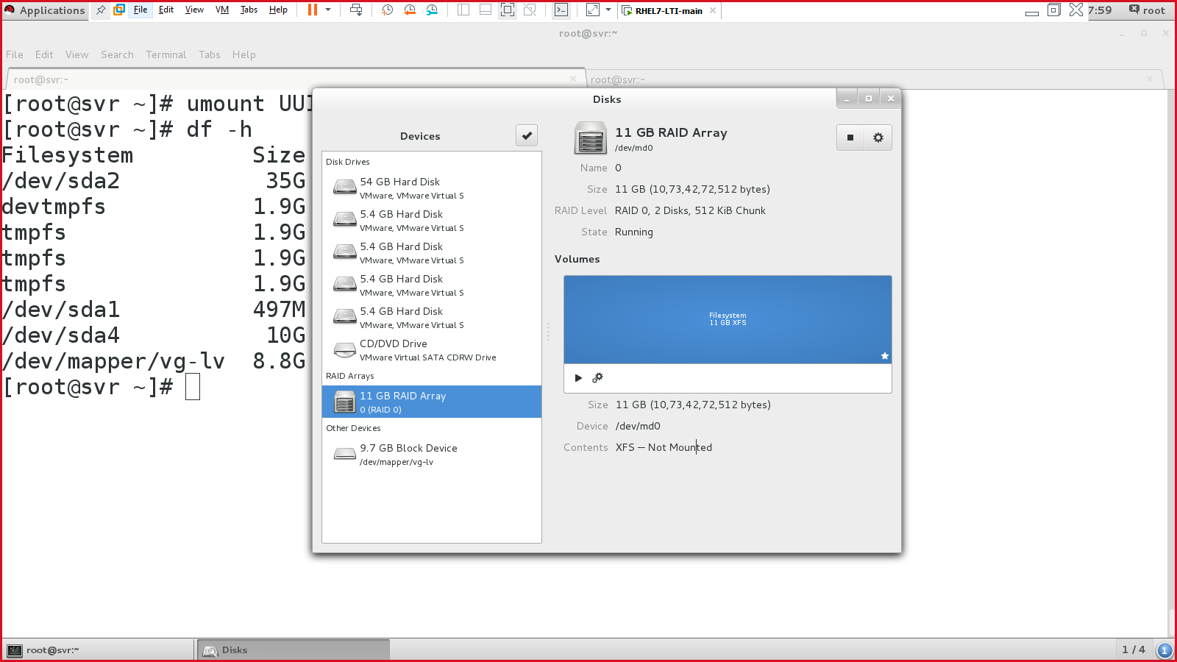

RAID CONFIGURATION OVER

Networking:

* #ifconfig
* #ifconfig | grep inet
* **NMCLI** – Network Manager Command Line Interface (RHEL 5, 6, 7, 8)
  + nmcli connection show
  + nmcli device status
  + nmcli device show
  + nmcli device show eno16777736
* **NMTUI** – Network Manager Text User Interface (RHEL 7, RHEL 6 = setup)
  + #nmtui
  + Then change the required settings (IP address)
  + Then restart the network service
    - #systemctl restart network
* **File**
  + /etc/sysconfig/network-scripts/ifcfg-eno16777736
  + Search using 🡪 #find /etc -name ifcfg*
  + Edit the file (change the IP address & gateway)
  + Then restart the network service again.
* GUI

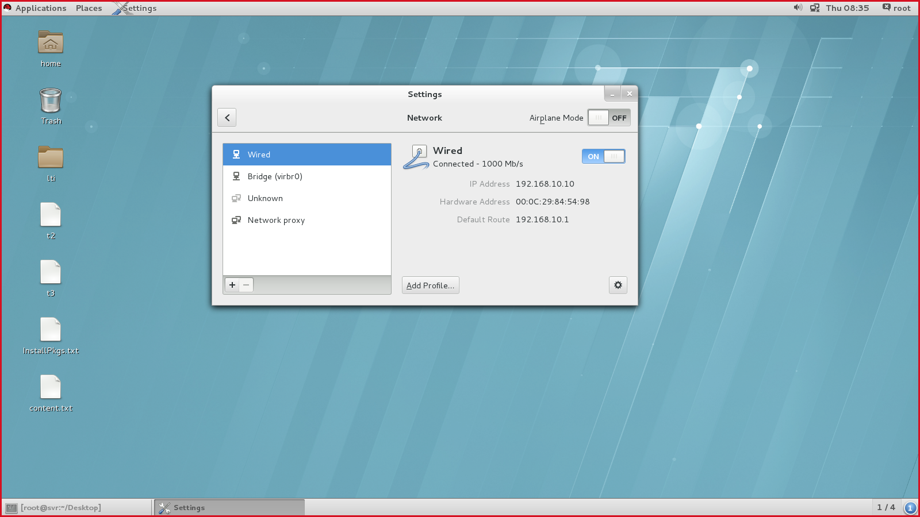

Working with services:

RHEL 6

* #service <service-name> <action>
* Ex:
  + #service network restart
  + #service network start
  + #service network stop

**RHEL 7**

* #systemctl <action> <service-name>
* Ex:
  + #systemctl restart network 🡪 restart the service
  + #systemctl start network 🡪 start the service
  + #systemctl stop network 🡪 stop the service
  + #systemctl disable network 🡪 disable the service, after the reboot
  + #systemctl enable network 🡪 enable the service, after the reboot
* Service
  + Network
  + Dhcp
  + Dns
  + Vsftpd
  + …

Firewall:

**RHEL 6**

* Netfilter / iptables (IPv4 traffic) / ip6tables (IPv6 traffic)

To list firewall rules (RHEL 6 method)

* #iptables -L //L = list the rules
* #iptables -F //F = flush/remove the rules.
* iptables -I INPUT -s 10.10.10.10 -j ACCEPT //accepting any traffic from specific IP address.
  + I = insert
  + ‘s’ = source
  + ‘j’ = jump
  + ACCEPT = allow, REJECT = deny, DROP = discard.

Blocking complete IP address range for SMTP protocol.

* iptables -I INPUT -s 192.168.11.0/24 -p tcp --destination-port 25 -j DROP
* iptables-save > /etc/iptables/rules.v4 🡪 save iptables rules in RHEL 6.

**RHEL 7**

* firewall-cmd
* To list all the zones in RHEL 7 system:
  + #firewall-cmd --get-zones
* To list default zone:
  + #firewall-cmd --list-all
* Change the default ‘public’ zone to ‘external’
  + #firewall-cmd --set-default-zone=external
  + To verify:
    - #firewall-cmd --list-all
  + To add http/https service
    - #firewall-cmd --add-service=http –permanent
    - #firewall-cmd --add-service=https –permanent
    - #firewall-cmd --add-service=ftp –permanent
    - #firewall-cmd --reload
  + To add port numbers in the firewall
    - #firewall-cmd --add-port=21/tcp --permanent
    - #firewall-cmd --add-port=53/tcp --permanent
    - #firewall-cmd --add-port=53/udp --permanent
    - #firewall-cmd --reload
  + To list all services and ports allowed in firewall
    - #firewall-cmd --list-all
  + To add specific IP address or address range in firewall
    - #firewall-cmd --add-source=10.10.10.10/8 --permanent 🡪 IP addr
    - #firewall-cmd --add-source=192.168.10.0/24 --permanent 🡪 range
    - #firewall-cmd --reload 🡪 reload
    - #firewall-cmd --list-all 🡪 verify/listing.

NTP:

* NTP = Network Time Protocol
* Time syncing between systems in the network.
* Port number = 123/udp

Lab setup:

* 1 NTP server
  + Centos OS 7
  + Internet is allowed.
* 1 NTP client
  + Windows based machine
  + Internet is allowed.
* Packages required: ntp
* Service for NTP server: ntpd
* Config file for NTP: /etc/ntp.conf

Steps:

* Install the NTP package.
  + #yum install ntp -y
* Edit the configuration file of NTP
  + #vim /etc/ntp.conf

|  |
| --- |
| Add below entries from line 25:  server 0.in.pool.ntp.org  server 1.in.pool.ntp.org  server 2.in.pool.ntp.org  server 3.in.pool.ntp.org |

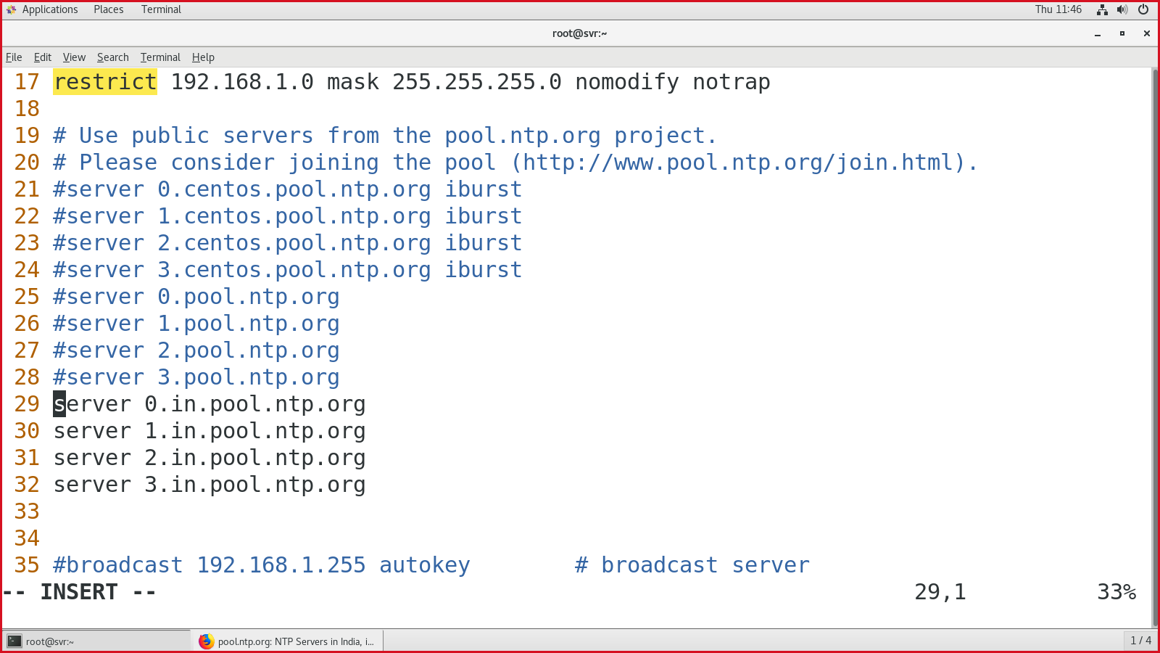

On line 17, allow your IP address range:

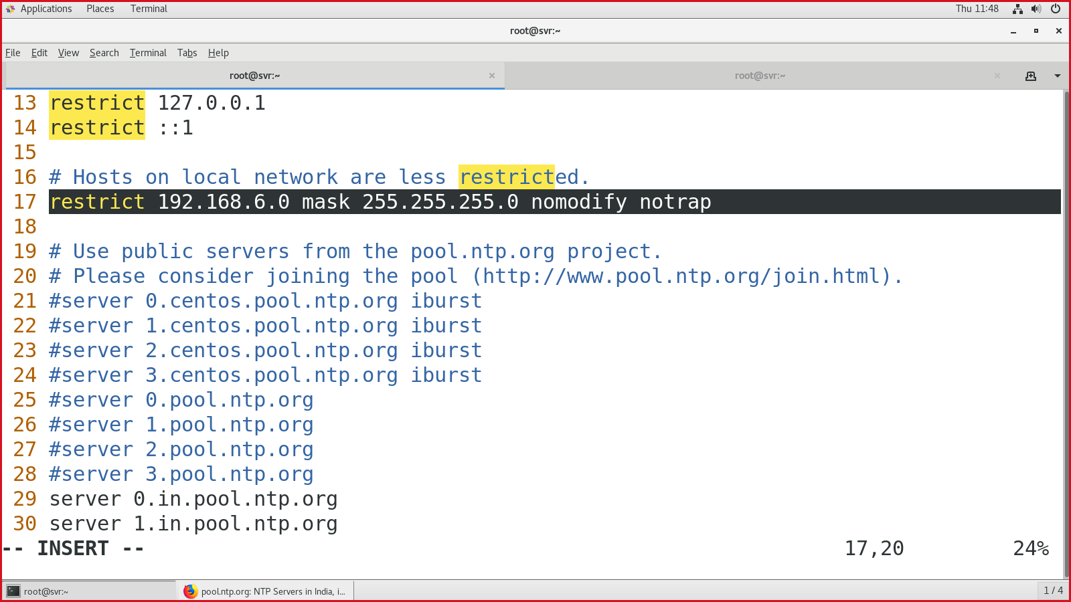

At the last line, add file to capture NTP logs:

#logfile /var/log/ntp.log

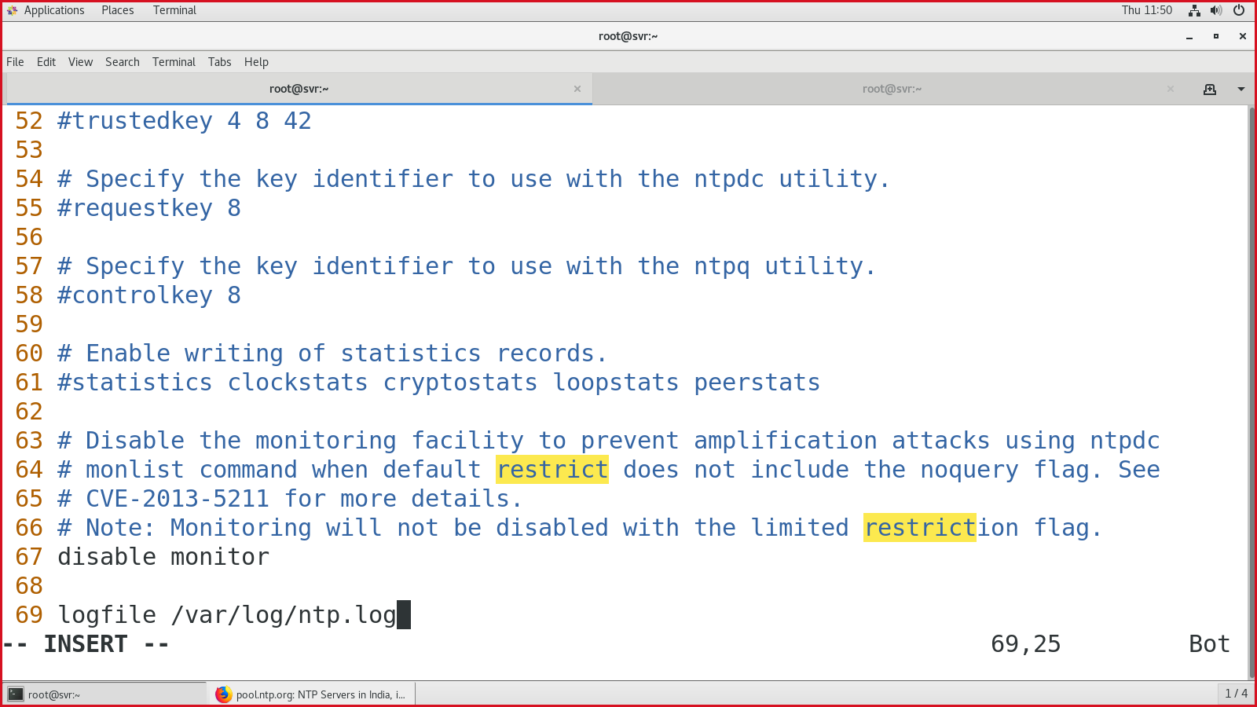

Save & quit.

Add the service in the firewall

* #firewall-cmd --add-service=ntp --permanent
* #firewall-cmd --add-port=123/udp --permanent
* #firewall-cmd --reload

Enable, start & status for NTP

* #systemctl enable ntpd
* #systemctl start ntpd
* #systemctl status ntpd

#############NTP SERVER CONFIG OVER################

On NTP-Client machine,

* Go to the date & time settings.
* And add the NTP server IP address.

In windows system

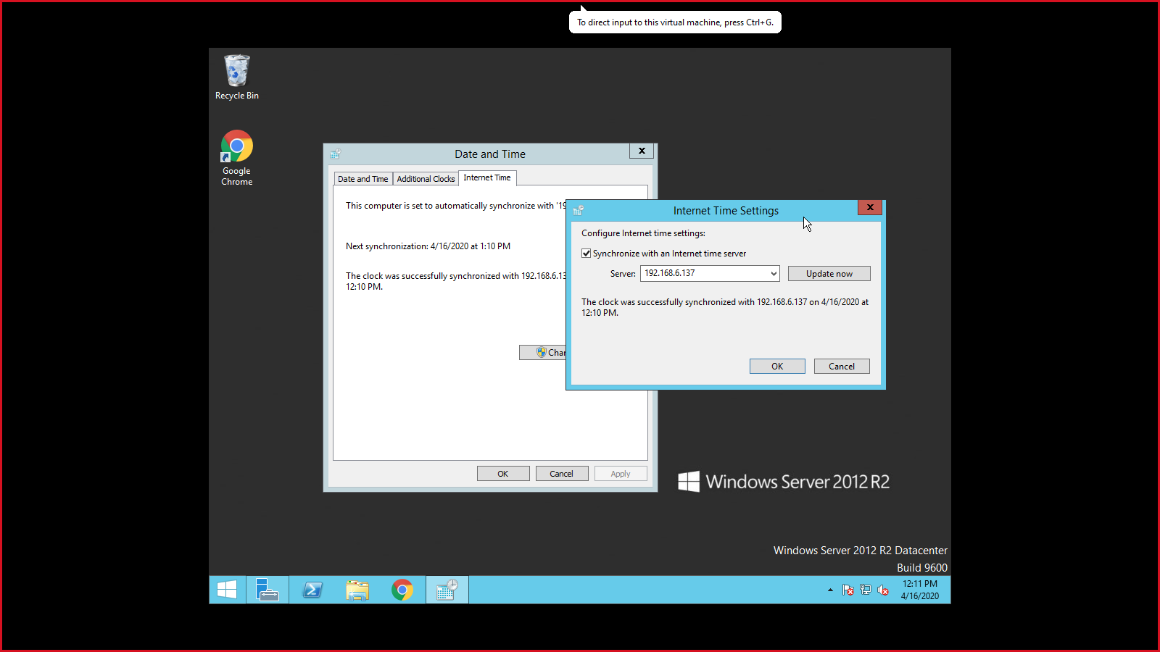

On linux system,

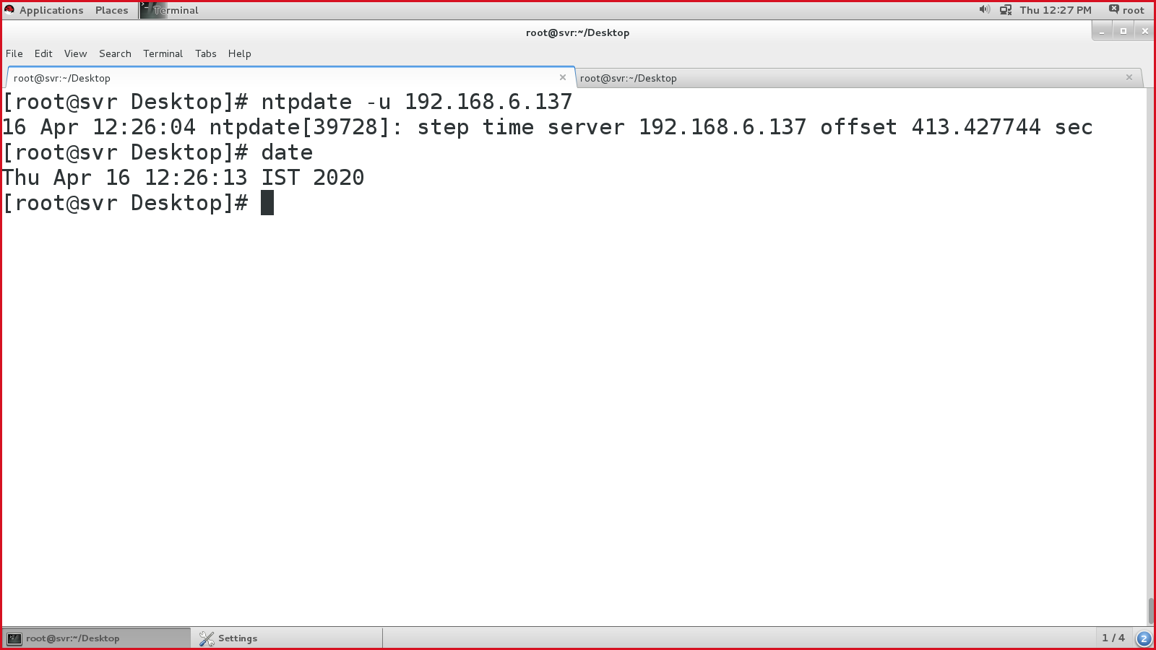

“-u” = update from NTP server.

#############################NTP SERVER CONFIG DONE##########################

DHCP server:

* Systems required: 2
* System 1: DHCP server, 192.168.10.10/24 (static IP), no internet required.
* System 2: DHCP client, (have to provide IP dynamically), no internet required.
* Packages: dhcp
* Port number: 67, 68
* Config file for DHCP: /etc/dhcp/dhcpd.conf

On DHCP server:

Install DHCP package:

* #yum install -y dhcp
* Copy the sample DHCP file to the DHCP config directory.

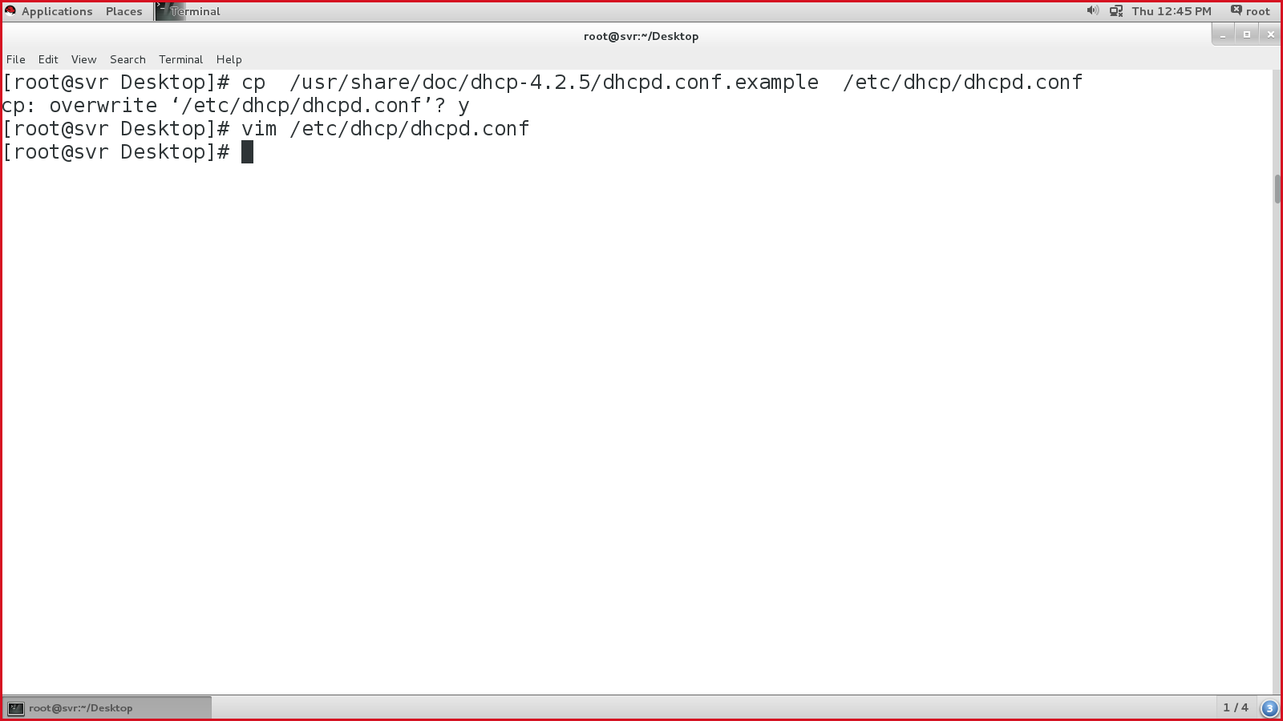

Perform the changes in the “dhcpd.conf” file:

|  |  |  |  |  |
| --- | --- | --- | --- | --- |
| On line 7, change the domain name to your working domain:  🡪 option domain-name "alpha.corp";  On line 27, make the below changes:  subnet 192.168.10.0 netmask 255.255.255.0 {  option routers 192.168.10.254;  option subnet-mask 255.255.255.0;  option domain-name-servers 192.168.10.10;  option time-offset -18000;  range 192.168.10.100 192.168.10.200;  }  :wq!  Save & quit:  #systemctl enable dhcpd  #systemctl start dhcpd  #systemctl status dhcpd 🡪 Active: (running)  On DHCP server – config file     |  |  | | --- | --- | | On linux machine, change the IP settings to dynamic | On windows machine: | |  |  |   ################DHCP CONFIG OVER####################### |

FTP:

* File transfer protocol.
* Port no: 21
* Packages: ftp

**[scenario 1]: install & access simple FTP server**

Install FTP packages:

* #yum install -y ftp vsftpd

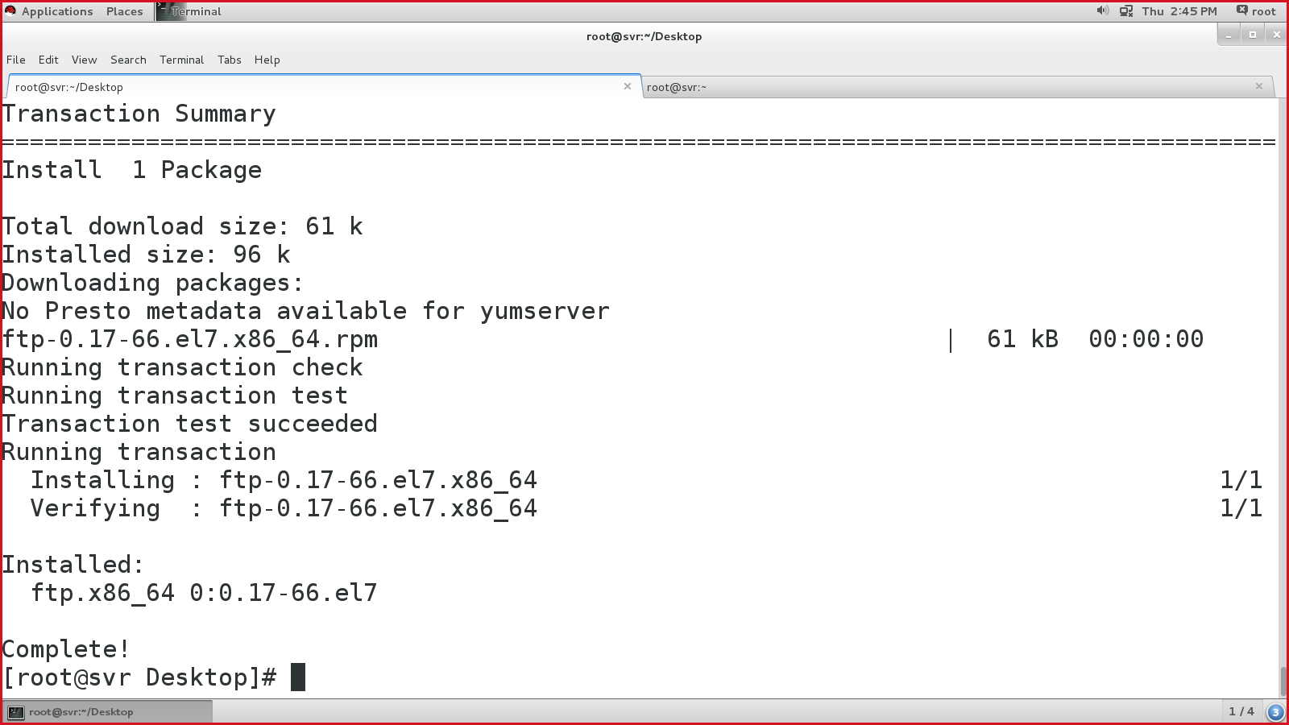

* Installing vsftpd:

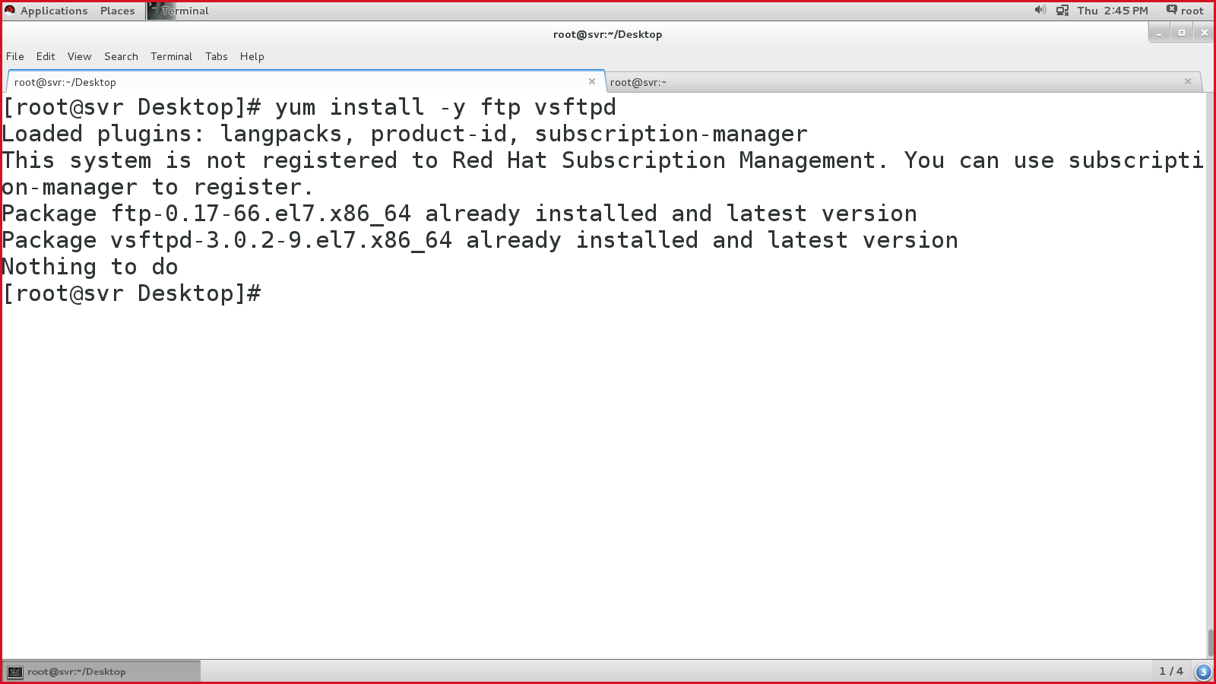

* Enable, start & status of vsftpd:

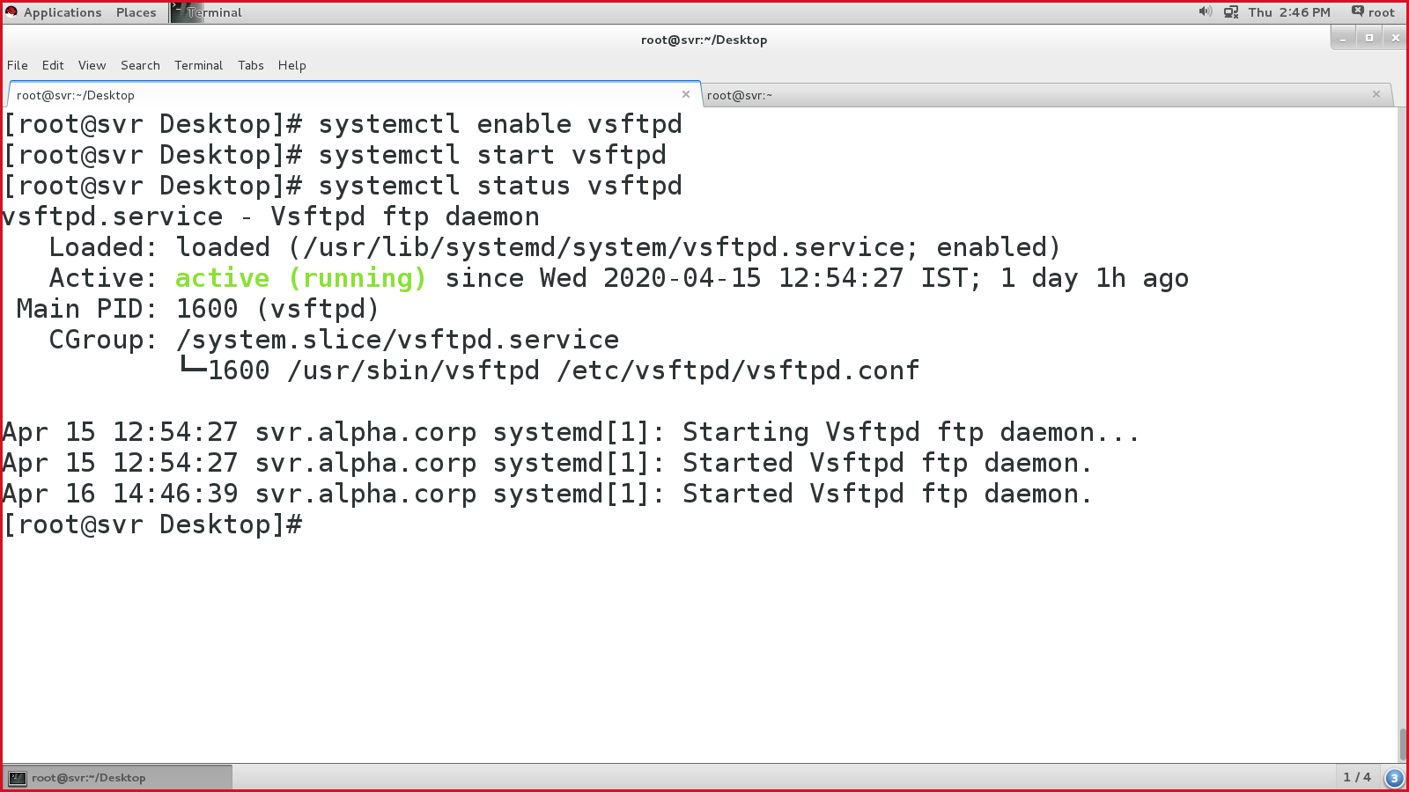

* Make the FTP entry in the firewall.

#firewall-cmd --list-all

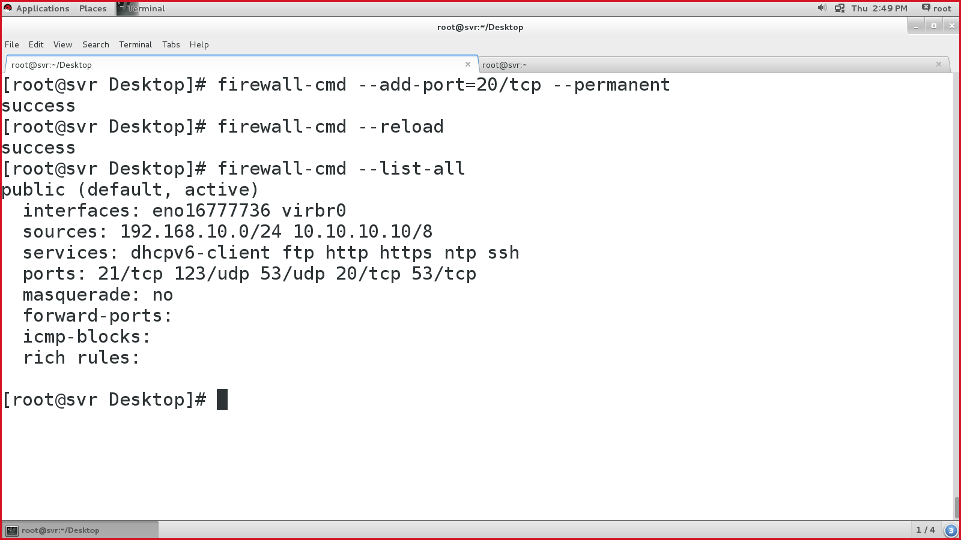

* Create a folder in /var/ftp/pub directory, & copy some random data in it.

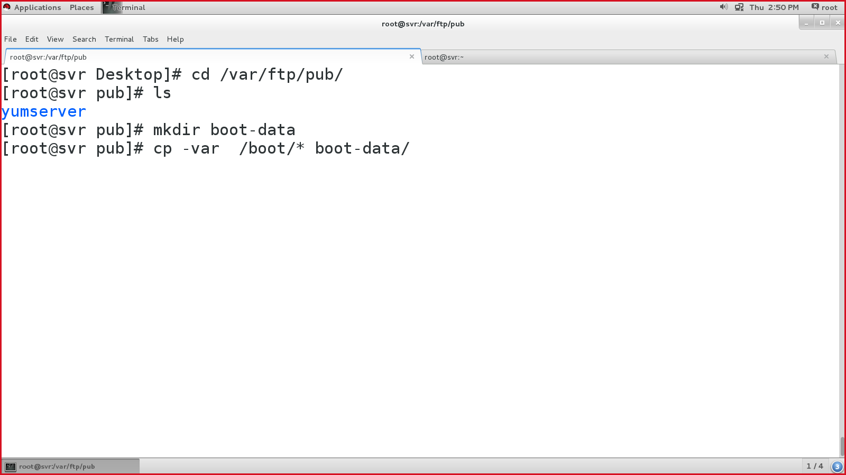

* Open firefox & visit ftp://<ip-address-of-ftp-server>
* Either open it on same FTP server or any other system within the network.

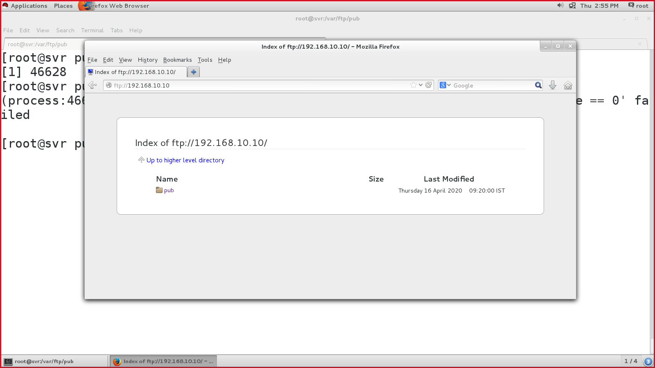

**[scenario 2]: secure the FTP server using username & password**

* Install vsftpd package.
* Enable, start & status of VSFTPD service.
* Configure the FTP config file 🡪 /etc/vsftpd/vsftpd.conf
* Before you proceed, take the backup of the config file.

# cp /etc/vsftpd/vsftpd.conf /etc/vsftpd/vsftpd.conf-backup

#vim /et/vsftpd/vsftpd.conf

* Edit line 12, from YES to NO

anonymous_enable=NO

* Append (in the bottom of the file), new lines:

userlist_file=/etc/userlist 🡪 allow list of users to access FTP

userlist_deny=NO 🡪 perms to not to block the list.

* Save & quit.
* Create few users with passwords.

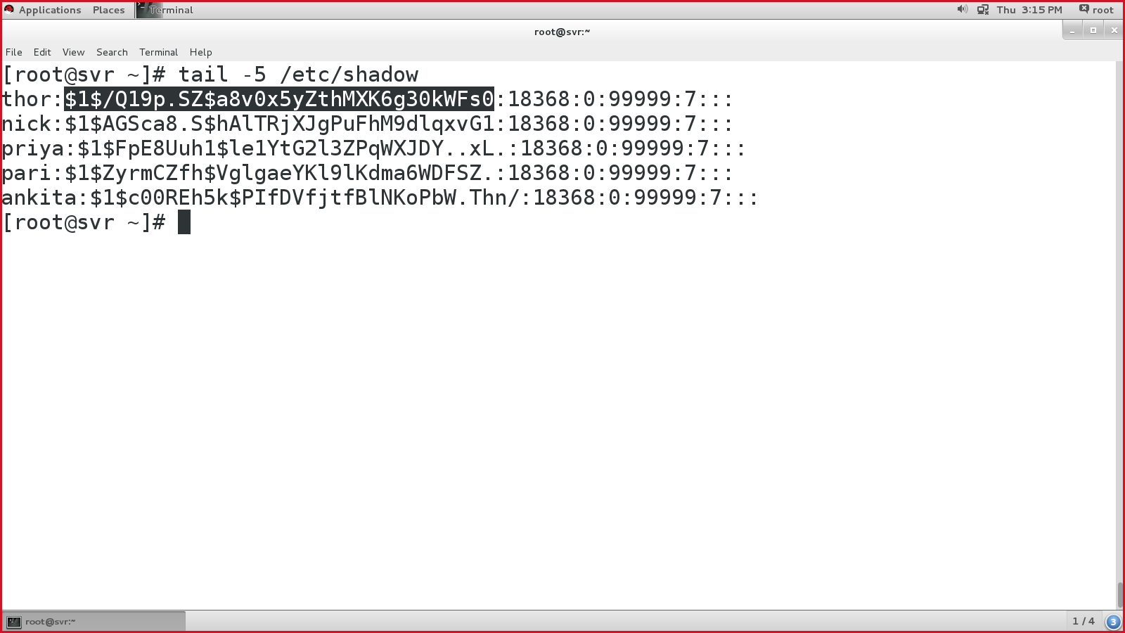

* Create /etc/userlist file & add abv user names in it.

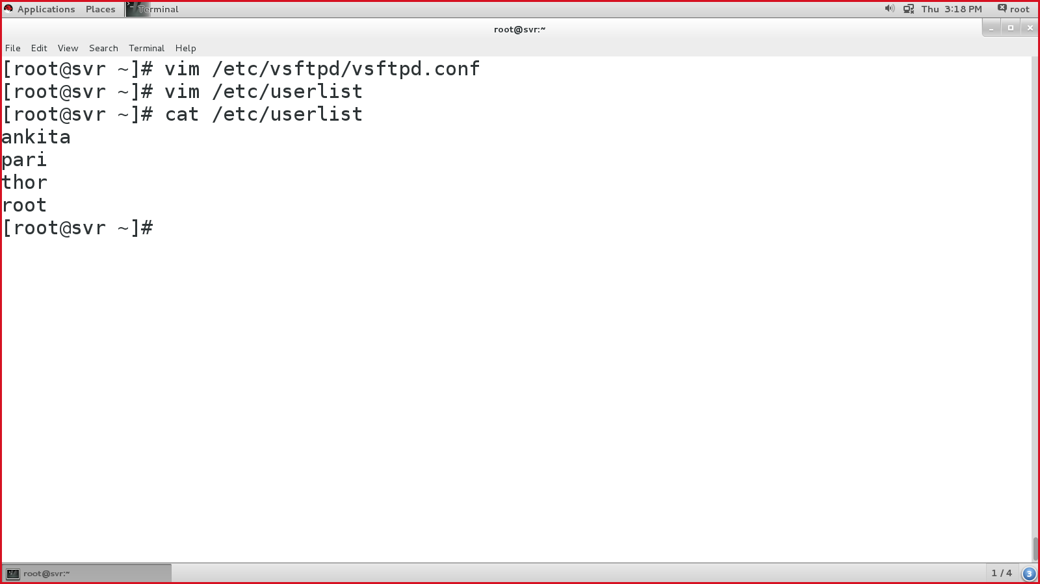

* Enable, start & status of vsftpd:



* #systemctl restart vsftpd

On client’s web browser:

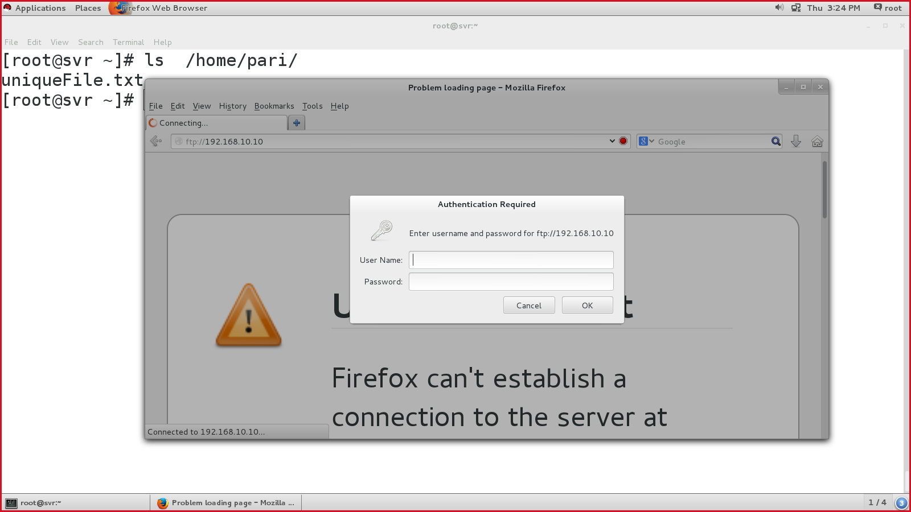

OR

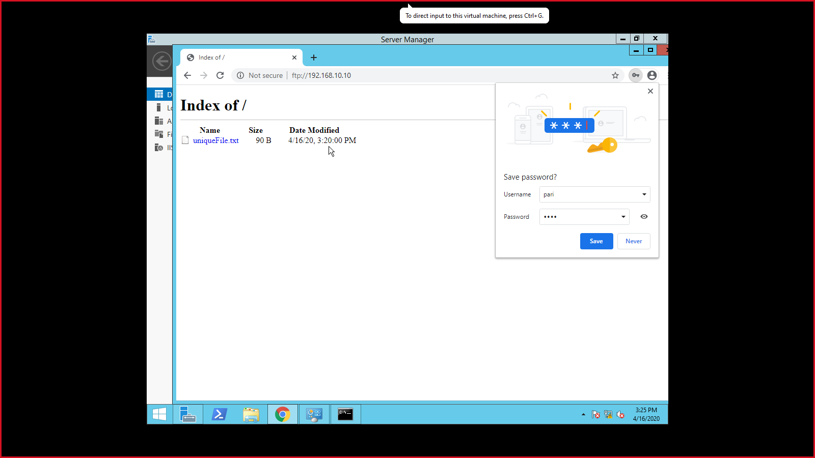

Login to user using linux terminal:

#ftp <ftp-server-ip>

type password of pari user

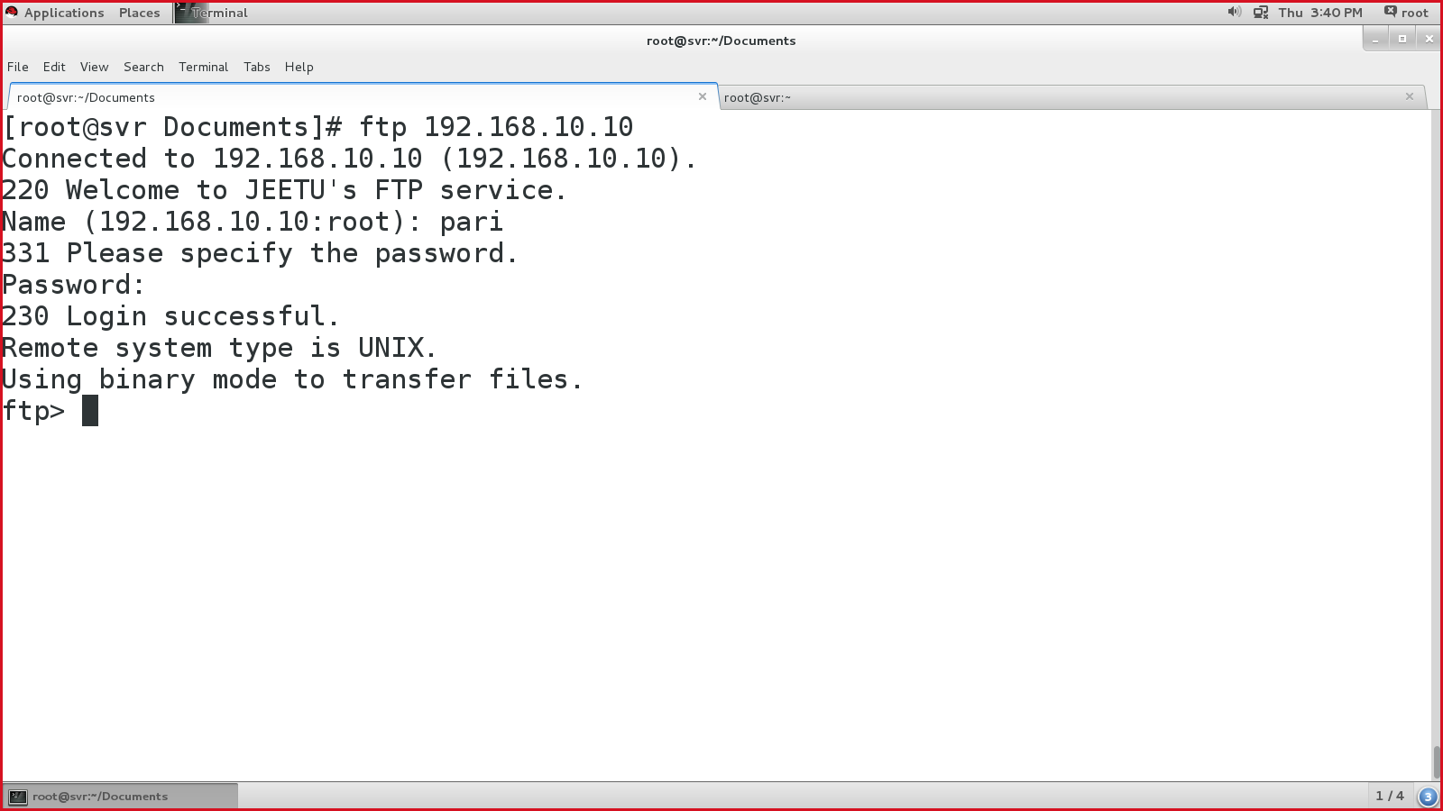

List & download a file and then quit the ftp console:

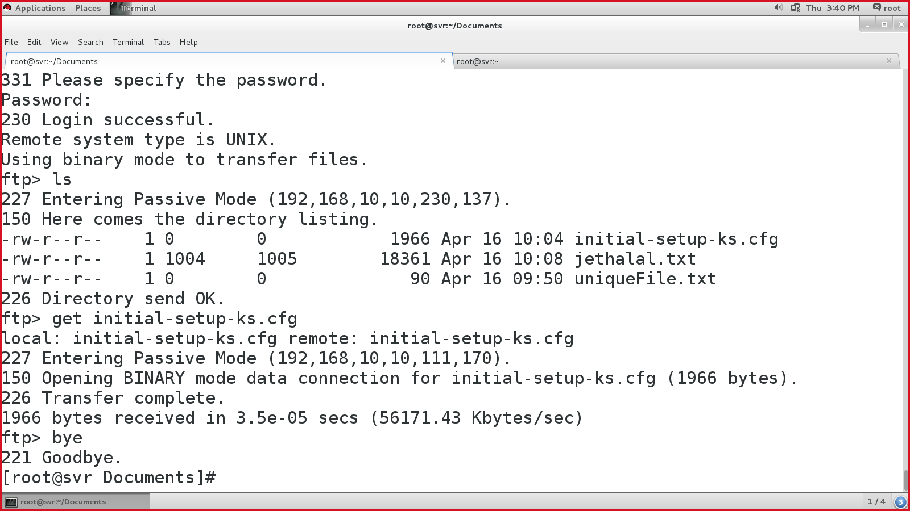

SSH

* Secure Shell
* Secure Remote access to the remote systems.
* Port number: 22
* Service name for SSH: sshd

Steps to configure SSH on server & client :

* Install SSH packages:

#yum install -y openssh*

* Enable, start & status of SSH

#systemctl enable sshd

#systemctl start sshd

#systemctl status sshd

Connect to SSH server from SSH client:

Syntax: #ssh <username>@<ip-address>

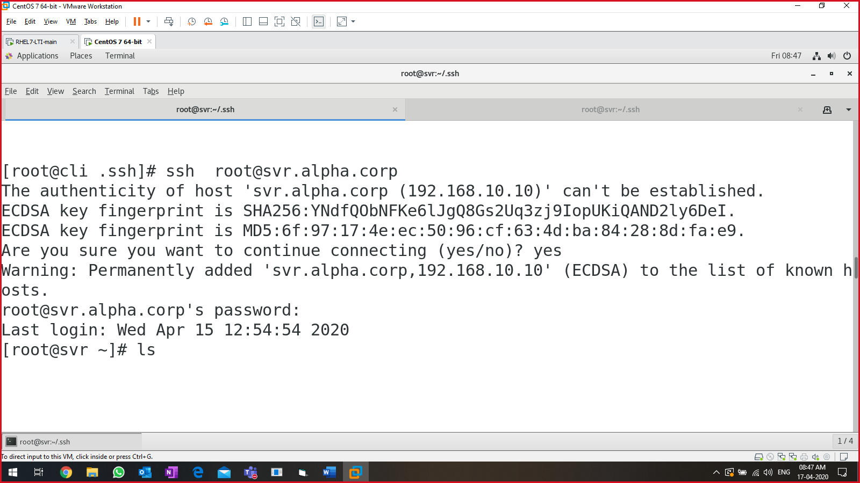

**Password-less SSH:**

* Ping the two servers (either name or IP)
* Ssh-keygen

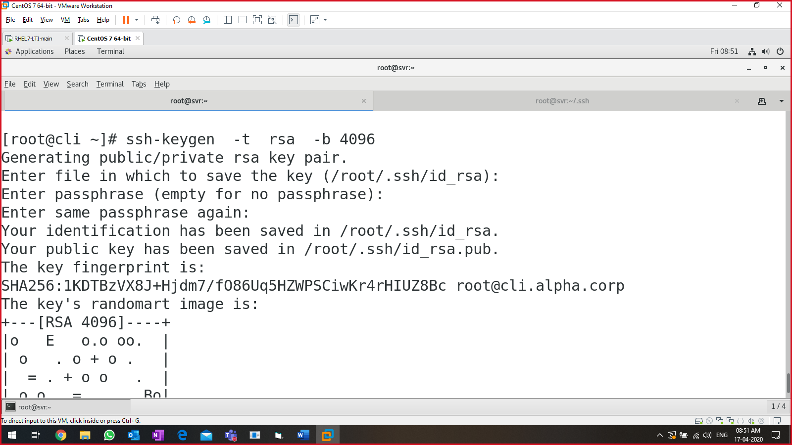

Verify:

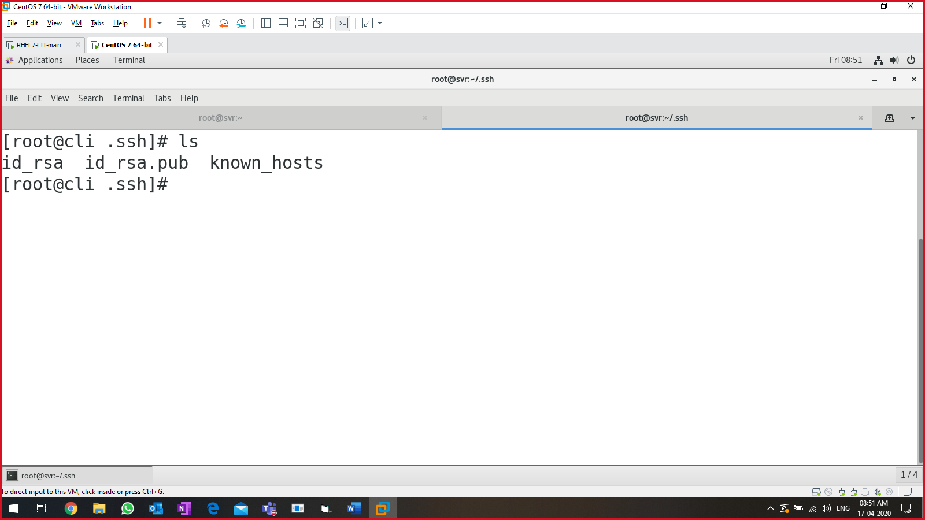

* Copy the generated keys to the remote computer.

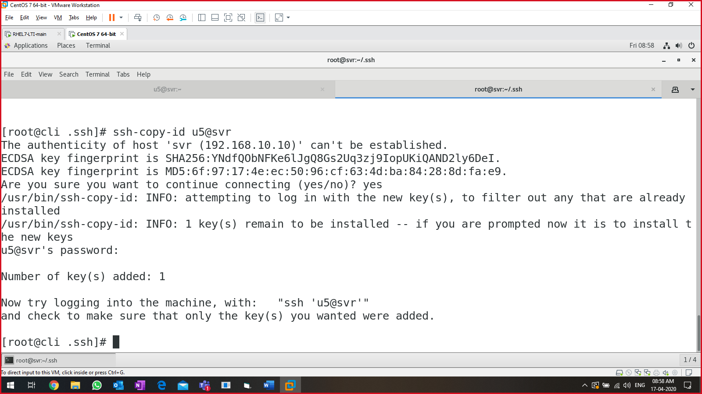

* Login:

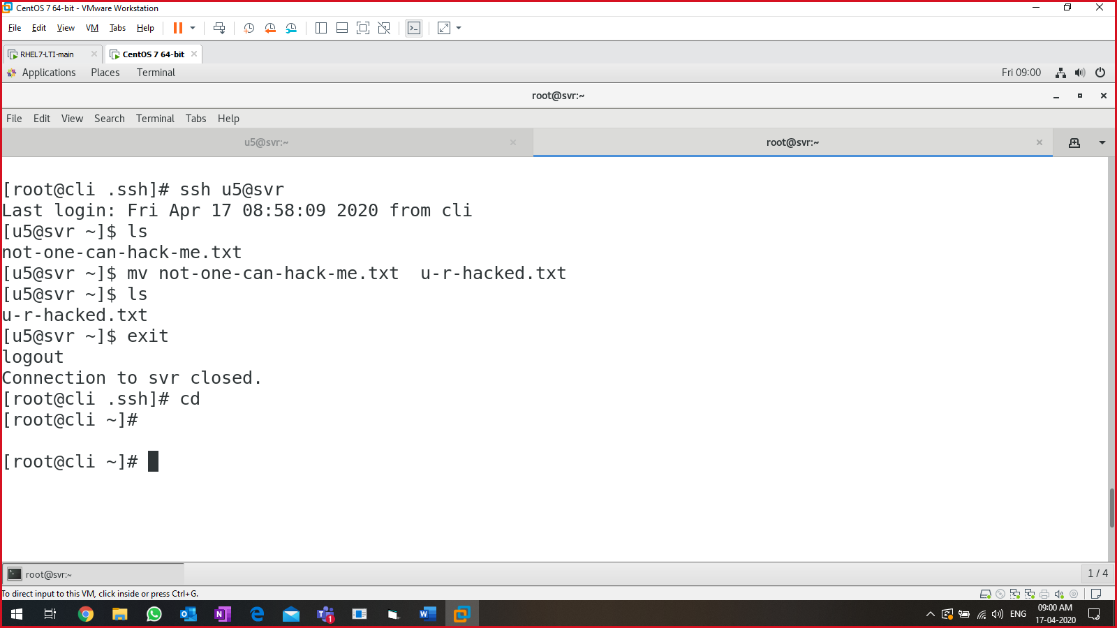

**SCP:**

* In windows, we have WinSCP.
* Secure copy.

Copy syntax:

* #cp <source> <destination>

Secure copy syntax:

* #scp <source> <destination>

*Source*: either on local machine or remote machine

*Destination*: either on remote machine or local machine.

Use SCP to copy a remote file on local system:

* #scp root@cli.alpha.corp:/root/pwsh.rpm /root/
  + *Source* = root@cli.alpha.corp:/root/pwsh.rpm
  + *Destination =* /root/

Use SCP to copy a local file on to remote system:

* #scp <local-file> <user>@<ip>:<absolute-path>
* scp /root/corona.tar root@cli:/root/tar-file

rsync:

* remote sync
* copy & paste file/directories to & from local m/c & remote m/c.
* It is faster that SCP.
* Uses less bandwidth.
* Incremental backup.

Syntax: #rsync -<option> <source> <destination>

Package for rsync: rync

Cmd:

#rsync -zvh /root/remote/* root@cli:/root/rsync-dir

* ‘z’ = compress
* ‘v’ = verbose
* ‘h’= human readable

Using rsync with ssh:

* # rsync -avzhe ssh root@cli:/root/rsync-dir/file.tar .

NFS:

* Network file system
* File sharing, L-L or W-W
* Packages: rpcbind, nfs-utils
* File: /etc/exports
* Port number: 2049/tcp

Installing NFS on server:

* # yum install -y nfs-utils rpcbind

Create a directory to be shared on the network.

* #mkdir /nfs
* Create some random files in it.

Edit NFS config file.

* #vim /etc/exports
  + Col1. What to share.
  + Col2. Where(how to share.)
    - * = share to all in the network
    - no_root_squash,rw,sync
      * no_root_squash = all user will have permission as root
      * rw = read/write
      * sync = synchronization
* /nfs *(no_root_squash,rw,sync)

:wq!

Make the entry in the SVR firewall:

* # firewall-cmd --add-port=2049/tcp --permanent
* #firewall-cmd --add-service=nfs --permanent
* #firewall-cmd --permanent --add-service=rpc-bind
* #firewall-cmd --permanent --add-service=mountd
* #firewall-cmd --permanent --add-port=2049/udp
* #firewall-cmd --reload
* #firewall-cmd --list-all

Export the NFS file system:

* #exportfs

Enable, start & status of the NFS services.

* #systemctl enable rpcbind
* #systemctl start rpcbind
* #systemctl status rpcbind
* #systemctl enable nfs-server.service
* #systemctl start nfs-server.service
* #systemctl status nfs-server.service

####NFS SERVER CONFIG OVER#####

Now switch to NFS client:

Install nfs packages

* #yum install -y nfs-utils rpcbind

Create a mount point to access the NFS server directory

* Mkdir /Lakshman

Enable, start & status nfs-server, rpcbind services:

* #systemctl status rpcbind nfs-server
* #systemctl enable rpcbind nfs-server
* #systemctl start rpcbind nfs-server
* #systemctl status rpcbind nfs-server

Show the NFS shared directories for SVR (192.168.10.10)

* #showmount -e 192.168.10.10

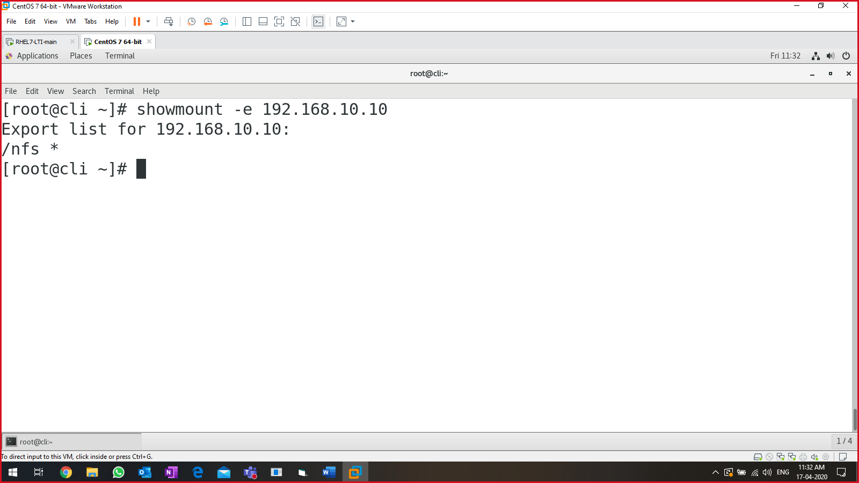

Mount the NFS shared directory in your system directory (step2)

* # mount 192.168.10.10:/nfs /Lakshman

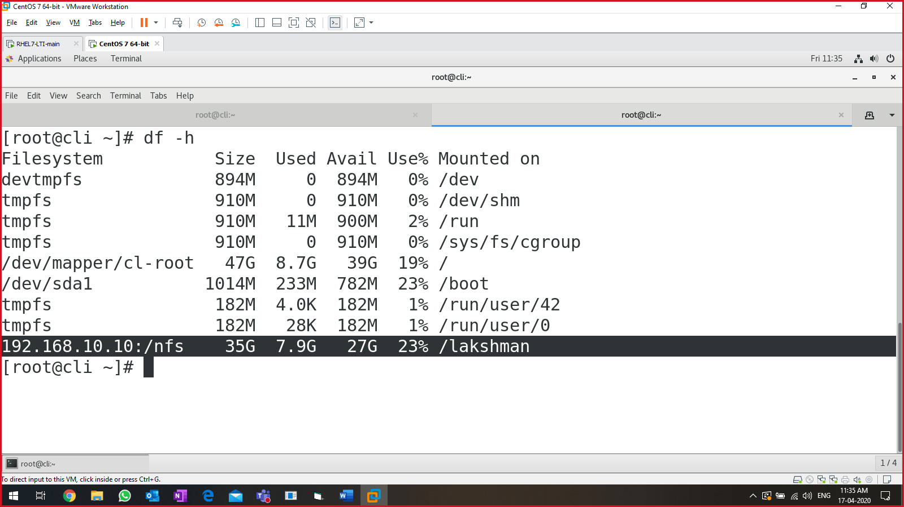

Samba server

* It is used for sharing the data between cross-platforms, windows to linux & vice-versa.

Lab setup:

* linux machine (192.168.10.10)
* windows machine (192.168.10.102)
* ensure both are pinging.

Packages required:

* # yum install samba-client samba cifs-utils

Add service in firewall:

* # firewall-cmd --permanent --add-service=samba
* #firewall-cmd --reload

Create a group with users & password in it.

* #groupadd grp1
* #useradd -G grp1 user1
* #useradd -G grp1 user2
* #useradd -G grp1 user3
* #grep grp1 /etc/group
* #passwd user1
* #passwd user2
* #passwd user3

Create a directory to be shared using SAMBA

* #mkdir /samba

Link the group (grp1) to the directory

* # chown -R root:grp1 /samba

Configure samba server config file:

* #vim /etc/samba/smb.conf

|  |
| --- |
| Edit from the line number: 275.    Save & quit |

Verify the configuration for “/etc/samba/smb.conf”

#testparm

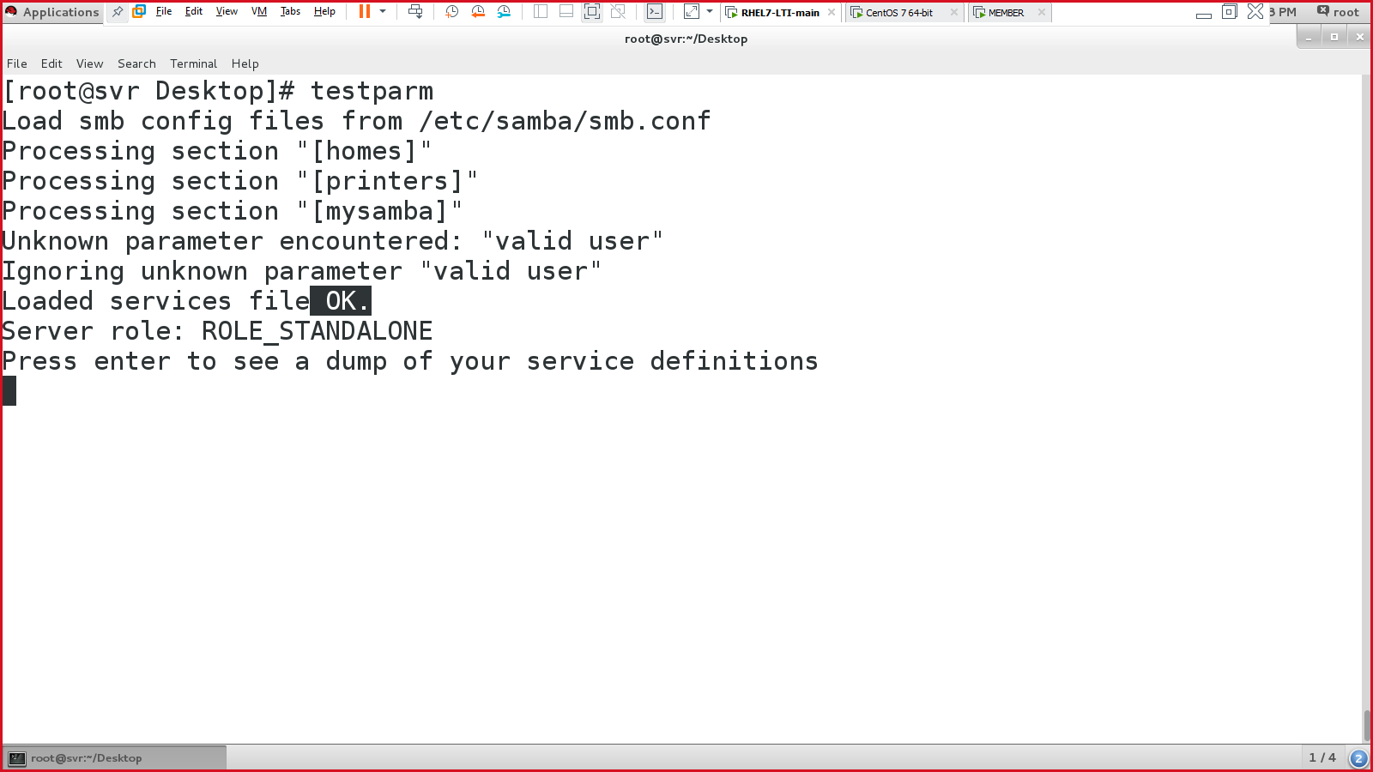

Hit enter again:

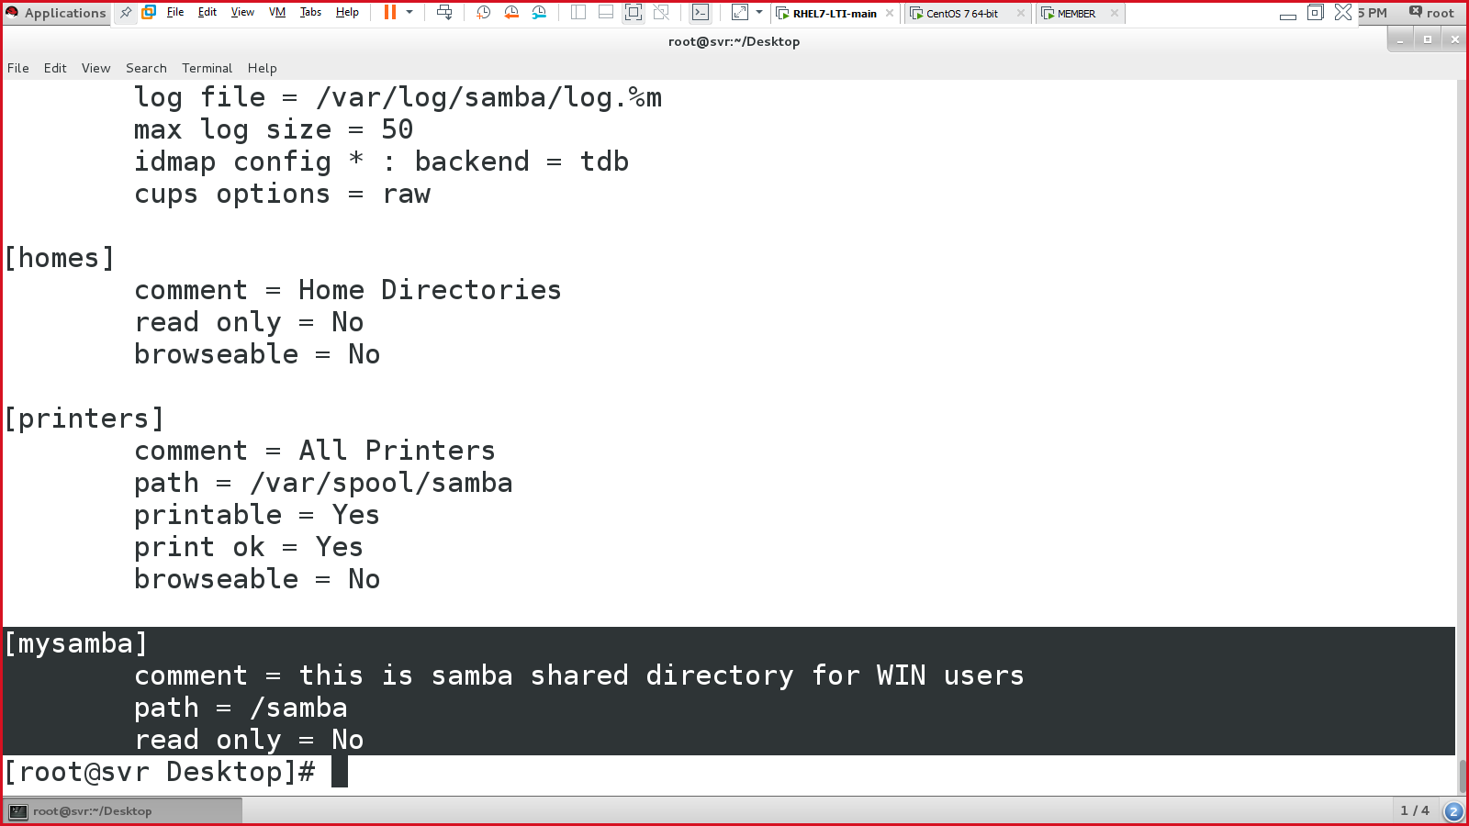

Now add the users in samba access by providing password:

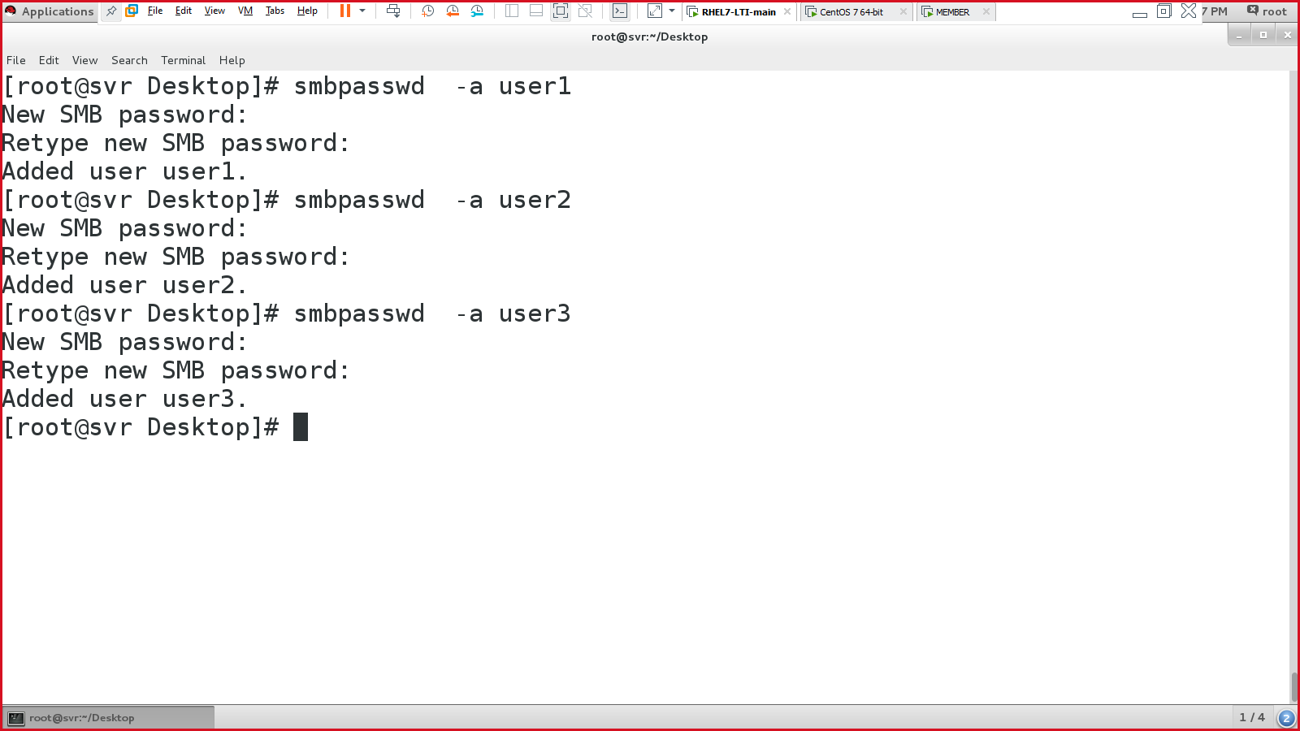

Enable, start & status samba service (smb)

* #systemctl enable smb
* #systemctl start smb
* #systemctl status smb

Verify for user1 from linux system:

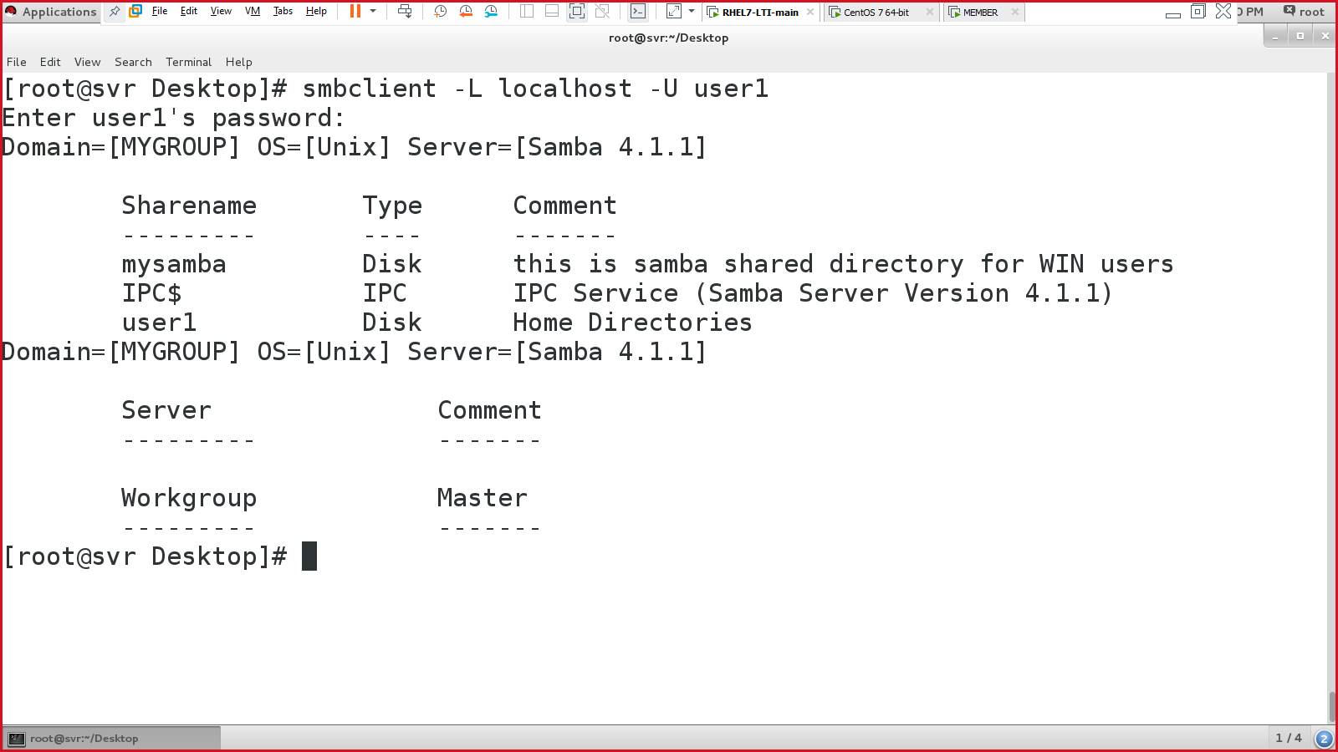

On windows system, open THIS PC, click on computer 🡪 Map network drive

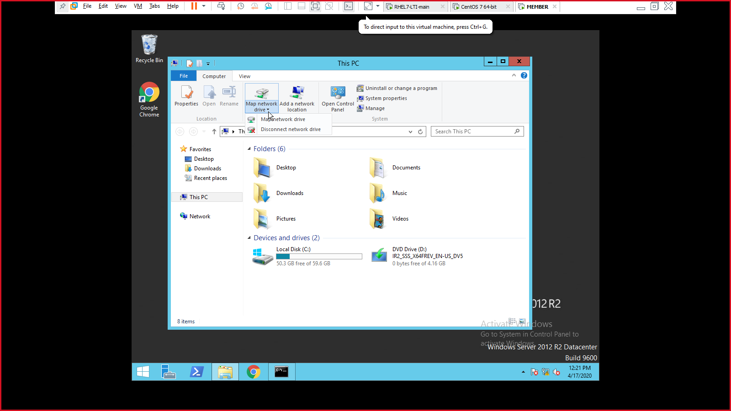

You will get something like:

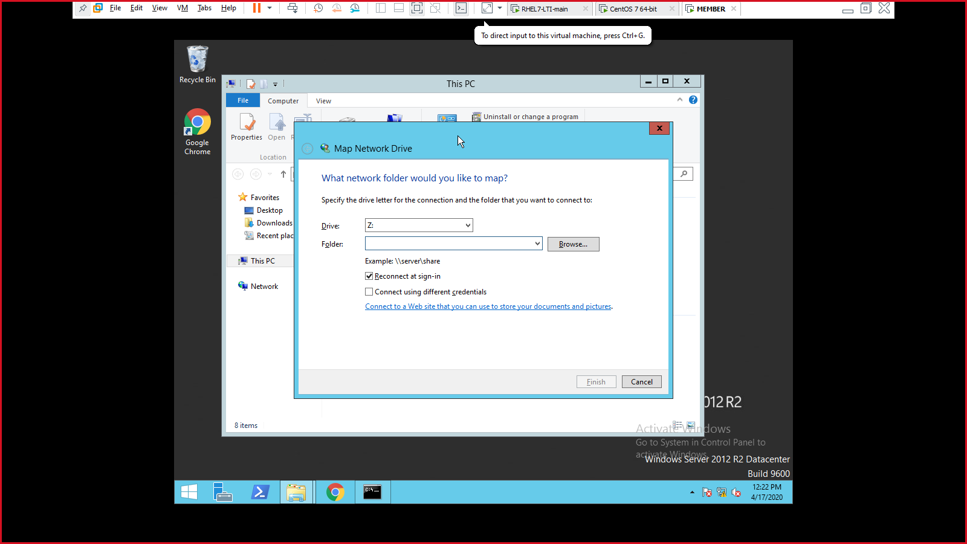

Provide the samba server address with shared folder information:

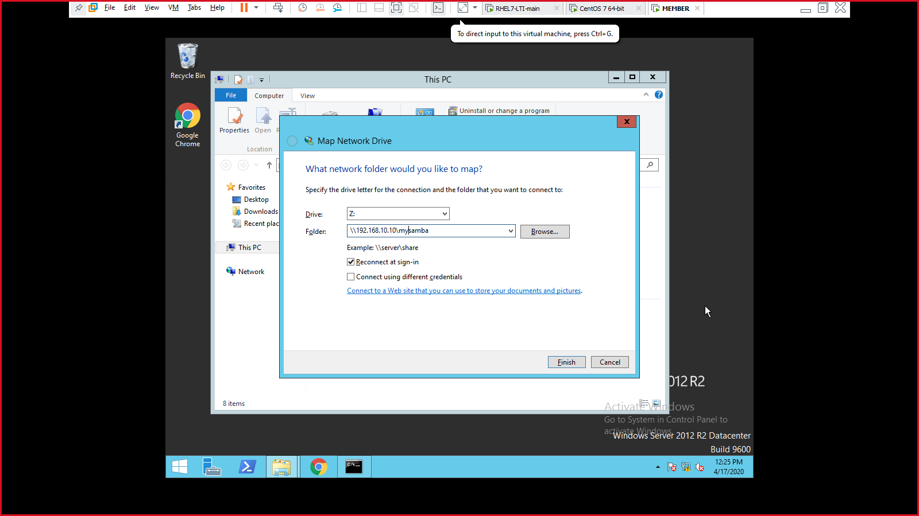

It will prompt the users credentials:

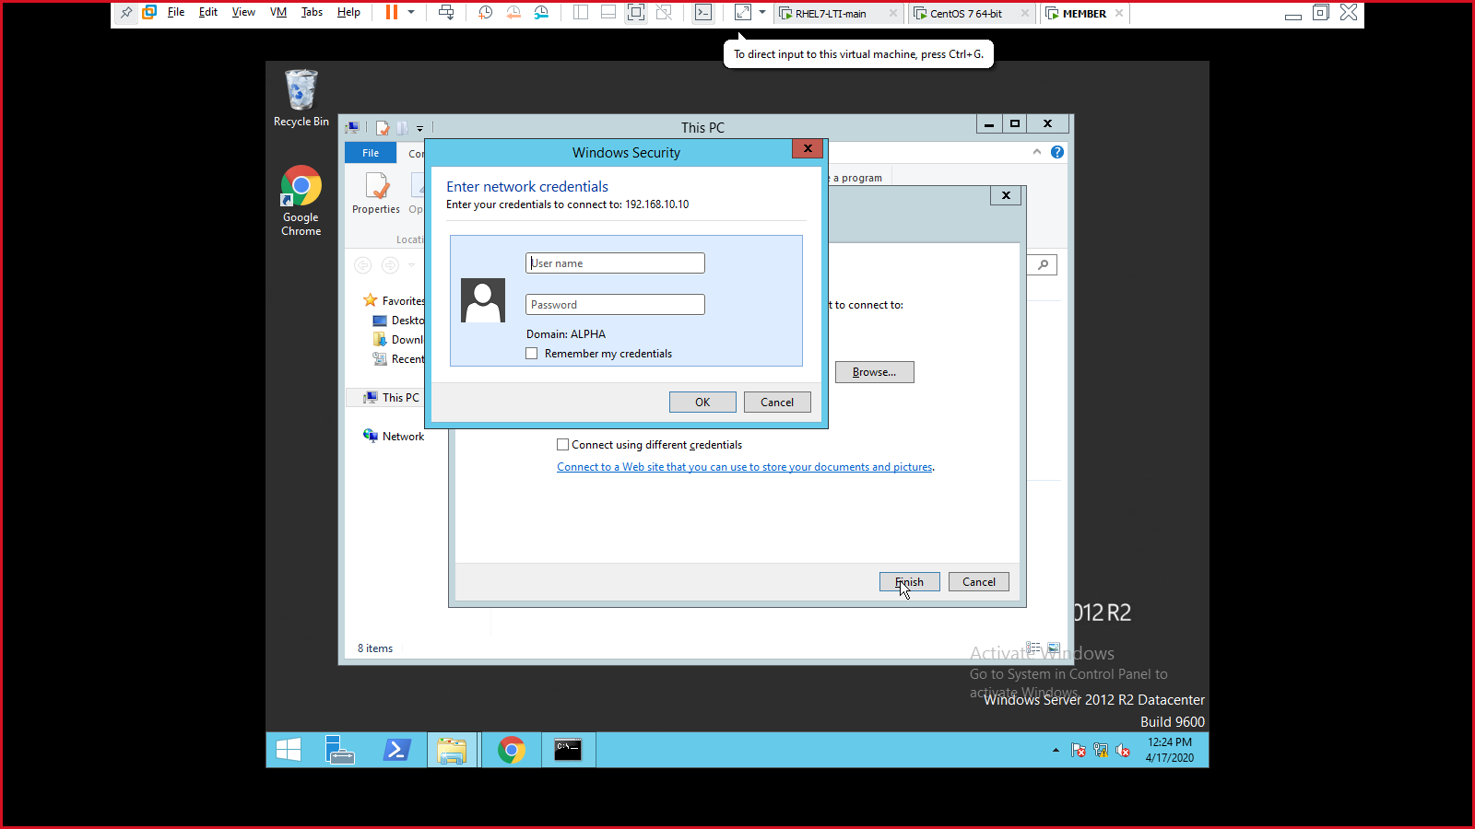

Enter user creds created on Linux server:

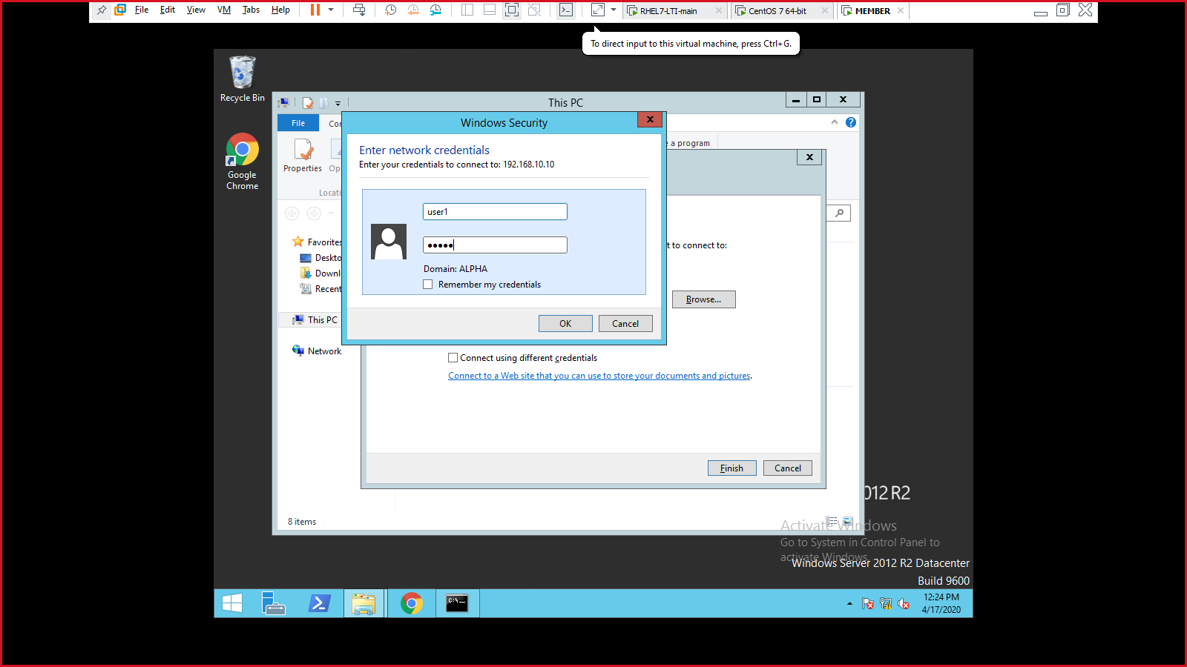

After entering correct creds:

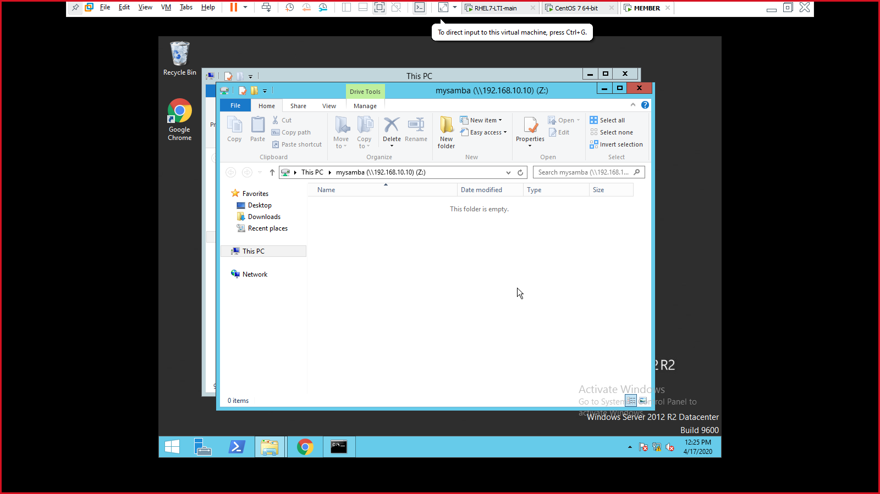

Copy & paste some random files & folders:

If it doesn’t allow to copy & paste, change the permission of /samba directory to 777

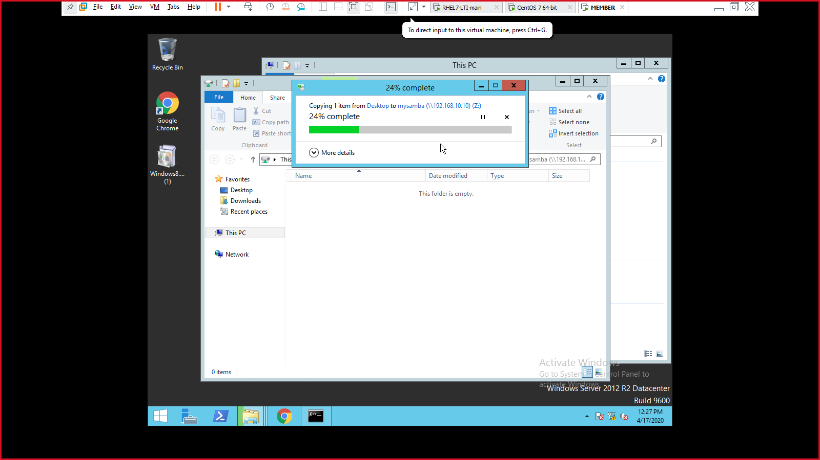

Switch to Linux VM & verify it the copied data is present:

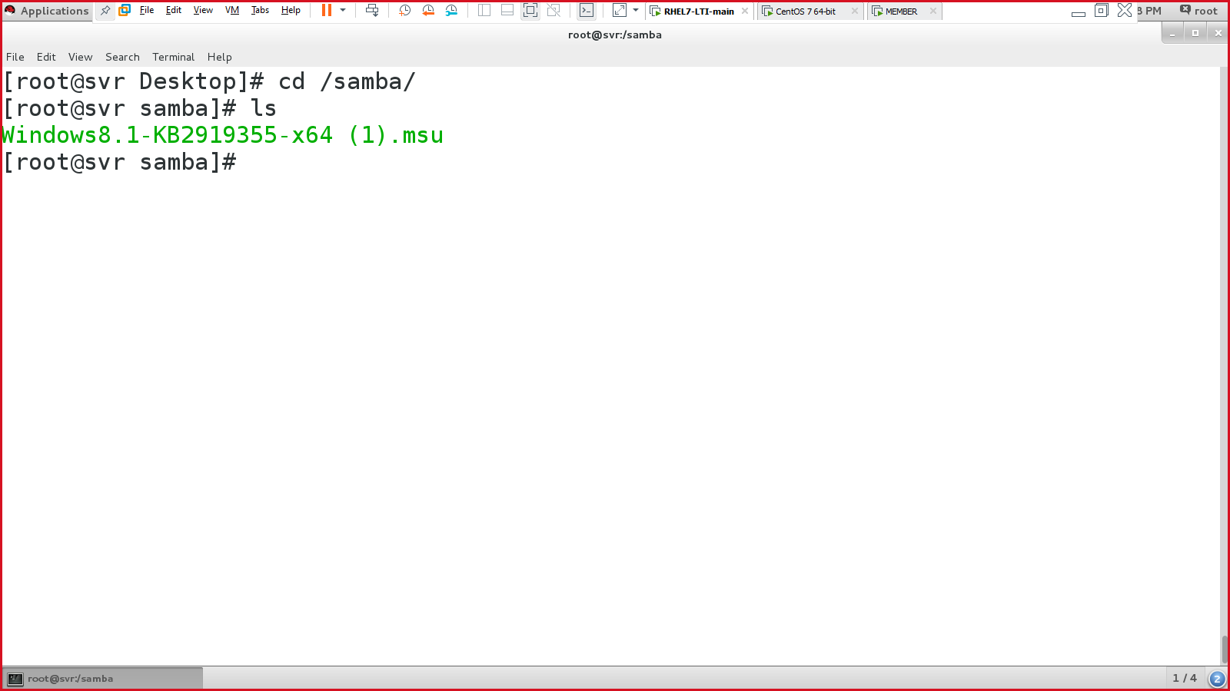

###############SAMBA CONFIG OVER#################

Apache web server:

* Web server in linux
* Similar to IIS web server in windows.
* Used for hosting your website on *intranet* or *internet*.
  + Package required: **httpd**
  + Service required: **httpd**
  + Port number: **80**
  + Config file**: /etc/httpd/conf/httpd.conf**

Install packages:

* #yum install -y httpd

In /etc/passwd 🡪 apache (service account)

**[scenario -1]: create default web site & access it**

Enable, start & status of httpd:

* #systemctl enable httpd.service
* #systemctl start httpd.service
* #systemctl status httpd.service

Open firefox and type <http://localhost> & verify if the ‘test page’ is present or not.

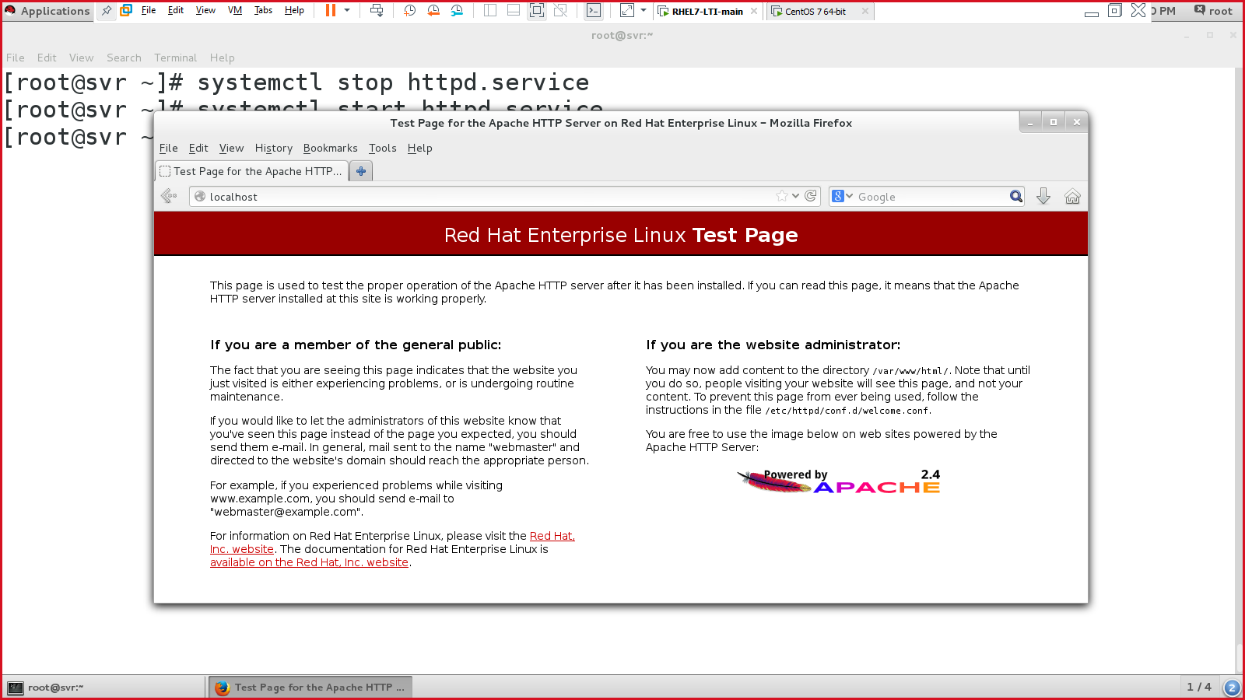

To create your own web page:

#vim /var/www/html/index.html

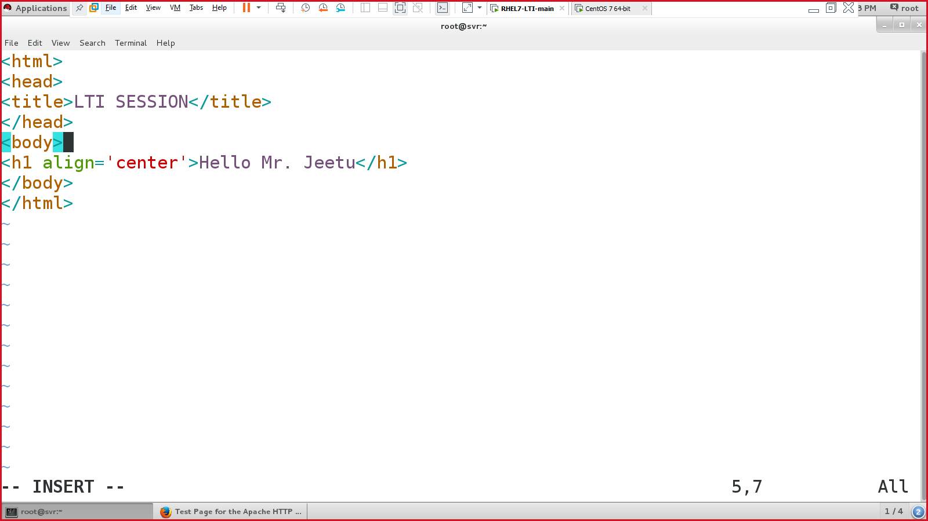 save & quit

Go to web browser & refresh the web page.

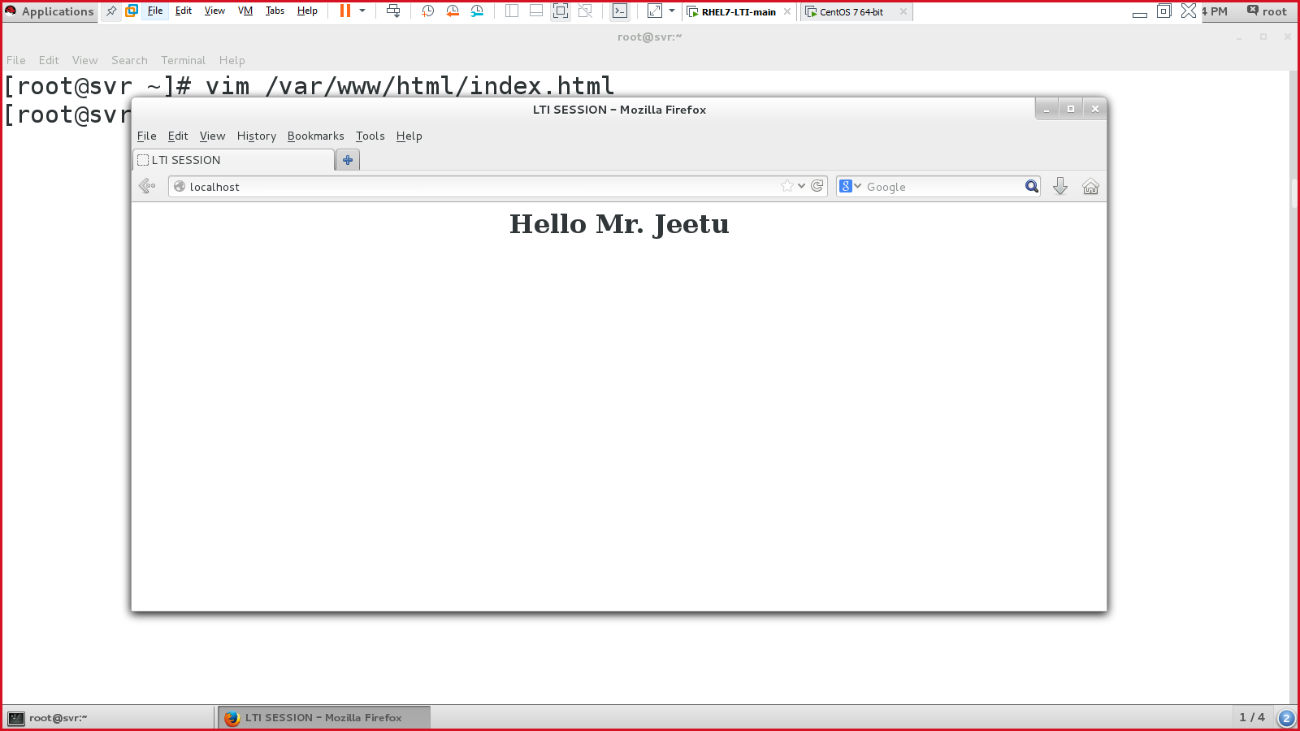

**[scenario -2]: create & access multiple site**

[www.site1.com](http://www.site1.com) 🡪 192.168.10.10

[www.site2.com](http://www.site2.com) 🡪 192.168.10.10

Create 2 folders (in /var/www):

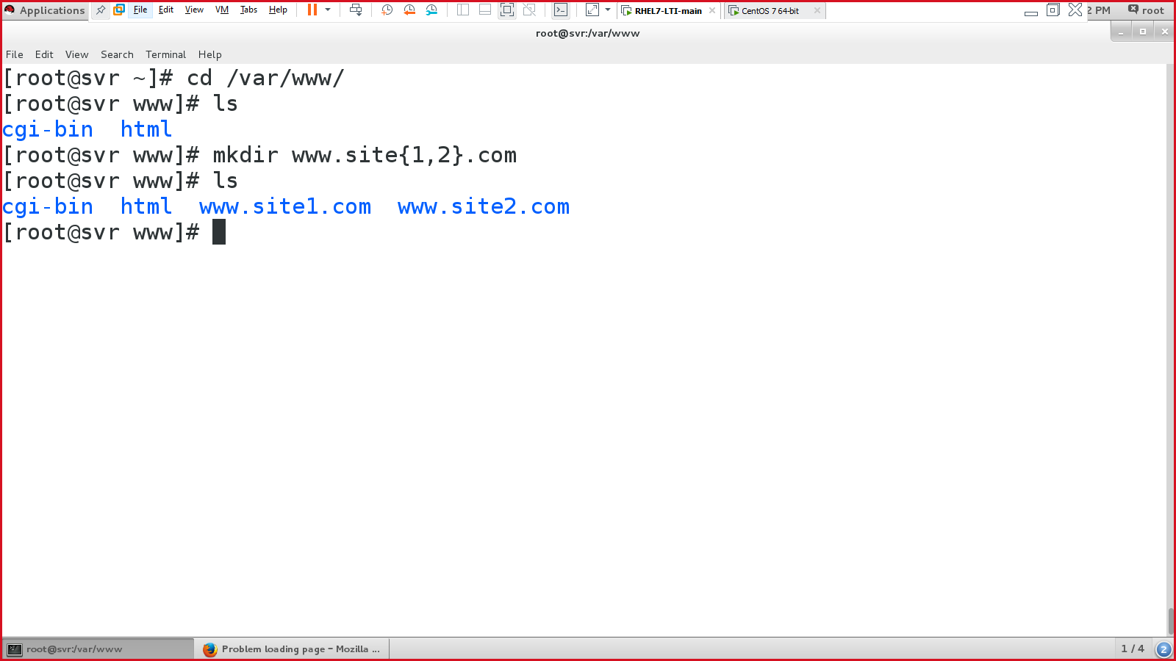

Either create 2 files in the above directories or copy & paste the /var/www/html/index.html file to the above directories

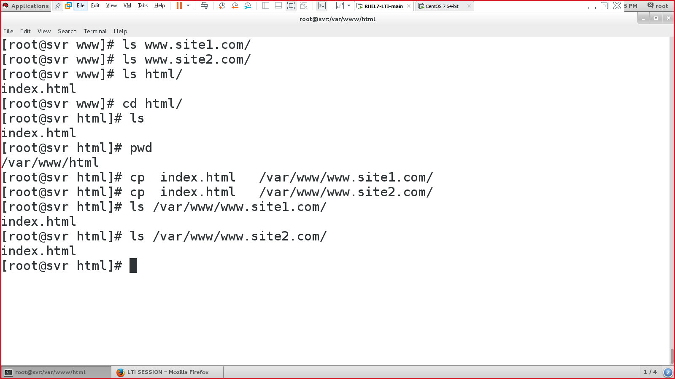

Verify:

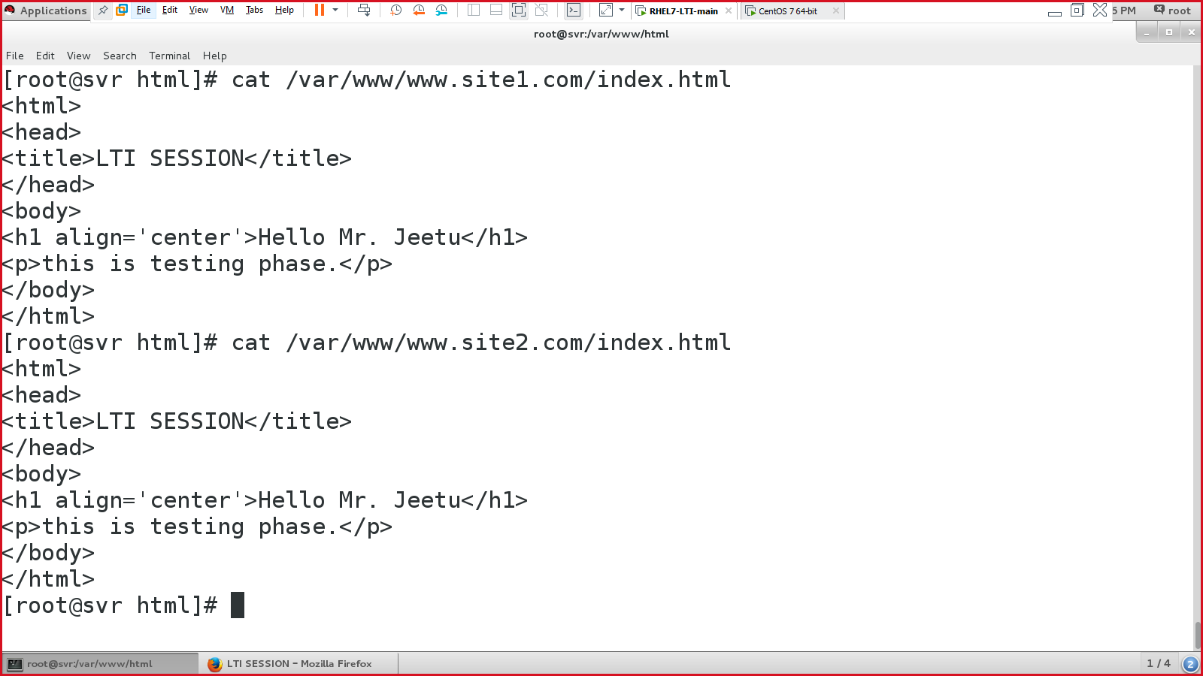

Edit the site contents:

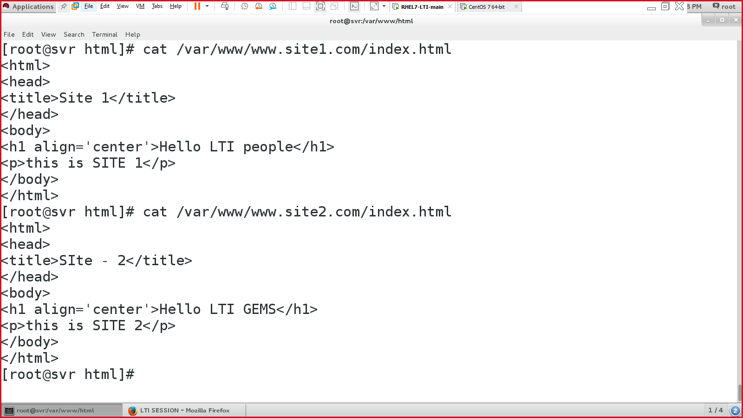

Configure the apache config file:

#vim /etc/httpd/conf/httpd.conf

Create a new line below line 42 & add below content

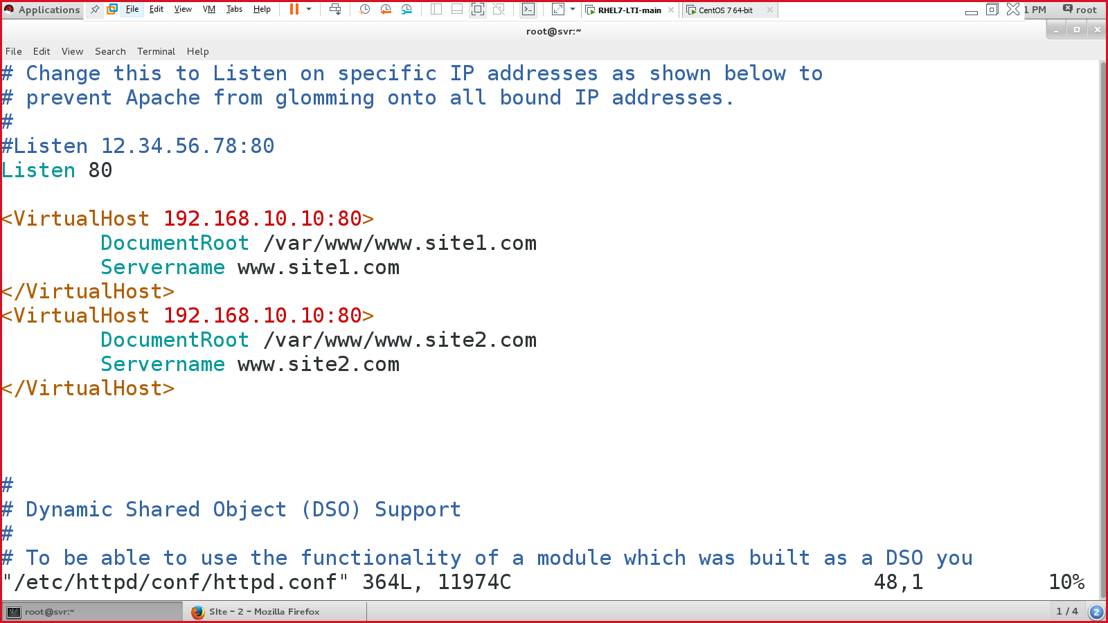save & quit

Make the entries in the /etc/hosts file, to access the site(s) – for name resolution :

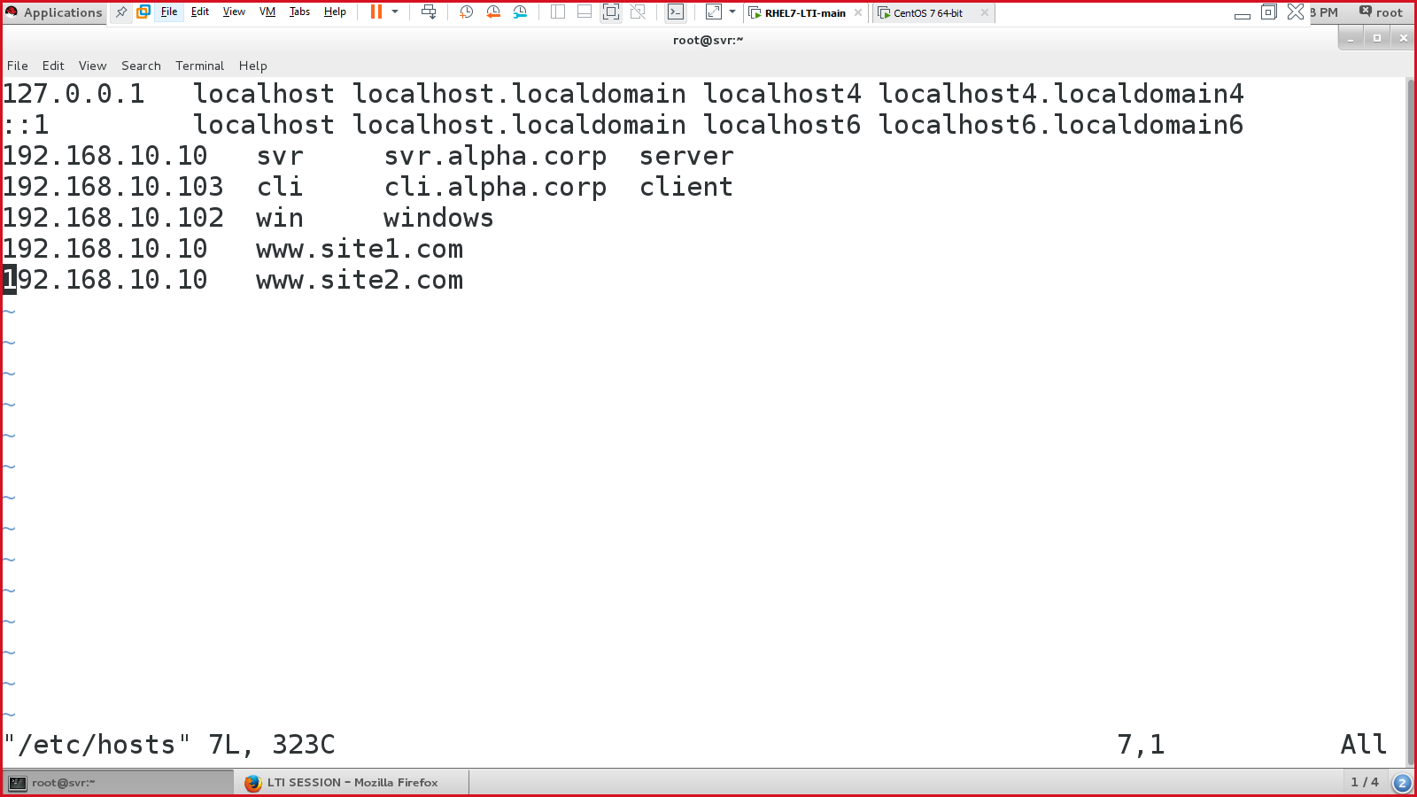:wq!

Enable, start & status httpd service:

* #systemctl enable httpd
* #systemctl start httpd
* #systemctl status httpd

**[scenario -3]: creating HTTPS (using SSL) website**

Steps:

* Create a directory in “/var/www/www.jeetusingh.in/”
* Create a web page “/var/www/www.jeetusingh.in/index.html”
* Config httpd file
* Restart the httpd service
* Edit /etc/hosts file

& verify using browser <http://www.jeetusingh.in>

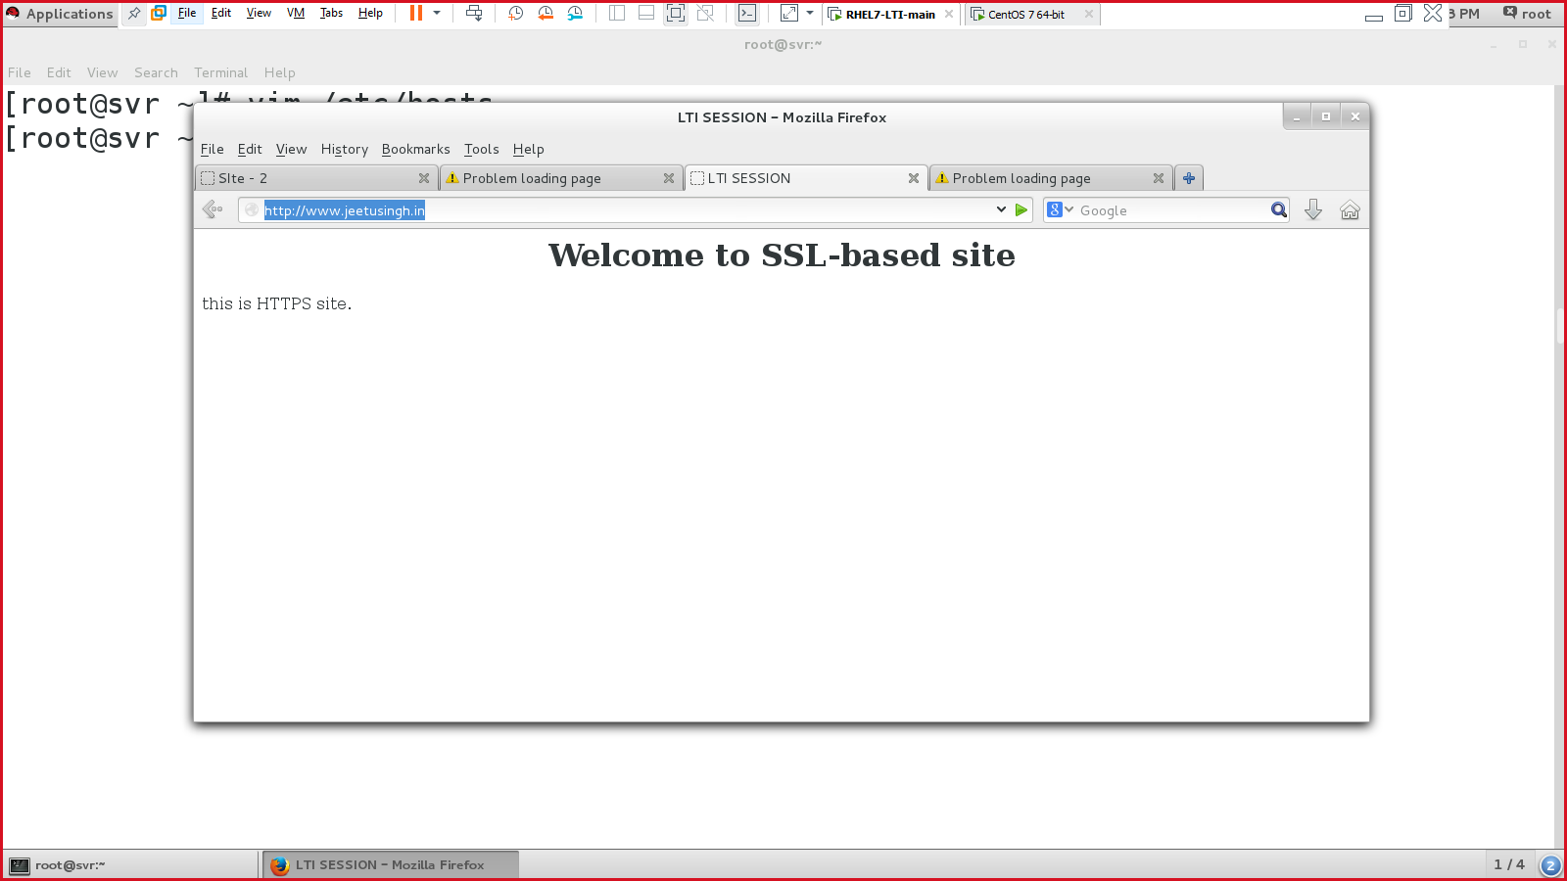

Configure HTTPS/SSL certificate & attach it to the site ([www.jeetusingh.in](http://www.jeetusingh.in))

* Install ssl packages:
  + #yum install -y mod_ssl openssh* openssl*
* Create SSL certificate:
  + go to certificate location “/etc/pki/tls/certs/”
* create a key certificate:
  + #make jeetusingh.key & enter the pass phrase
  + #ls

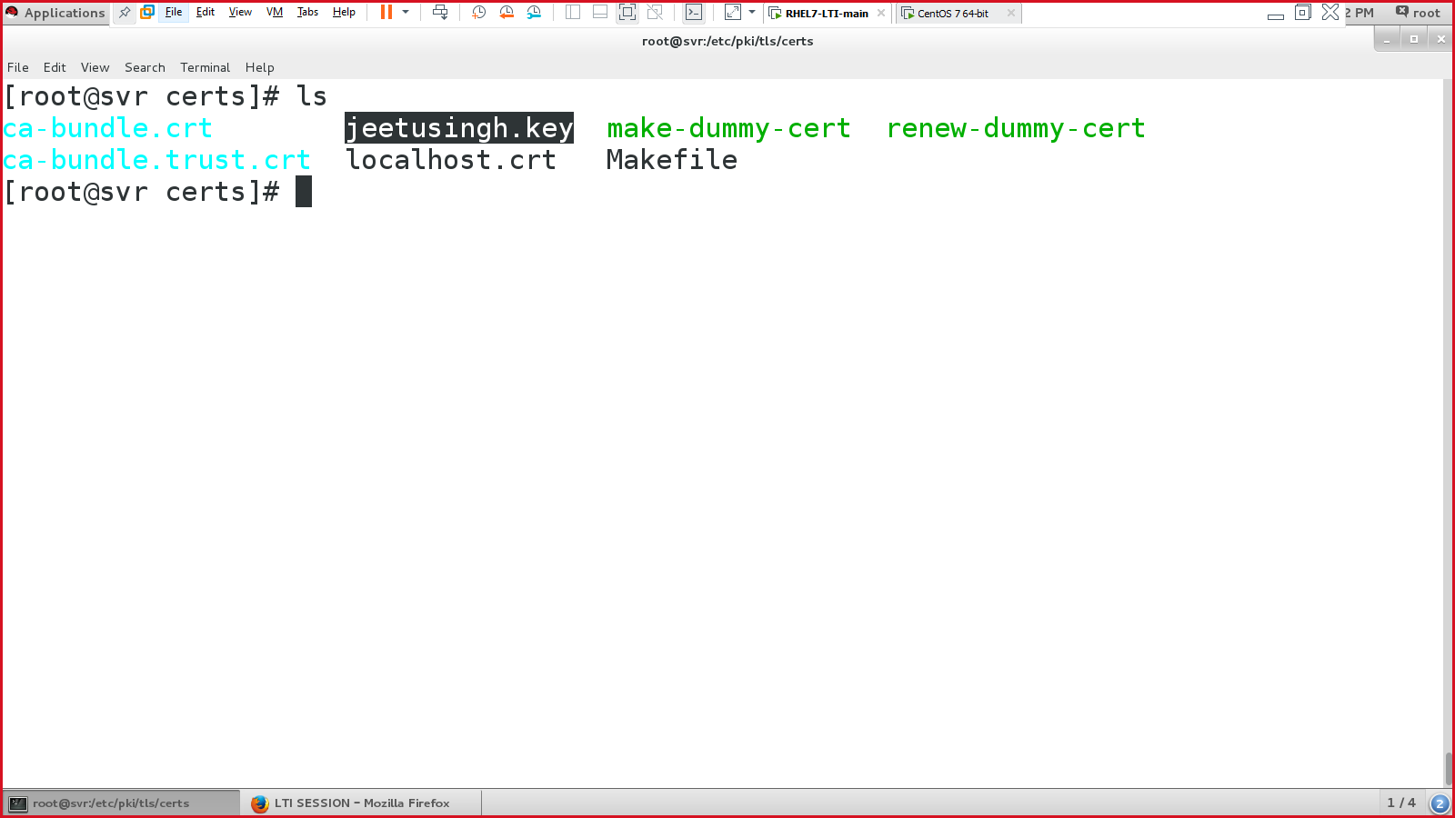

* Create a CSR file
  + #openssl rsa -in jeetusingh.key -out jeetusingh.key
* Create a CRT file
  + #cp localhost.crt jeetusingh.crt
  + #ls 🡪 look for jeetusingh.crt file in the directory.

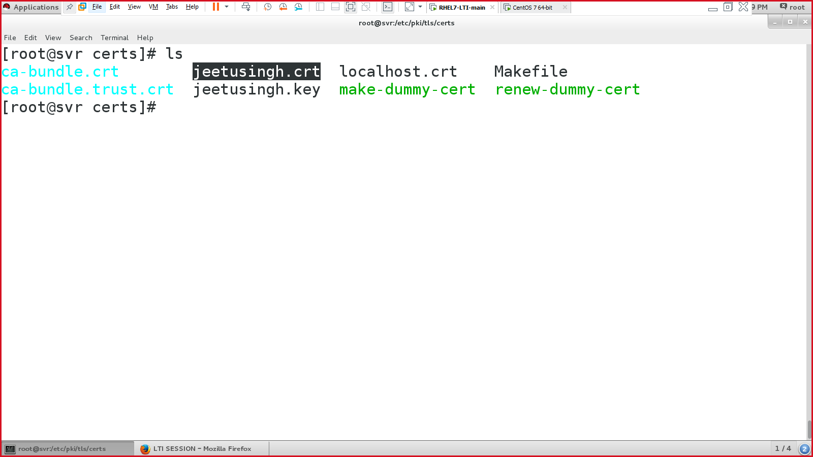

* Create a new “jeetusingh.csr” file

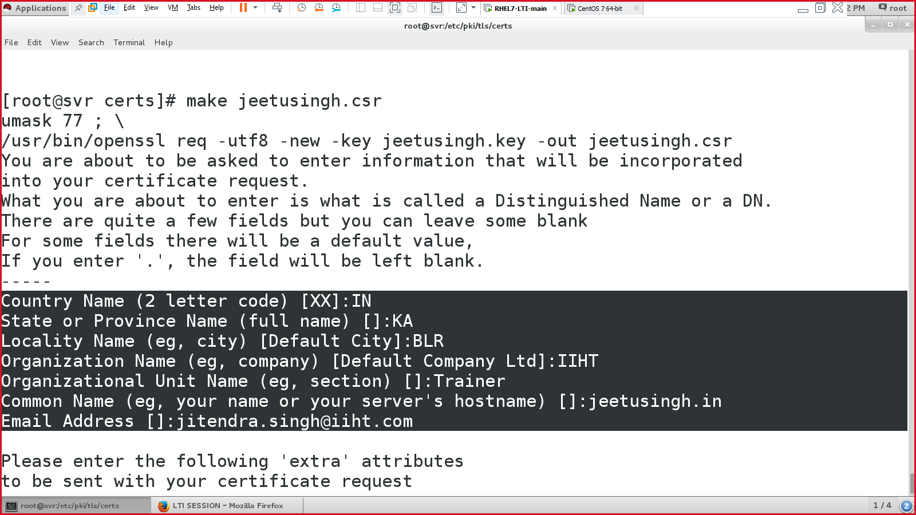

* Validate & bind the certificate:

#openssl x509 -in jeetusingh.csr -out jeetusingh.crt -req -signkey jeetusingh.key -days 365

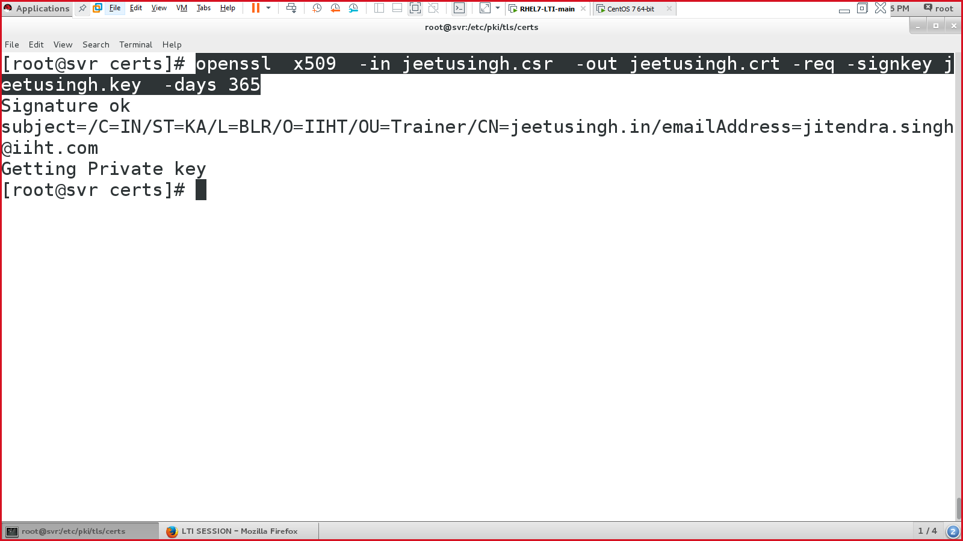

* Configure the SSL config file:
  + #vim /etc/httpd/conf.d/ssl.conf
  + Uncomment line 59 & 60 & edit accordingly
  + On line 100,

SSLCertificateFile /etc/pki/tls/certs/jeetusingh.crt

* + On line 107,

SSLCertificateKeyFile /etc/pki/tls/certs/jeetusingh.key

:wq!

* Restart & status httpd service:

#systemctl restart httpd

#systemctl status httpd

* Go to web browser & type <https://www.jeetusingh.in>

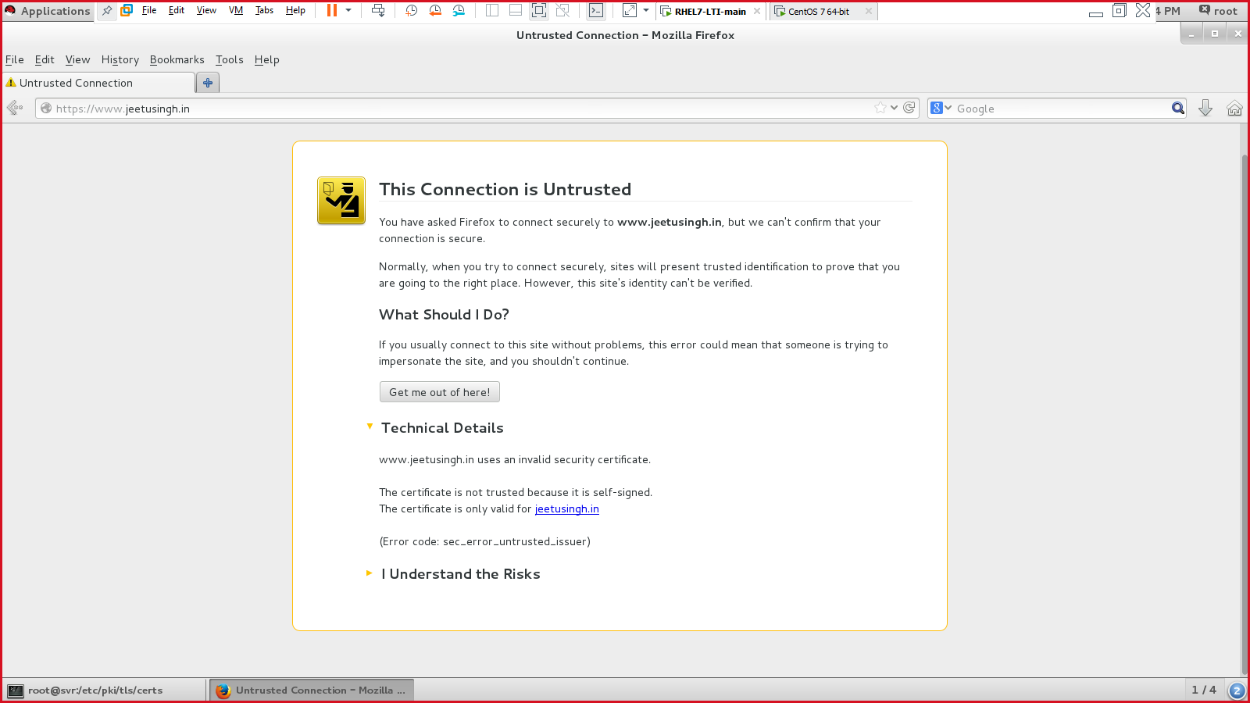

Click on “I Understand the Risks” & click on “Add exception”

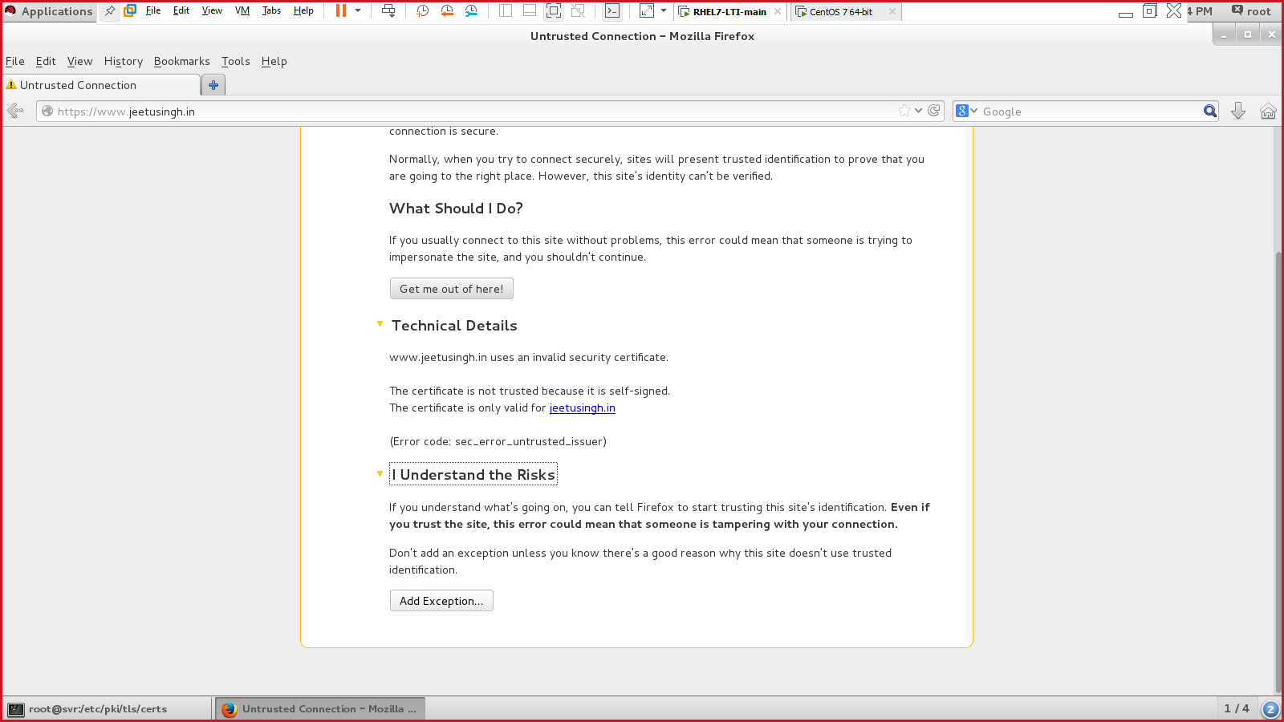

Click on “Confirm security exception”

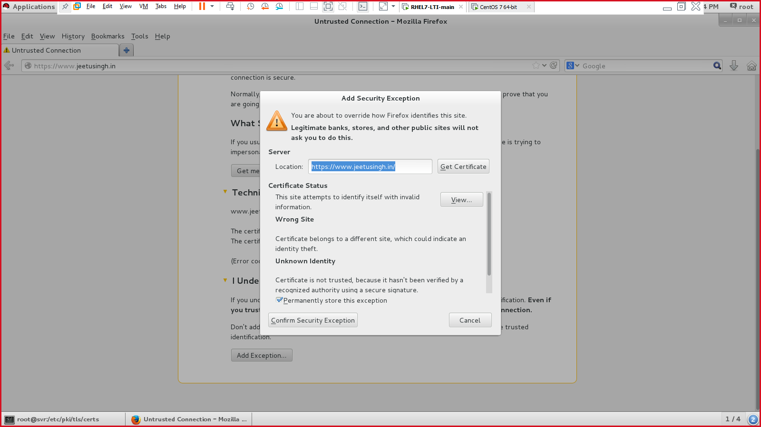

Access the site on HTTPS network:

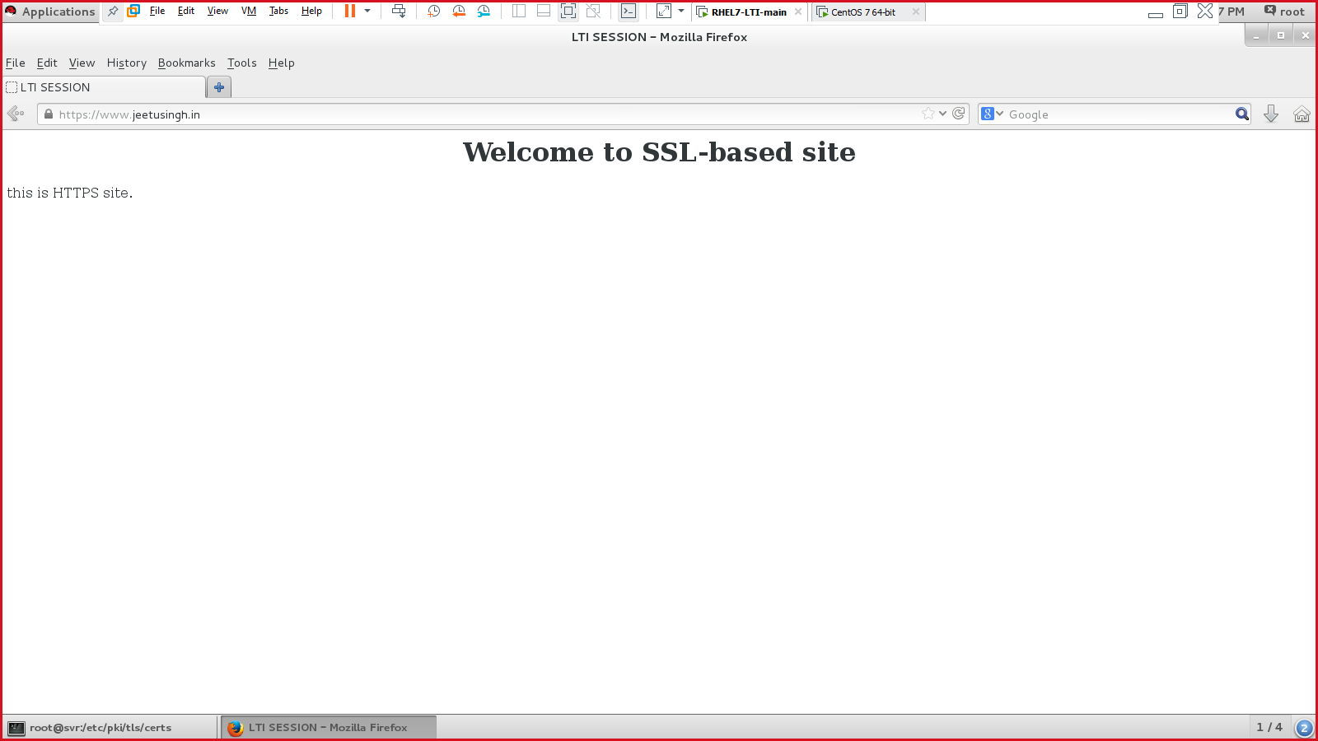

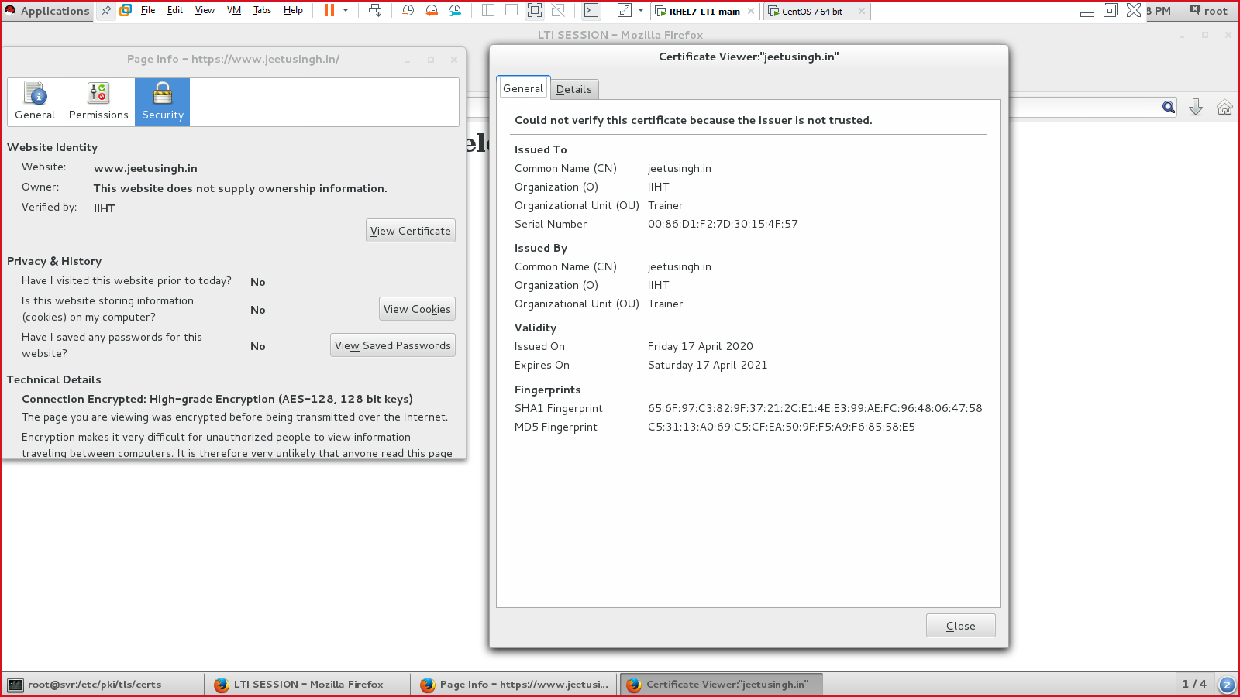

Telnet:

* Remote connection
* Similar to SSH
* BUT: it is not SECURE

Lab setup:

* System 1: telnet server 🡪 192.168.10.10
* System 2: telnet client 🡪 192.168.10.11

Install telnet packages:

* #yum install -y telnet telnet-server xinetd

On telnet server:

#vim /etc/xinetd.conf

* :set nu
* Go to line 14, and uncomment it.
* Then, write
* disabled = no

:wq!

Enable, start & status of xinetd & telnet services

* #systemctl enable xinetd telnet.socket
* #systemctl start xinetd telnet.socket
* #systemctl status xinetd telnet.socket

###########telnet server config over######

On telnet client machine,

* Install telnet services

#yum install -y telnet*

* Enable, start & status telnet services

#systemctl enable telnet.socket

#systemctl start telnet.socket

#systemctl status telnet.socket

* Connect to telnet server via client machine: 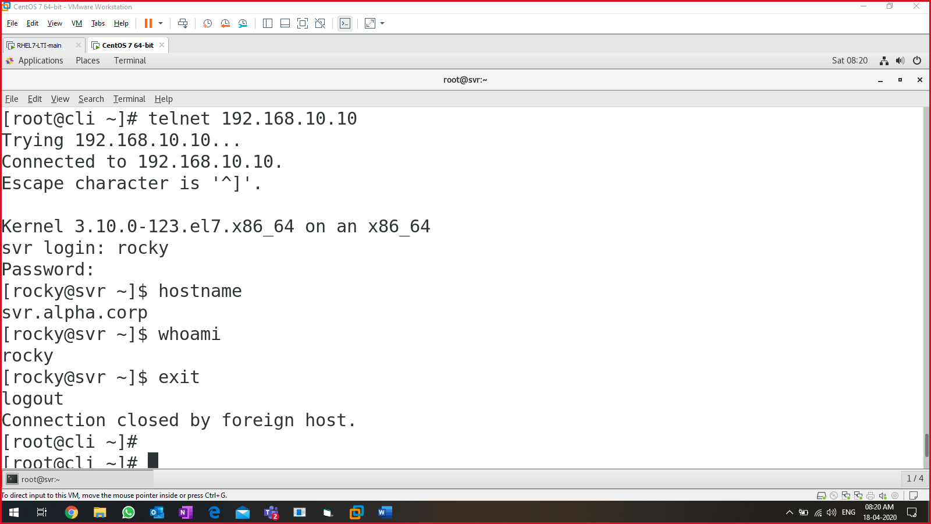

Connecting to telnet using telnet server:

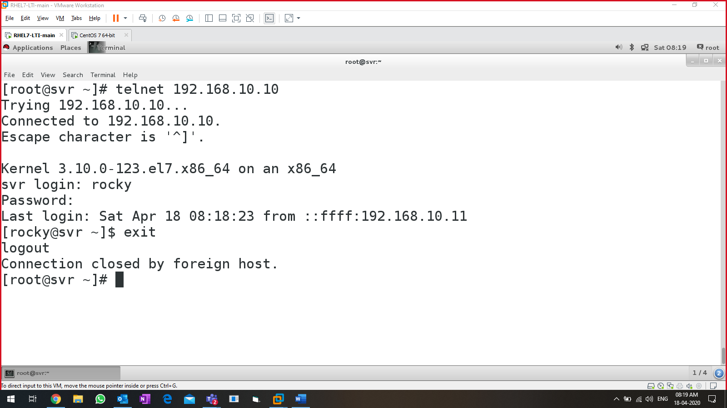

Connect to a service to check if the service is working.

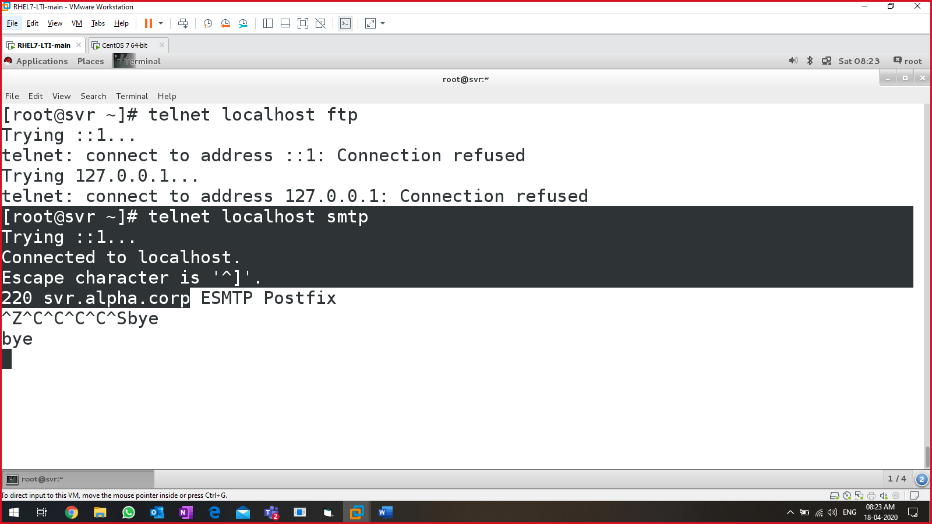

SQUID server:

* It is a proxy server
* Filtering the traffic on the network
* Blocking the unwanted sites within the network
* Squid server uses port 3128
* Config file: /etc/squid/squid.conf
* Service: squid

Lab setup:

* One linux based server (squid server) (svr –– internet is present)
* One linux / windows-based client. (cli –- internet is present)

Steps

* Install squid server using yum.

#yum install -y squid OR

#rpm -ivh /run/media/root/RHEL…/Packages/squid<hit-tab>.rpm (enter)

* Add additional NIC card in the server VM & client VM with NAT service.

Server machine:

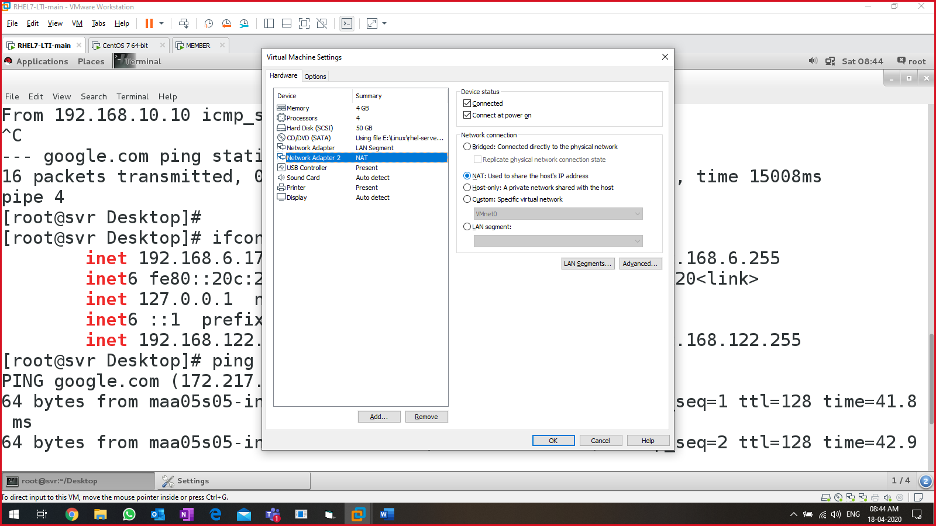

Client machine:

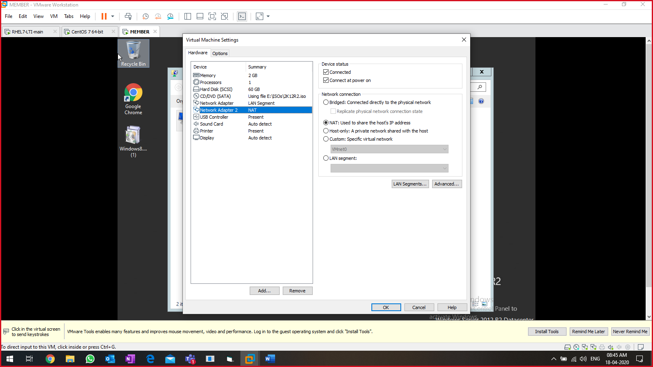

* Disable internal network with the VMs

Install SQUID on the server machine.

* #yum install -y squid

Steps:

* On client, open any webpage (link facebook.com)
* Start the monitoring of the client.
* Go to client machine & configure proxy IP:port on the client.

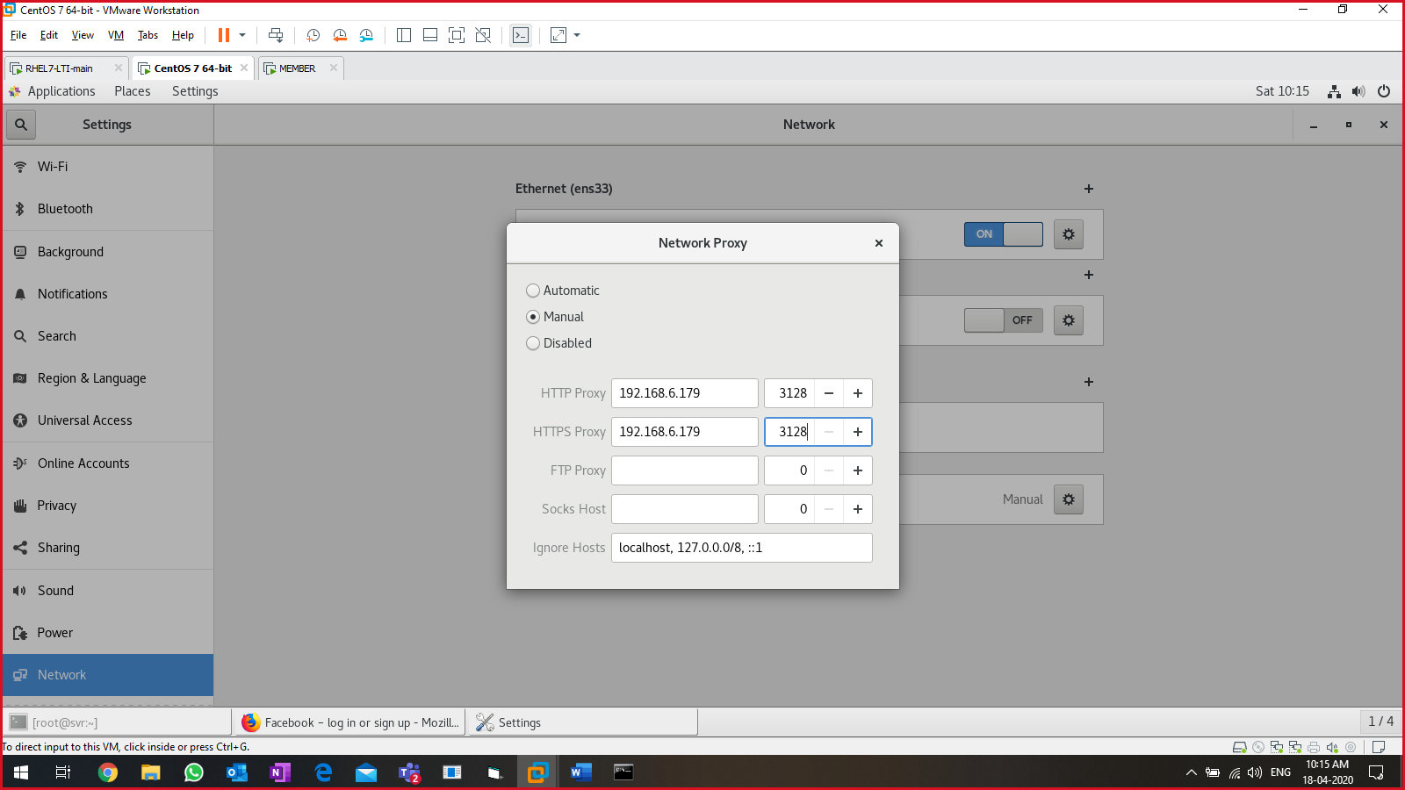

Enable, start & status of squid service:

* #systemctl enable squid
* #systemctl start squid
* #systemctl status squid

Log file of squid: /var/log/squid/access.log

* #vim /etc/squid/squid.conf
* Set the line numbers (:set nu)
* Add a new entry in the line number 11

acl localnet src 192.168.6.0/24 🡪 copy the content from line 10 & add ur IP.

* Go to line 38, and append localnet in the line (ex😊)

http_access allow localhost manager localnet

* Save & quit the file (:wq!)

Run command: tail -f /var/log/squid/access.log

Go to client & open <https://ziyad-bhombal.web.app>

Switch back to squid server & verify the logs contain keywork “ziyad-bhombal.web.app”.

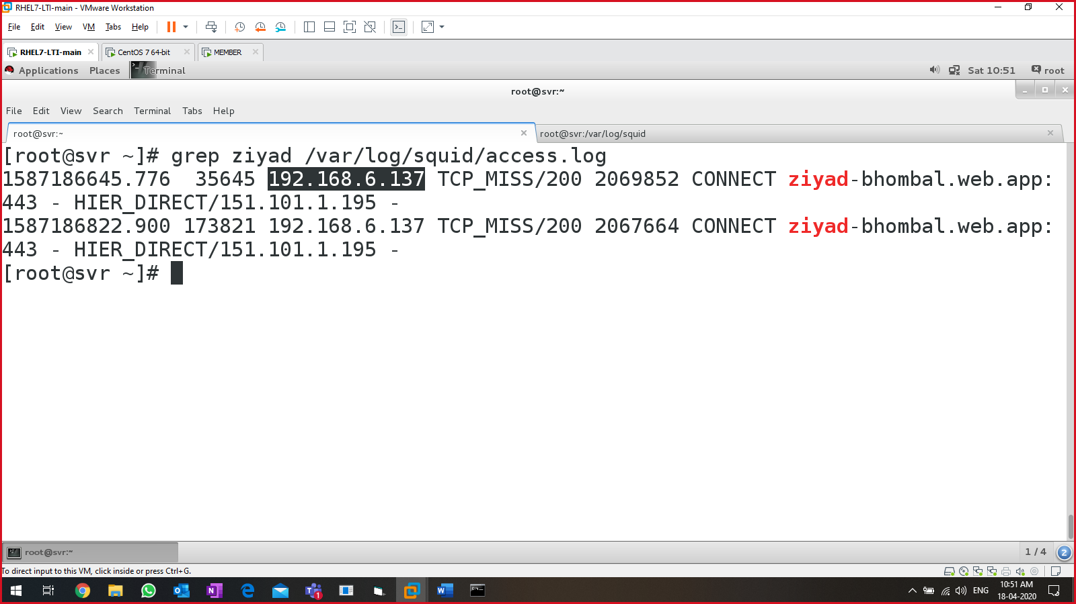

**NOW: To block the unwanted websites using SQUID**

* Go to squid config file
* Undo the changes, and add the below content on the top of the file:

acl badsites url_regex "/etc/squid/badsites"

http_access deny badsites

acl pgnetwork src 192.168.6.0/24

http_access allow pgnetwork

* :wq!

Create the file to block the websites without '-‘ sign:

#cat > /etc/squid/badsites

* Facebook.com
* Youtube.com
* ziyad-bhombal.web.app

press ctrl+d

Restart the SQUID service:

* #systemctl restart squid
* #systemctl status squid

Go to client machine to verify the sites are working.

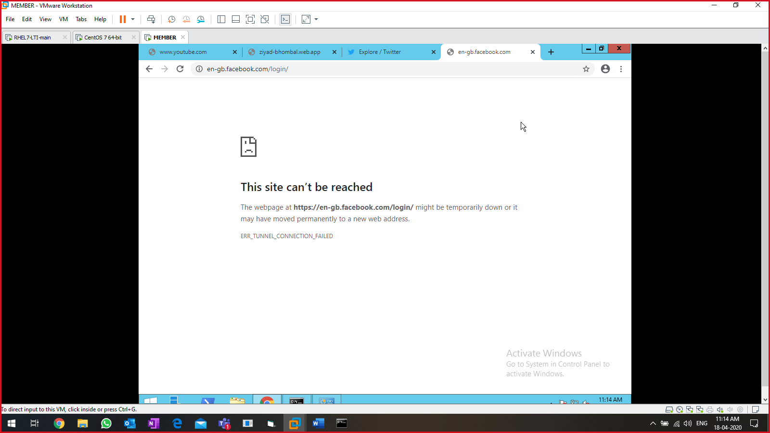

###########END OF SQUID SERVER ###############

DNS server:

* Resolves IP into name & vice-versa.
* Local system
  + Linux 🡪 /etc/hosts
  + Windows 🡪 C:\Windows\System32\drivers\etc\hosts
* Port number: 53
* Service: named
* Files:
  + /etc/named.conf (main config file)
  + /var/named/forward.alpha.corp (create a new file)
  + /var/named/reverse.alpha.corp (create a new file)

Lab setup:

* One server
  + DNS server
  + Static IP
  + Add DNS port in firewall or turn off
  + Internet is not required.
  + Hostname must a domain-based name (svr.alpha.corp)
* One/multiple client (windows or linux)
  + DNS client
  + Static/dynamic IP
  + Add DNS port in firewall or turn off
  + Internet is not required.
  + Hostname must a domain-based name (cli.alpha.corp)
  + PING SERVER & CLIENT SYSTEM BY IP ADDRESS
* Disable SQUID server on client & server machine

Install BIND/DNS

* # yum install -y bind bind-utils

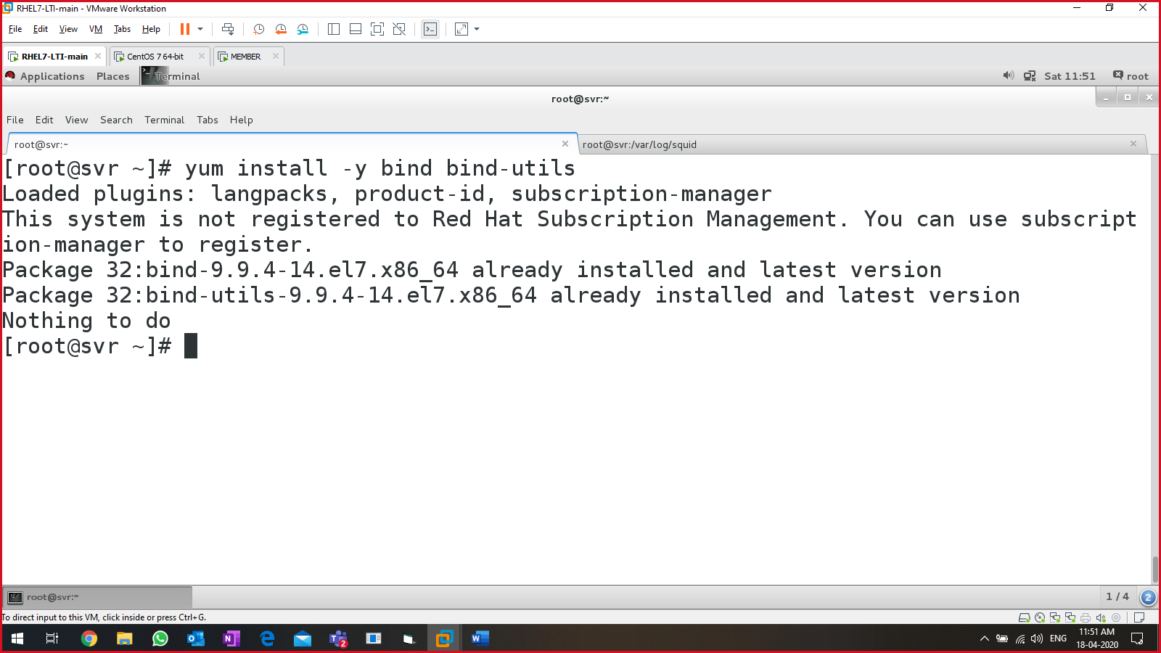

* Edit /etc/named.conf file:

On line 11, add your DNS ip address at the end. Followed by ‘;’

listen-on port 53 { 127.0.0.1; 192.168.10.10; }

on line 17, add ‘any;’ to the end:

allow-query { localhost; any; };

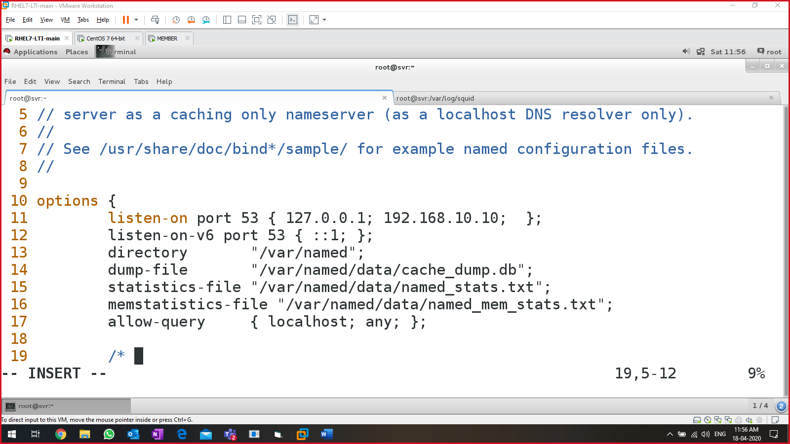:wq!

Enable, start & status ‘named’ service:

* #systemctl enable named
* #systemctl start named
* #systemctl status named 🡪 active (Running)

Open & modify /etc/named.conf file again:

Go to line 55, & add below data in it.

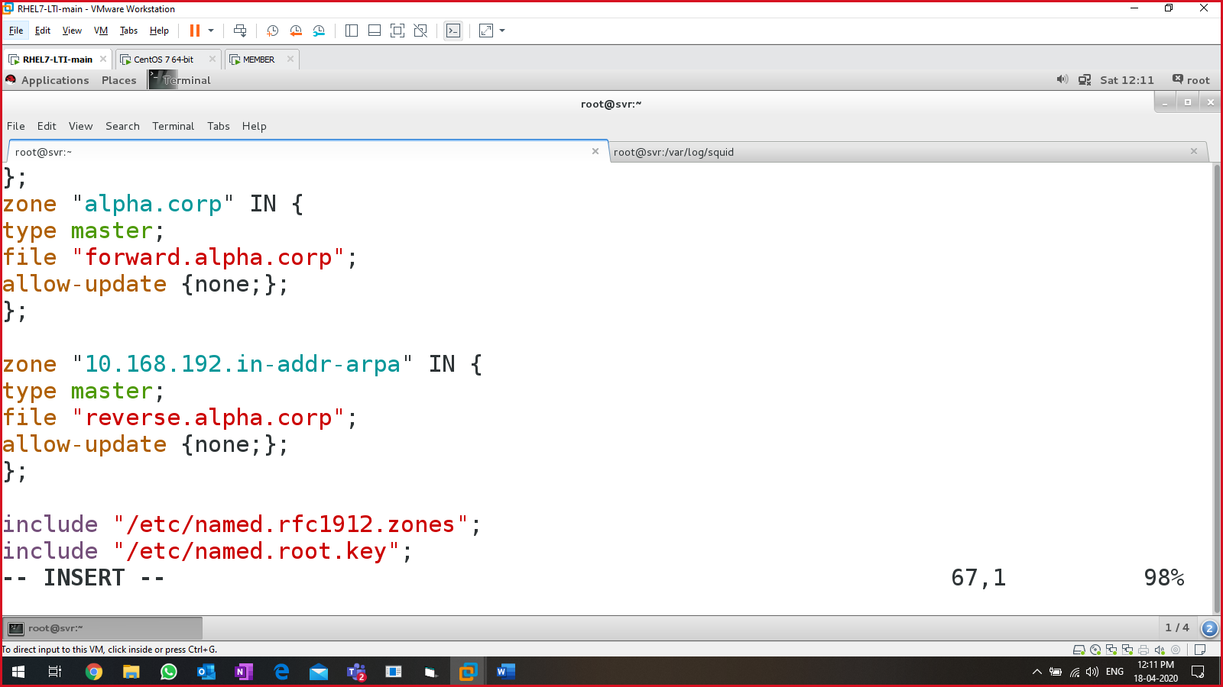

|  |
| --- |
| zone "alpha.corp" IN {  type master;  file "forward.alpha.corp";  allow-update {none;};  };  zone "10.168.192.in-addr-arpa" IN {  type master;  file "reverse.alpha.corp";  allow-update {none;};  }; |

#cd /var/named; ls 🡪 look for the named.localhost file

#cp named.localhost forward.alpha.corp

#vim forward.alpha.corp

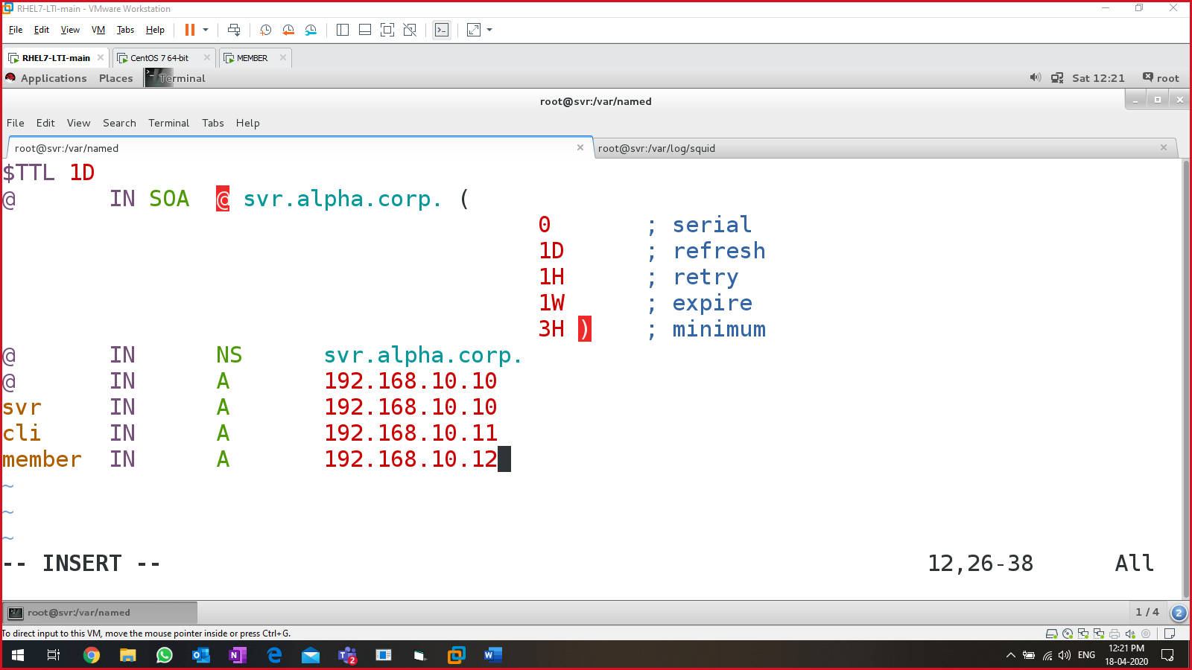:wq!

|  |
| --- |
| $TTL 1D  @ IN SOA @ svr.alpha.corp. (  0 ; serial  1D ; refresh  1H ; retry  1W ; expire  3H ) ; minimum  @ IN NS svr.alpha.corp.  @ IN A 192.168.10.10  svr IN A 192.168.10.10  cli IN A 192.168.10.11  member IN A 192.168.10.12  save & quit |

#cp forward.alpha.corp reverse.alpha.corp

#vim reverse.alpha.corp

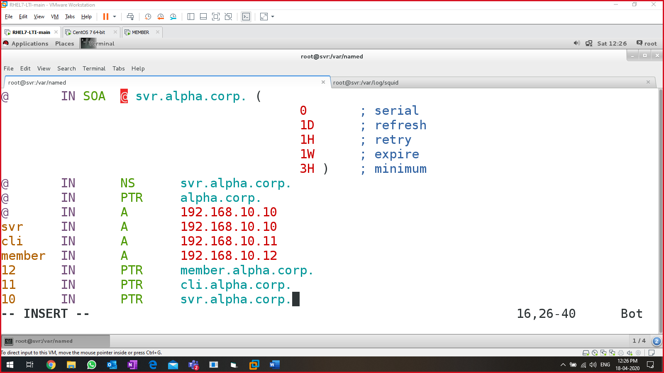

|  |
| --- |
| @ IN SOA @ svr.alpha.corp. (  0 ; serial  1D ; refresh  1H ; retry  1W ; expire  3H ) ; minimum  @ IN NS svr.alpha.corp.  @ IN PTR alpha.corp.  @ IN A 192.168.10.10  svr IN A 192.168.10.10  cli IN A 192.168.10.11  member IN A 192.168.10.12  12 IN PTR member.alpha.corp.  11 IN PTR cli.alpha.corp.  10 IN PTR svr.alpha.corp.  Save & quit |

[IMP: Change the ownership of the forward.alpha.corp & reverse.alpha.corp file]

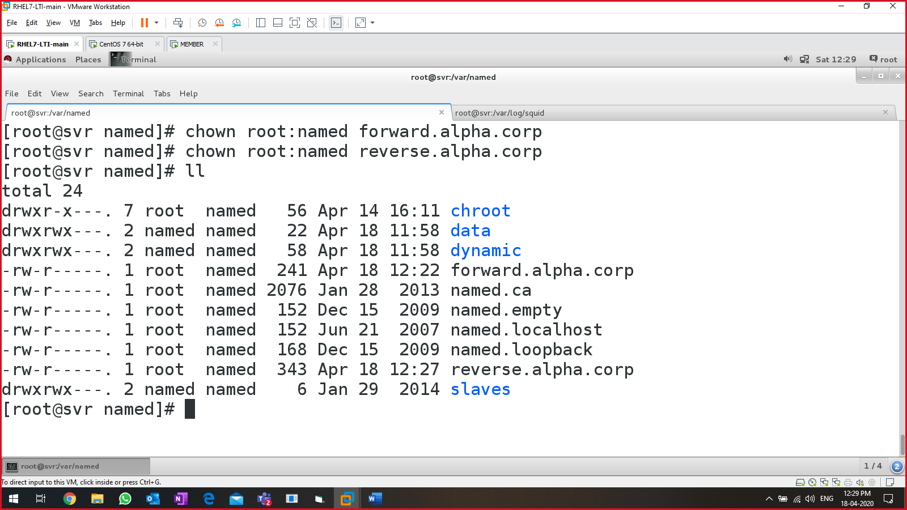

**Verify the named.conf**

#named-checkconf -z /etc/named.conf

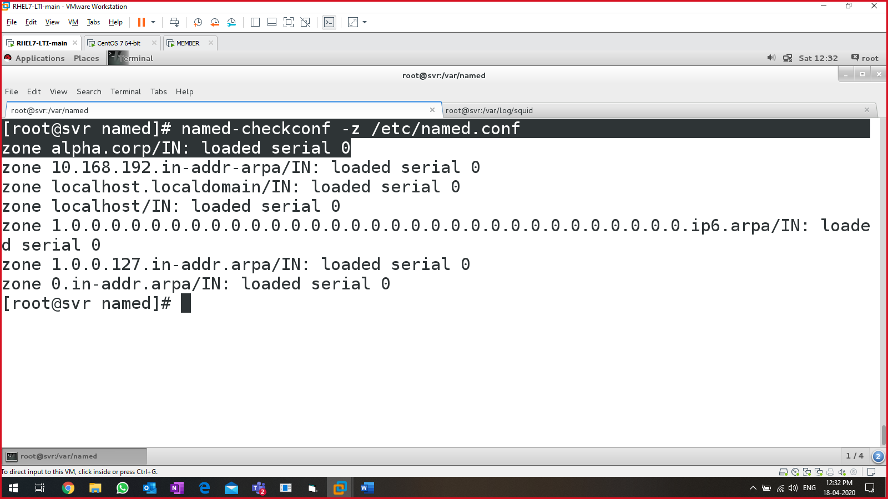

Output of the command must give 🡪 “…loaded serial 0”

**Verify forward.alpha.corp**

# named-checkzone forward forward.alpha.corp

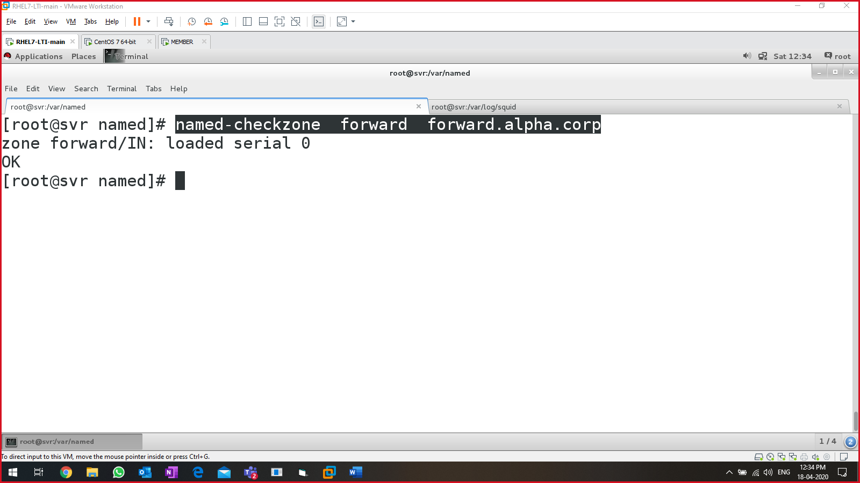

Output 🡪 “loaded serial 0”

**Verify reverse.alpha.corp**

# named-checkzone reverse reverse.alpha.corp

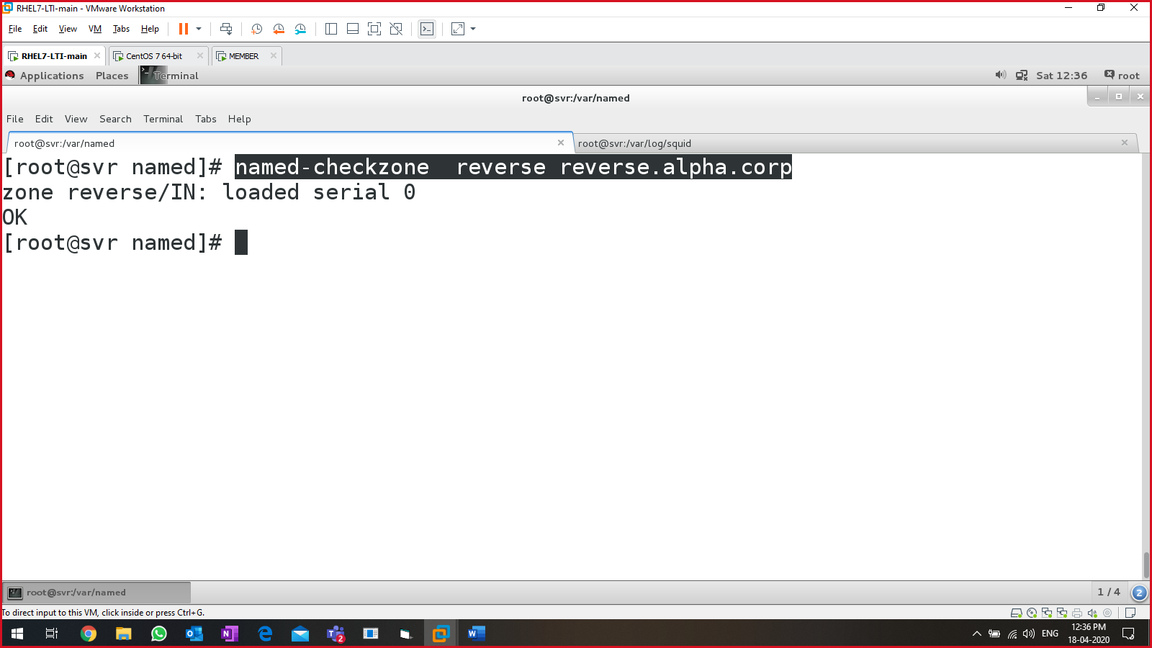

Output 🡪 “loaded serial 0”

Enable, start, restart & status of named

* #systemctl enable named
* #systemctl restart named
* #systemctl status named

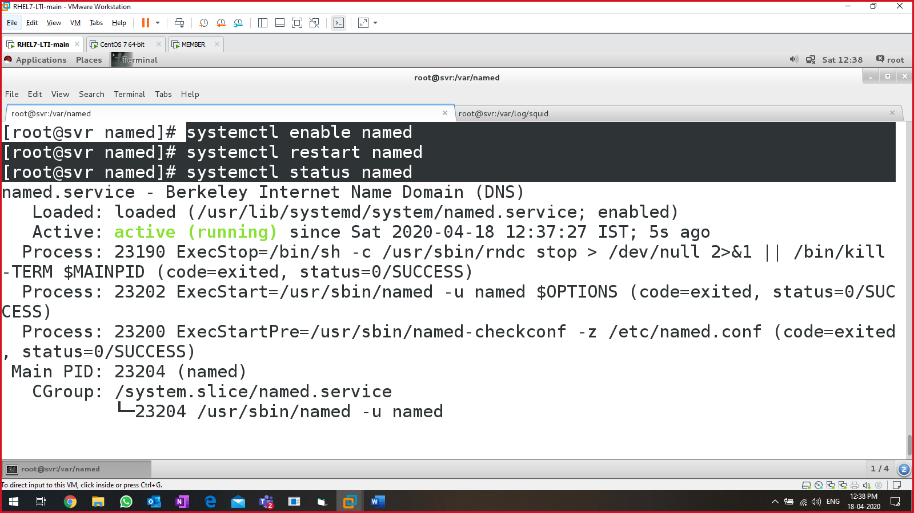

From server machine:

* #ping svr.alpha.corp 🡪 pinging
* #ping cli.alpha.corp 🡪 pinging

Switch to client machine:

# vim /etc/resolv.conf

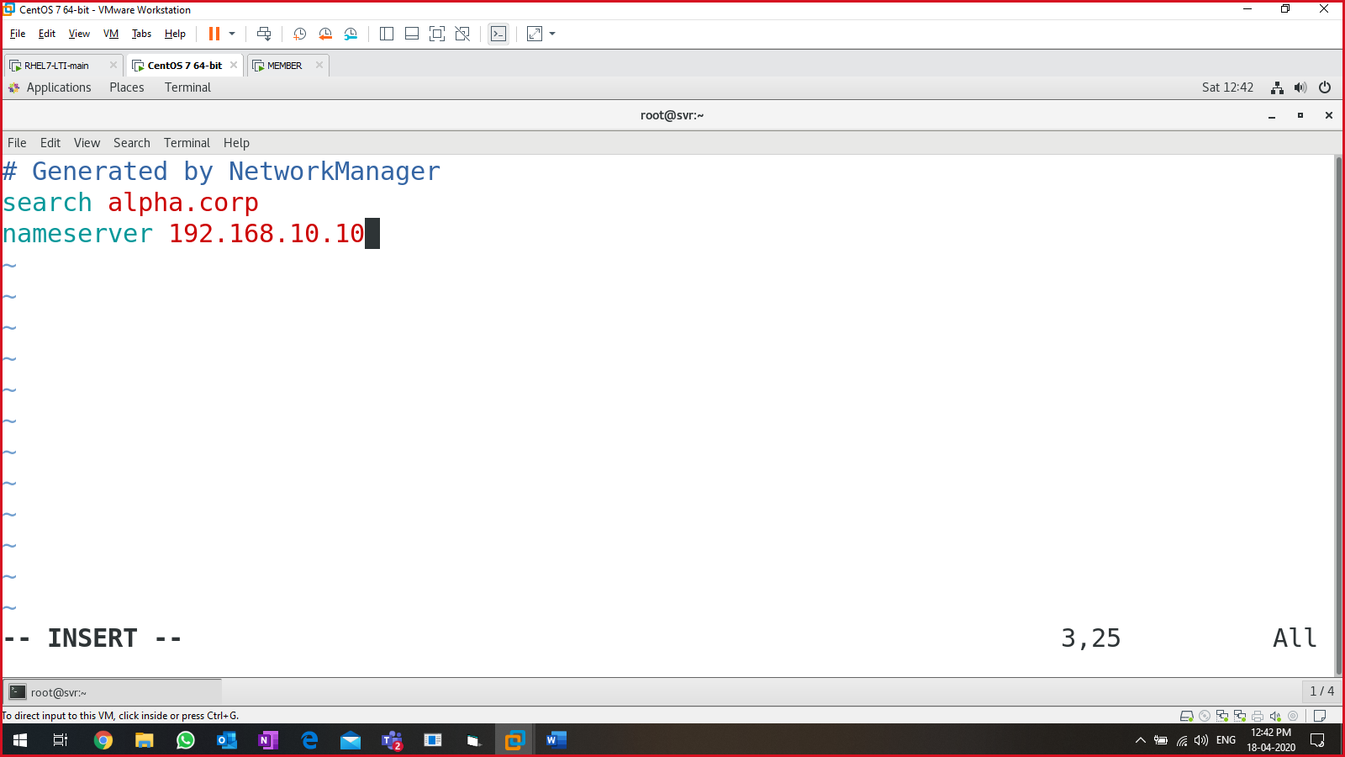:wq!

Restart & status the network & NetworkManager services

#systemctl restart network

#systemctl restart NetworkManager

#systemctl status network

#systemctl status networkmanager

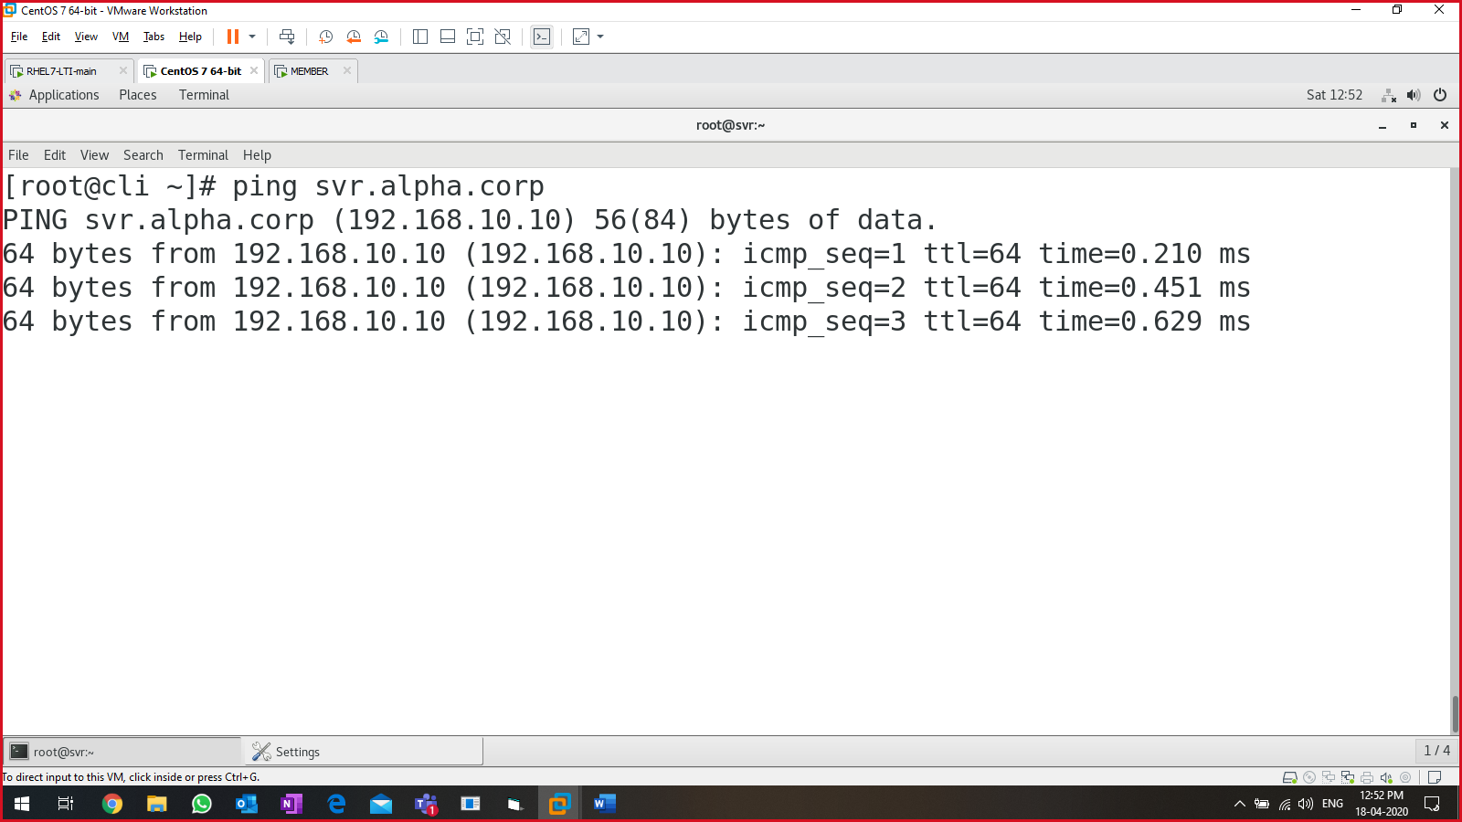

To verify the DNS name:

#dig <domain-name> or #dig alpha.corp

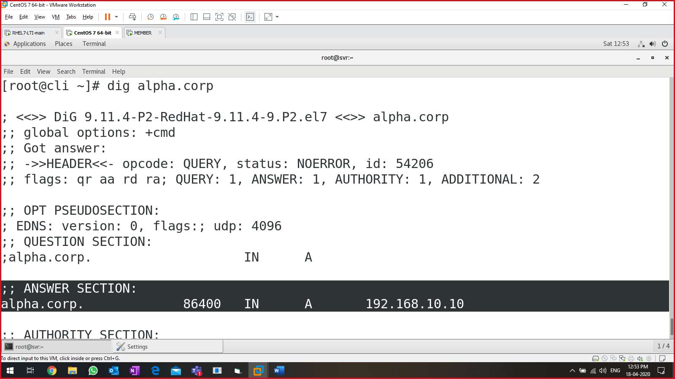

#########END OF DNS/BIND server configuration ############

Mail server:

* Linux: **for sending** (Postfix**), for receiving** (dovecot), GUI-web (squirrel mail or thunderbird)

Components of a mail server:

* MTA
  1. Mail transfer agent
  2. Send/receive email to & from other systems using SMTP
* MUA
  1. Mail user agent
  2. Email client
  3. Outlook, thunderbird, lotus, Squirrel mail
* MDA
  1. Mail delivery agent
  2. Delivery of the mail

For configuring mail server:

* Postfix
  + For sending an email
  + SMTP protocol
  + Already in DVD
* Dovecot
  + For receiving emails
  + POP3/IMAP protocol
  + Already in DVD
* Squirrel mail / ThunderBird
  + MUA
  + Download it from internet (URL: <https://squirrelmail.org/download.php>)

Lab setup:

* Mail server: svr.alpha.corp
* Domain name: alpha.corp
* IP address: 192.168.10.10/24
* DNS is required

On server (svr.alpha.corp)

* In the DNS forward lookup zone file (MX), add below command at line 8

#svr IN MX 10 svr.alpha.corp.

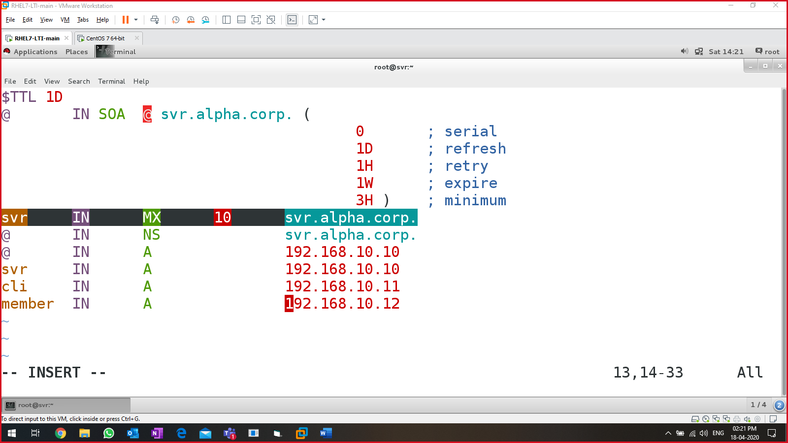:wq!

Restart & status of ‘named’ service:

* #systemctl restart named
* #systemctl status named 🡪 active running, proceed further

Above setup will only if DNS is present. Else edit /etc/hosts file to proceed further.

POSTFIX server config starts

* Install required packages (in DVD)

#yum install -y postfix

* Configure postfix configuration file:

#vim /etc/postfix/main.cf

line75 (uncomment & write this)🡪 myhostname = svr.alpha.corp

line83 (uncomment & write this)🡪 mydomain = alpha.corp

line99 *uncomment*

line113 *uncomment*

line116 *comment* *it.*

line164 (appendat last) mydestination = $myhostname, localhost.$mydomain, localhost, $mydomain

line264 mynetworks = 192.168.10.0/24, 127.0.0.0/8

line419 (uncomment) home_mailbox = Maildir/

:wq!

* Enable, start & status postfix:

#systemctl enable postfix

#systemctl start postfix

# systemctl status postfix

Verify the postfix configuration:

#systemctl enable telnet.socket

#systemctl start telnet.socket

#systemctl status telnet.socket 🡪 active (listening)

Communicate using telnet service:

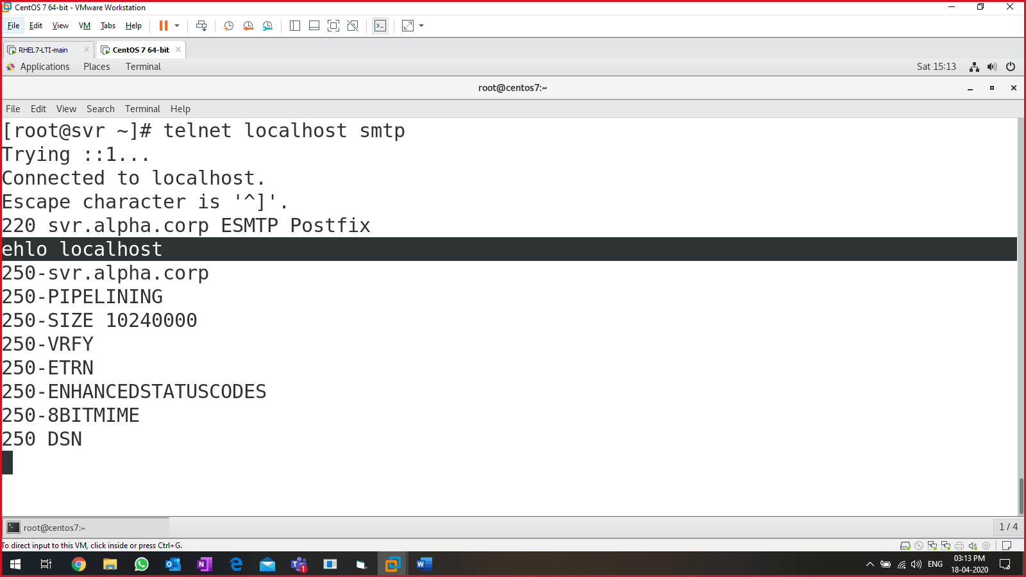

Sending email from THOR to LOKI:

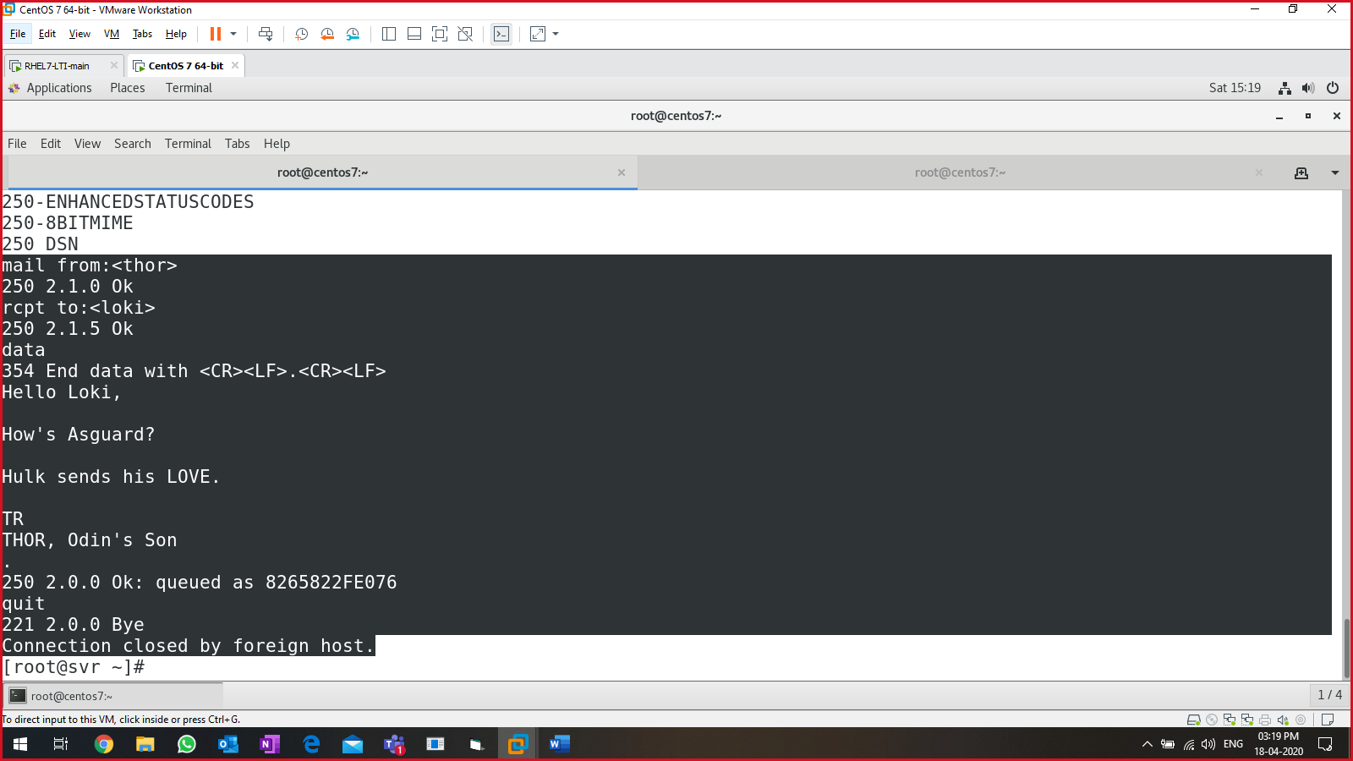

Switch to user’s home directory:

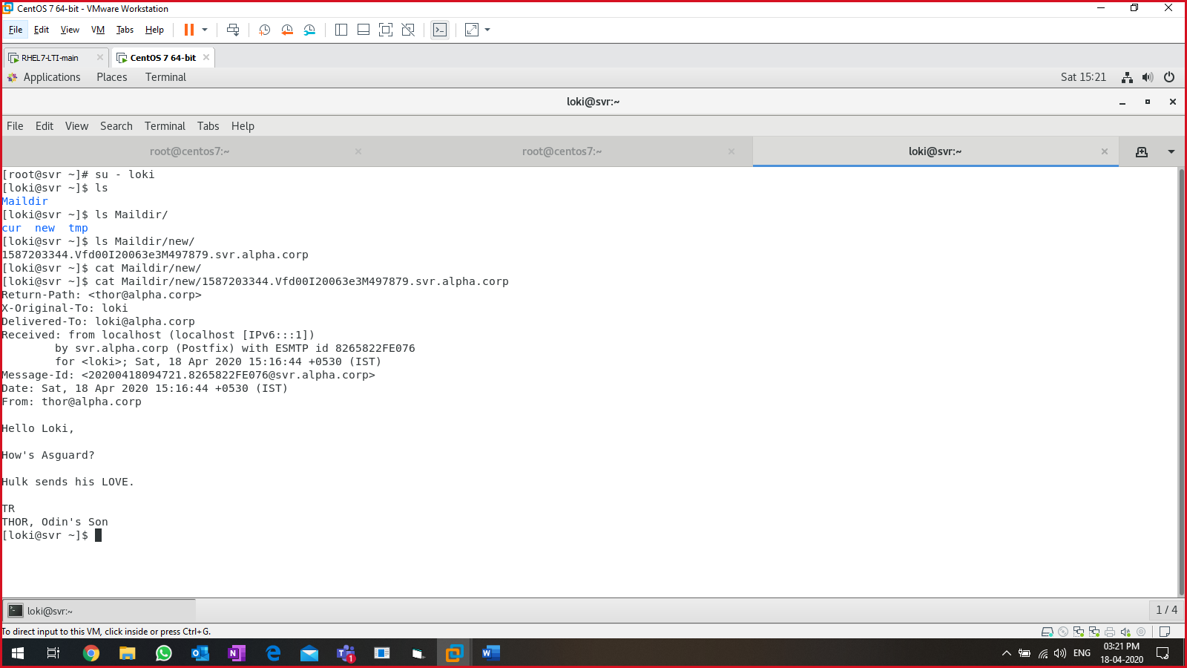

POSTFIX CONFIGURATION IS OVER

CONFIGURING DOVECOT

* Install dovecot server

#yum install -y dovecot

* To verify

#rpm -q dovecot

Edit the config file for dovecot server.

* Edit main file:

# vim /etc/dovecot/dovecot.conf

Uncomment line 24,

protocols = imap pop3 lmtp

:wq!

* Edit supportive files in dovecot:

1. # vim /etc/dovecot/conf.d/10-mail.conf

Uncomment line 24, to download the mails

mail_location = maildir:~/Maildir

1. #vim /etc/dovecot/conf.d/10-auth.conf

Uncomment line 10

disable_plaintext_auth = yes

on line 100, append ‘login’

auth_mechanisms = plain login

:wq!

1. #vim /etc/dovecot/conf.d/10-master.conf

Line 91 & 92, uncomment & add “postfix” to user and group:

user = postfix

group = postfix

:wq!

Enable, start & status of dovecot service:

* #systemctl enable dovecot
* #systemctl start dovecot
* #systemctl status dovecot 🡪 active (running)

Verify dovecot configuration:

# telnet localhost pop3

|  |
| --- |
| [root@centos7 ~]# telnet localhost pop3  Trying ::1...  Connected to localhost.  Escape character is '^]'.  +OK Dovecot ready.  user loki 🡪 **login to user “loki”**  +OK  pass loki 🡪 **password for user loki**  +OK Logged in.  list 🡪 **list the mail present**  +OK 1 messages:  1 389  .  retr 1 **🡪 retrieve <mail-number>**  +OK 389 octets  Return-Path: [thor@alpha.corp](mailto:thor@alpha.corp)  X-Original-To: loki  Delivered-To: loki@alpha.corp  Received: from localhost (localhost [IPv6:::1])  by svr.alpha.corp (Postfix) with ESMTP id 021A322FE076  for <loki>; Mon, 20 Apr 2020 00:48:39 +0530 (IST)  Message-Id: <20200419191847.021A322FE076@svr.alpha.corp>  Date: Mon, 20 Apr 2020 00:48:39 +0530 (IST)  From: thor@alpha.corp  Hahaha 🡪 **mail body**  Hahahahah 🡪 **mail body**  .  quit 🡪 **quit the console**  +OK Logging out.  Connection closed by foreign host.  [root@centos7 ~]# |

Example:

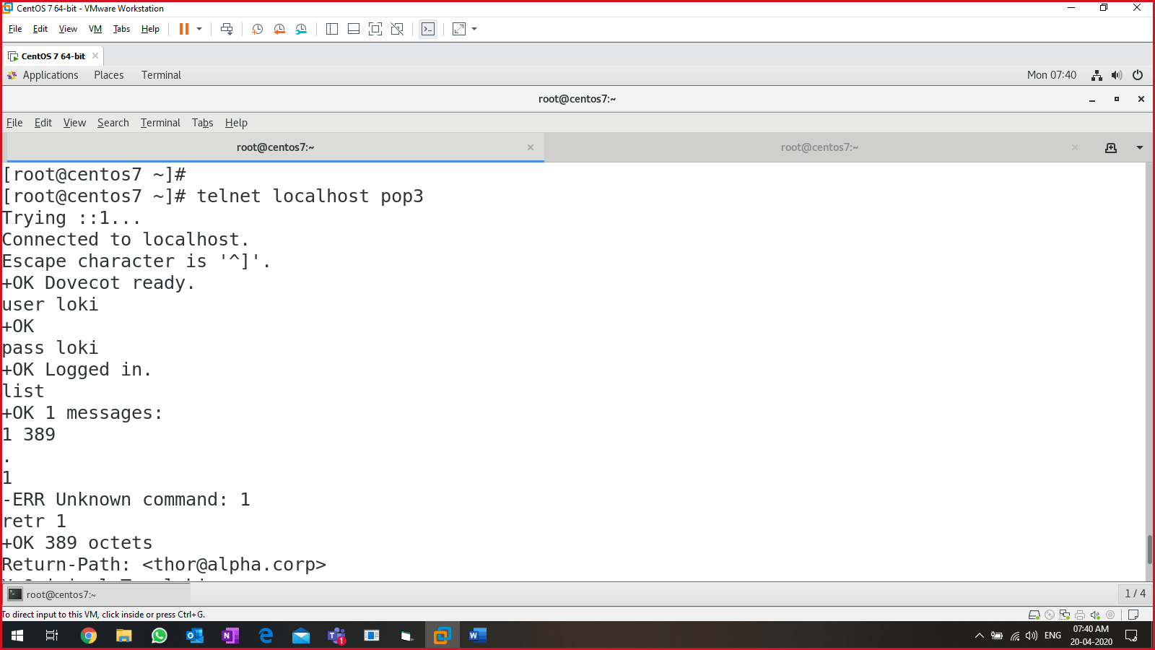

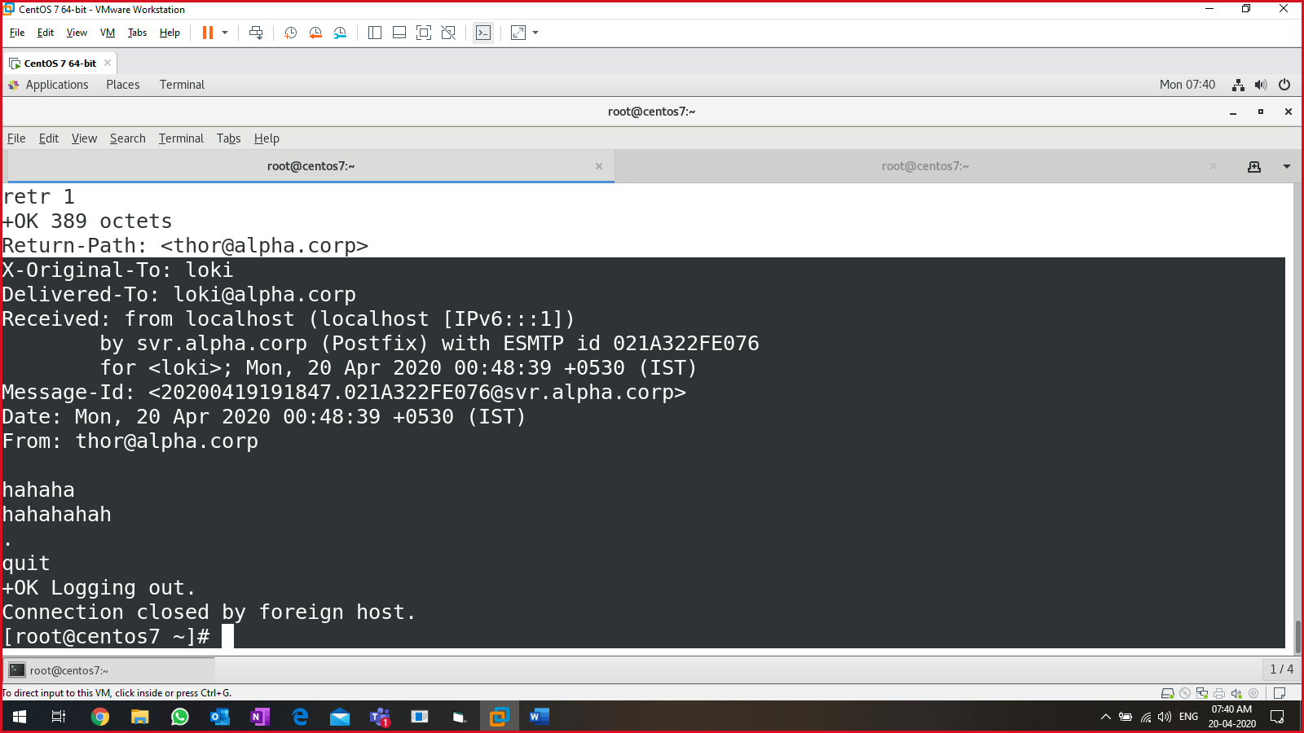

Squirrel mail to send, receive and read mail in linux system:

* Install squirrelmail, apache (httpd) & PHP packages.

#yum install -y httpd

#yum install -y php

* Install epel in centos to download & install squirrel mail:

#yum -y install epel-release

* Install squirrel mail:

#yum install -y squirrelmail

* Switch to squirrelmail config directory

#cd /usr/share/squirrelmail/config

#ls 🡪 conf.pl

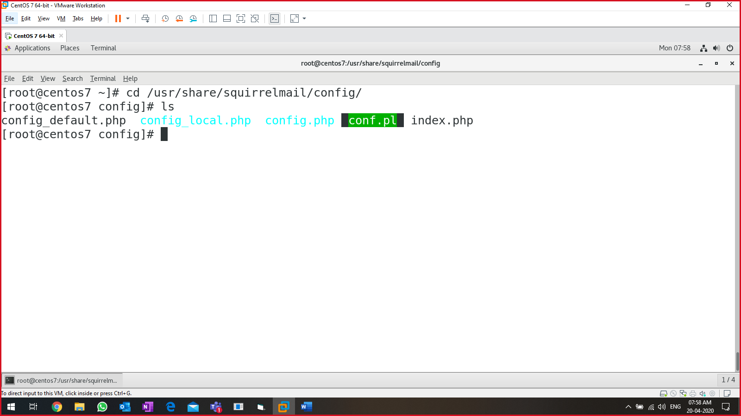

To execute the conf.pl file,

#./conf.pl

In the main menu, change below settings:

* + 1. Organization Preferences
  + 2. Server Settings
  + 7. Message of the Day (MOTD)

Save & quit the console.

Edit httpd file for squirrel mail:

* # vim /etc/httpd/conf/httpd.conf

Go to the bottom of the file & append below content:

|  |
| --- |
| Alias /webmail /usr/share/squirrelmail  <Directory /usr/share/squirrelmail>  Options indexes FollowSymLinks  RewriteEngine On  AllowOverride All  DirectoryIndex index.php  Order allow,deny  Allow from all  </Directory> |

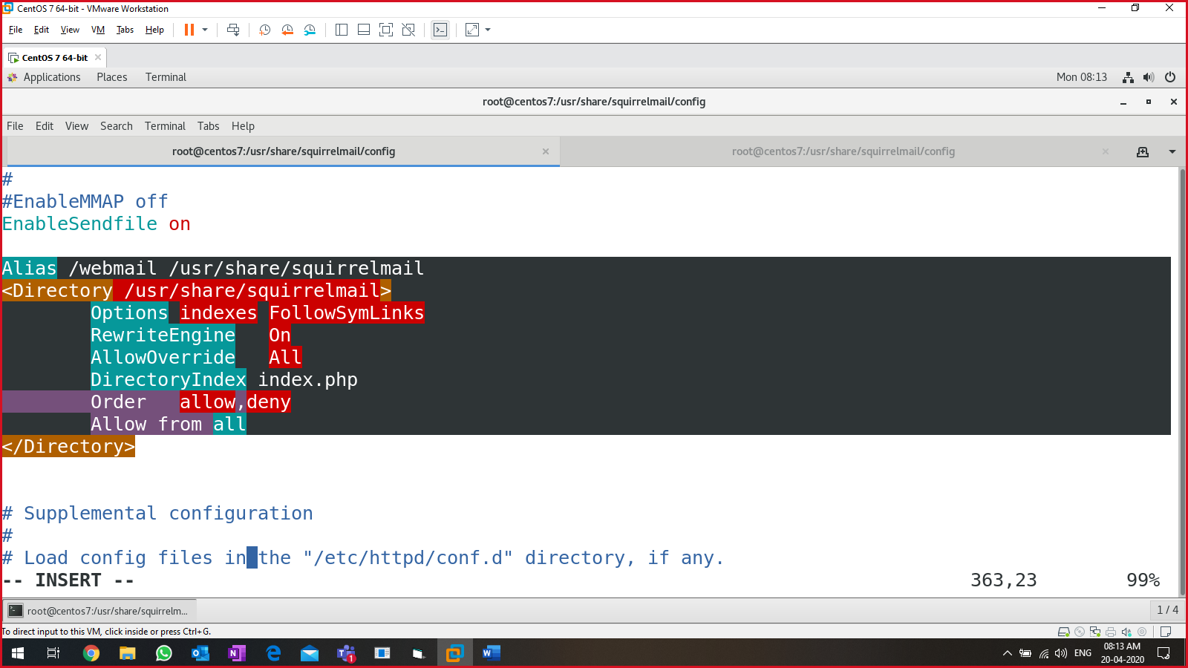

:wq!

Restart “httpd” & “dovecot” service & view the status

Launch firefox web browser & type below path

* http://<IP-Address>/webmail

we installed THUNDERBIRD for sending and receiving emails:

steps:

* thunderbird-68.7.0.tar.bz2
* uncompress it:
  + #bzip2 thunderbird-68.7.0.tar.bz2
* output -> thunderbird-68.7.0.tar
* extract the abv:
  + #tar -xvf thunderbird-68.7.0.tar
* output -> thunderbird --> directory

|  |
| --- |
| Single system env:  ---------  name: svr.lti.com  domain: lti.com  DNS is running  install  - postfix  - dovecot  - squirrelmail or thunderbird  users on same system  - user1  - user2 |

===========MAIL SERVER CONFIG OVER==========

Recommendation for LAB setup:

**sys-1** (2 LAN cards- 1 LAN segment, 1 NAT)

* GUI/text installation
* file, user, service mgmt
* RPM / YUM (full and shortcut)
* partitioning (attach 3GB disks)
  + Simple
  + LVM
  + RAID
* Networking
* Firewall
* NTP + internet
* FTP
* SSH
* telnet
* SCP
* rsync
* apache web server
* DNS
* MAIL server (postfix, dovecot, (thunderbird or squirrel mail)

**sys-2** (2 LAN cards- 1 LAN segment, 1 NAT)

* DHCP
* SCP (win to linux with NAT)
* rsync
* NFS (l-l)
* SAMBA (linux-windows)
* Squid proxy

Text based installation:

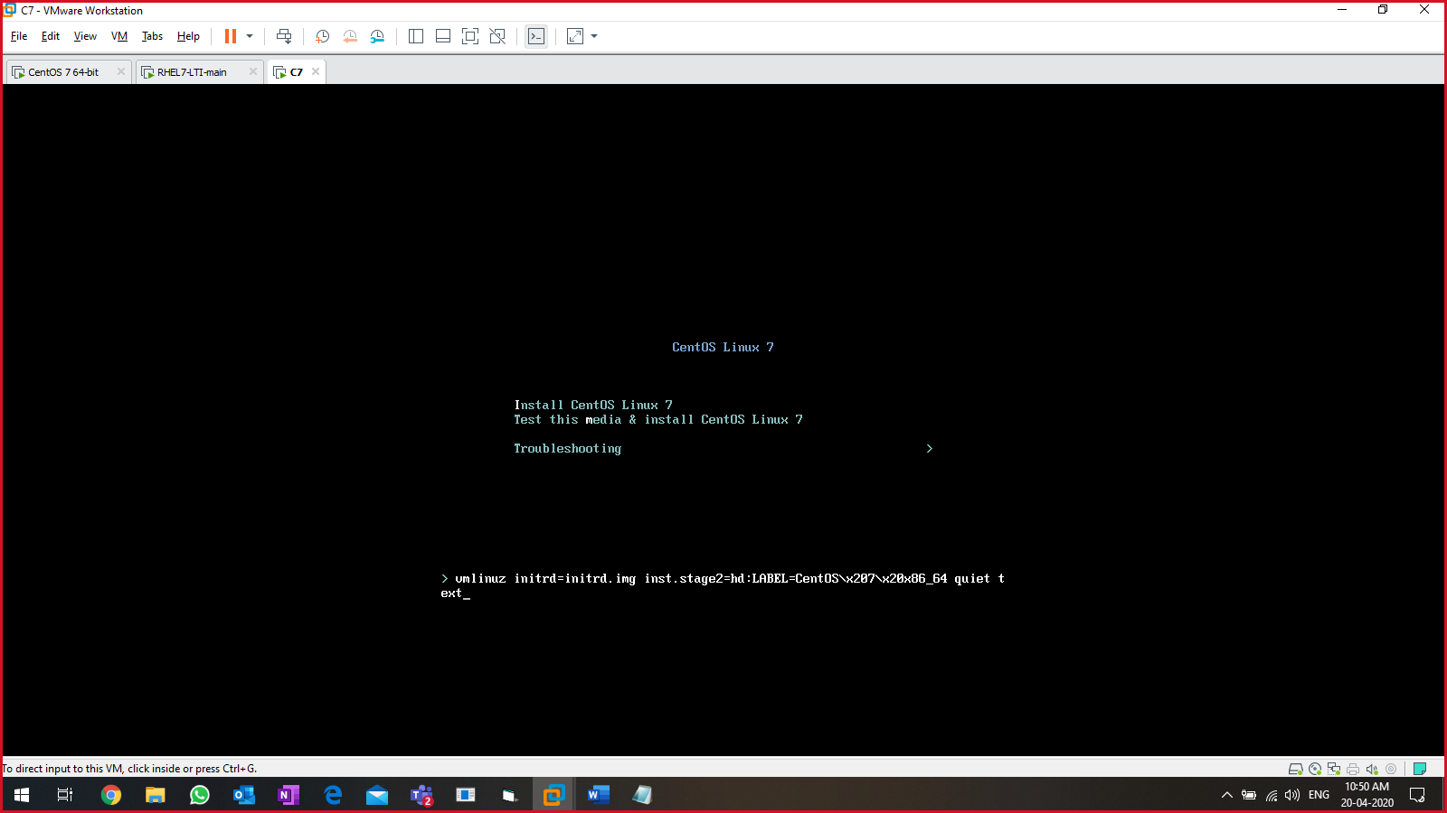

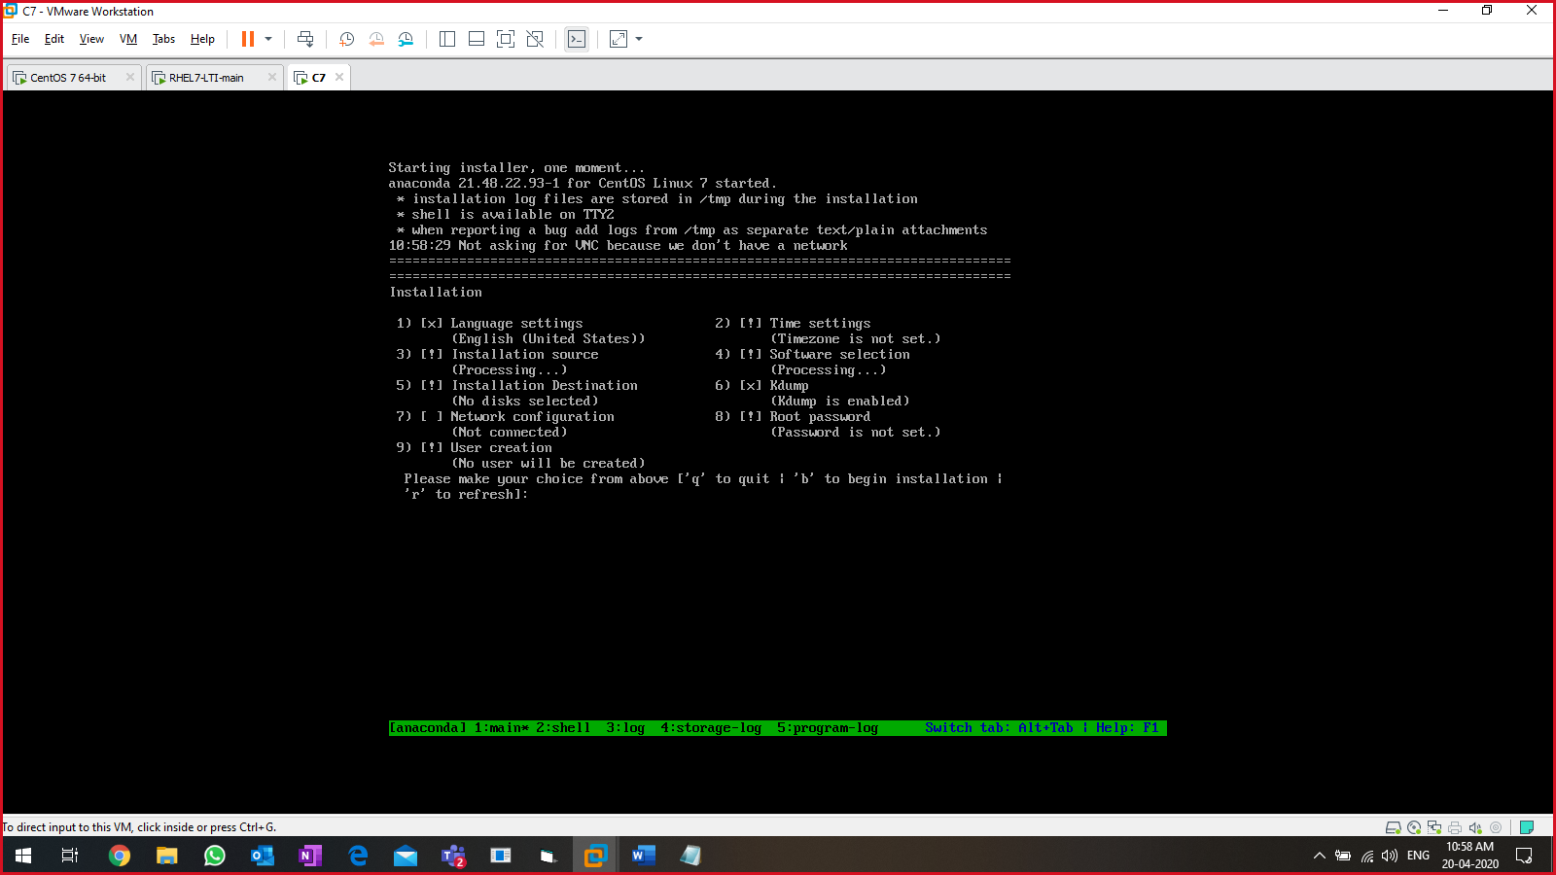

URL: <http://www.geekpills.com/linux_tutorial/rhel7centos7-text-installation>

Convert GUI to CLI permanently

* # systemctl set-default multi-user.target & reboot

Convert CLI to GUI permanently

* # systemctl set-default graphical.target & reboot

FSCK:

* File system consistency check
* Use cases
  + System failure at boot time
  + File System is corrupted.
  + External devices

Scan HDD without reboot:

* List all available device:
  + #ls -l /sys/class/scsi_host/
* search for the device having keyword “mpt” in it & check the “host<value>”
  + #grep mpt /sys/class/scsi_host/host??/proc_name
* reset the values for the host<value> file
  + #echo “- - -“ > /sys/class/scsi_host/host32/scan
* Check using the commands
  + “disks” GUI
  + #lsblk

FSCK = RHEL 6,

Xfs_repair = RHEL 7

At boot time, file check:

* 0 = dont scan at boot time
* 1 = scan at boot time -> /
* 2 = scan at boot time -> /boot, /usr, /home

Redirection:

* Redirecting the output in a certain file/location
* 3 std
  + Standard input 🡪 ‘0’ 🡪 keyboard, file…
    - # cat < lti-history.txt
  + Standard output 🡪 ‘1’
    - #cat >> lti-history.txt
  + Standard error 🡪 ‘2’
    - #ld 2> error.txt
* To send success messages/outputs in one file & errors in another file:
  + # ls -l f1 f2 lti-history.txt pkgs.txt d1 d2 1>success.txt 2>error.txt
* Send the output to null zone
  + #ld 1> success.txt 2>/dev/null

Reset root password in RHEL 7:

* Reboot the linux system
* Stop the booting process at GRUB screen.
* Select the linux kernel line & press “e”.
* Search for the line that starts with “Linux 16” and on the same line append “rd.break”
* Press CTRL+X

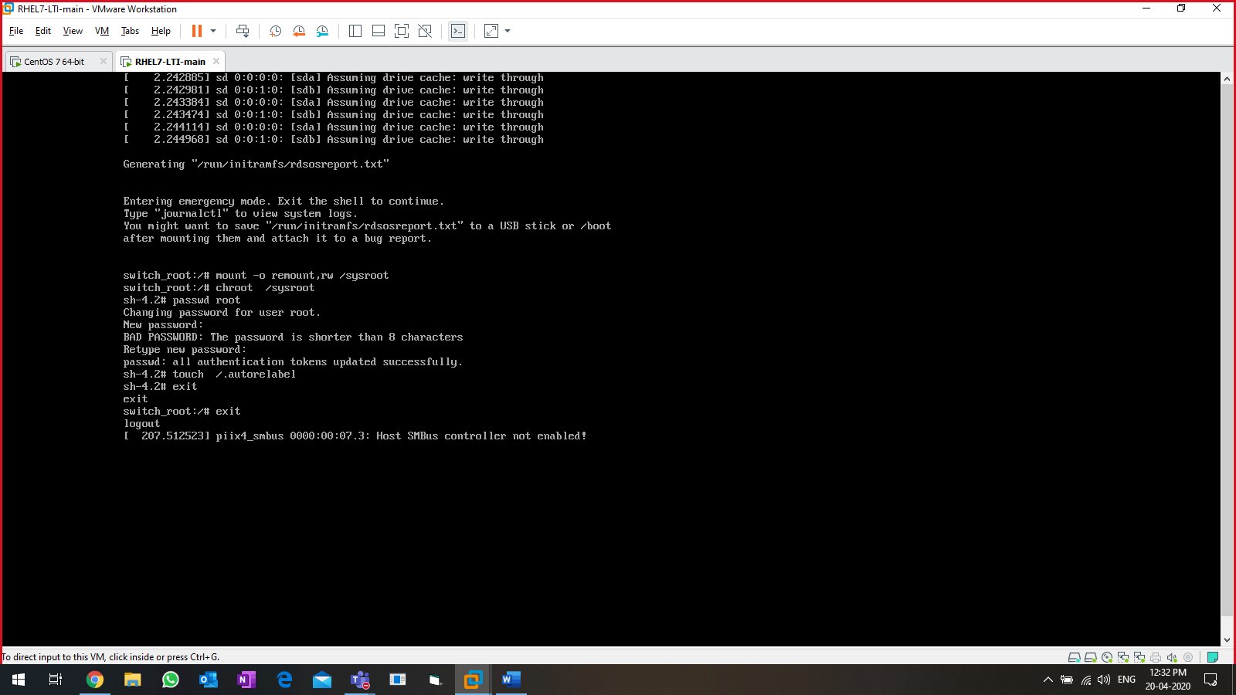

Get system information:

* #cat /proc/meminfo 🡪 list memory information
* #free 🡪 list memory & swap
* #free -k 🡪 list memory info in KBs
* #free -m 🡪 list memory info in MBs
* #free -g 🡪 list memory info in GBs
* #cat /proc/cpuinfo 🡪 list CPU info (file)
* #lscpu 🡪 list CPU info (command)

[Task: increase the SWAP space to twice the current SWAP space size]

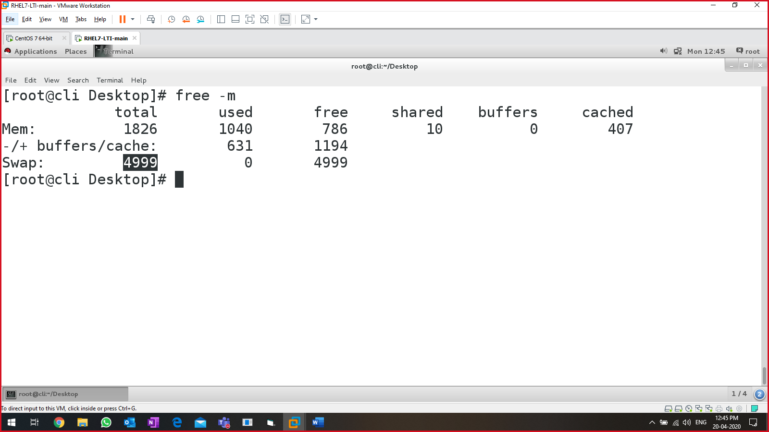

Powershell

Lab setup:

* One domain controller – **DC**
* Two members – **svr**, **member**

Powershell:

* Command-line utility
* **Administrative tasks**
  + Manage local system
  + Manage remote system
    - Domain-joined systems
    - Non-domain joined systems
  + Report of users, drives, spaces…
* Microsoft product, which does not have any GLOBAL EXAMINATION.
  + 10961 – basics of powershell
  + 10962 – advanced powershell
* CMD prompt commands can be executed on powershell.

Powershell version:

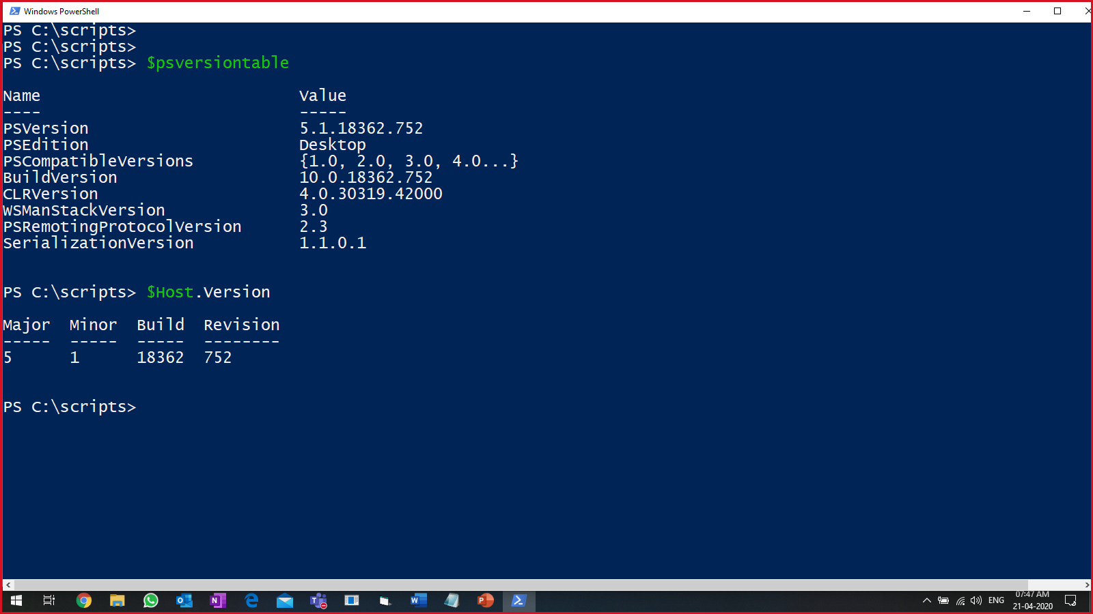

Powershell commands:

* Cmdlets
* Verb-noun

To update PS:

* Update-help -force

To check date:

* Get-date or
* date

to check the list of cmdlets, present in PS:

* get-command or
* gcm

to count the number of cmdlets:

* get-command | measure
* gcm | measure

to create a new alias

* new-alias -name <new-name-u-want> -value <original-cmd>
* Ex: new-alias -name d -value get-date

To create a directory in PS:

* mkdir <directory-name-with-path> or
* new-item -type directory -path <path-with-name-of-directory>
* Ex: New-Item -Type Directory -Path C:\lti-ps\testDir

To change the directory:

* cd <full-path-to-the-location> //Linux or CMS
* Set-Location C:\lti-ps\ //powershell

To list cmdlets with a specific keyword (‘item’)

* get-help *item* 🡪 search for key in start, middle or end of the cmdlet
* Get-Command -Noun item 🡪 search for the key END’s with the ‘item’

List top 10 processes which are consuming higher CPU:

Listing service:

* Get-Service -Name "T*" | Where-Object Status -eq "running"
* Get-Service | Where-Object {($_.Status -eq 'running') -and ($_.Name -like 'T*')}

|  |
| --- |
| #list running processes & send it to a text file  Get-Service `  | Where-Object Status -EQ "running" `  | Select-Object DisplayName `  | Out-File running-servvvv.txt  #display the file  notepad.exe running-servvvv.txt  #[Method-1:] to list services starting with "T" & status is running  Get-Service -Name "T*" | Where-Object Status -eq "running"  #[Method-2:]to list services starting with "T" & status is running  Get-Service | Where-Object {($_.Status -eq 'running') -and ($_.Name -like 'T*')} `  | select Name  #to convert it into different outputs  Get-Process | Out-File pro1.txt  .\pro1.txt  #to convert it into CSV format  Get-Process | ConvertTo-Csv | Out-File pro1.csv  .\pro1.csv  #to convert it into csv + list 10 lines  Get-Process | select -First 10 `  |Select-Object processname, cpu `  | ConvertTo-Csv -NoTypeInformation `  | Out-File pro1.csv  .\pro1.csv  #to convert it into HTML append the data using "-append" parameter  Get-Process `  | select -First 10 `  |Select-Object processname, cpu `  | ConvertTo-Html | Out-File pro1.html -Append  .\pro1.html |

Execution policy:

* Run a script in powershell
* Do u have permissions to run a script.
* Locally, remotely
* Policy:
  + **Restricted**
    - Locally, remotely NO script is allowed to get executed.
  + **Unrestricted**
    - Locally, remotely ALL script is allowed to get executed.
  + **All-signed**
    - Locally, remotely ALL script must be digitally signed.
  + **Remote-signed**
    - Locally no digital signature but remote script must be digitally signed.
* Cmdlets:
  + Get-executionpolicy
  + Set-executionpolicy <Policy-name> 🡪 admin mode only

To create a self-sign certificate:

1. Create certificate using below cmdlet:

|  |
| --- |
| New-SelfSignedCertificate -CertStoreLocation cert:\currentuser\my `  -Subject "CN=wakanda-forever" `  -KeyAlgorithm RSA `  -KeyLength 2048 `  -Provider "Microsoft Enhanced RSA and AES Cryptographic Provider" `  -KeyExportPolicy Exportable `  -KeyUsage DigitalSignature `  -Type CodeSigningCert |

To verify, either of these can be executed.

- ls Cert:\CurrentUser\My\

- Get-ChildItem Cert:\CurrentUser\My\

1. Export the certificate.
   * Open MMC using run prompt
   * Add certificate snap-in
   * Export the certificate:

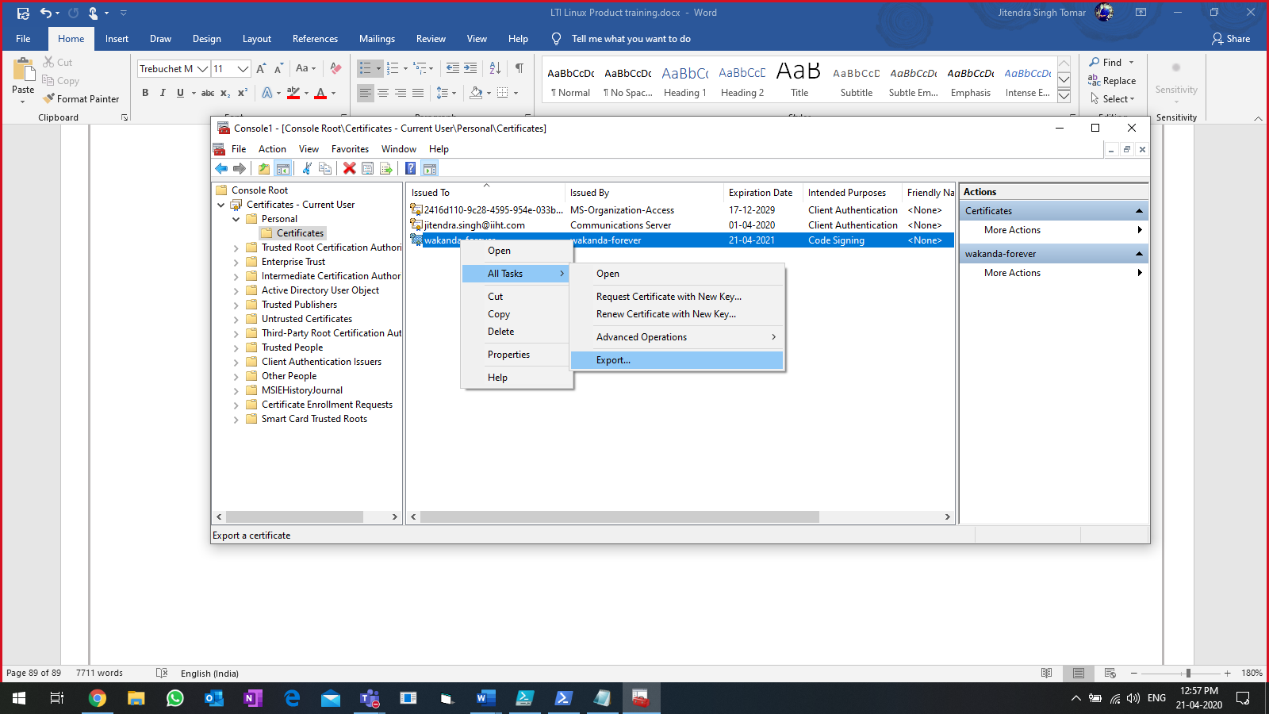

1. Install/Importing the exported certificate.
   * Double click on the certificate
   * Install it in TRUSTED ROOT CERTIFICATE AUTHORITY.
2. Digitally sign the script.

|  |
| --- |
| PS C:\lti-ps> $cert = Get-ChildItem Cert:\CurrentUser\My\D3757C6C9AC98C9BBD805B51037783FCC7B70288  PS C:\lti-ps> $cert  PSParentPath: Microsoft.PowerShell.Security\Certificate::CurrentUser\My  Thumbprint Subject  ---------- -------  D3757C6C9AC98C9BBD805B51037783FCC7B70288 CN=wakanda-forever |

1. Bind the certificate

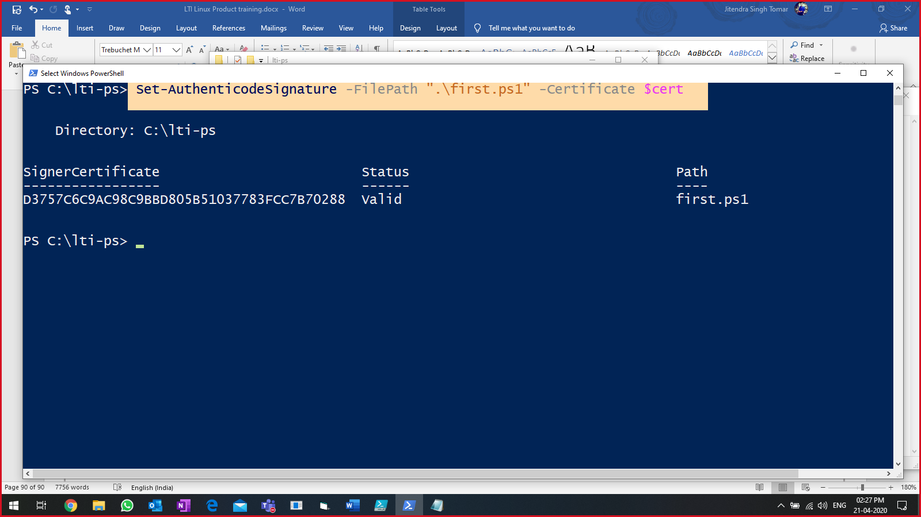

To read 10 newest application event logs in local system:

PS C:\lti-ps> Get-EventLog -LogName Application -Newest 10 | Select-Object EntryType, Message | Format-Table -AutoSize -Wrap

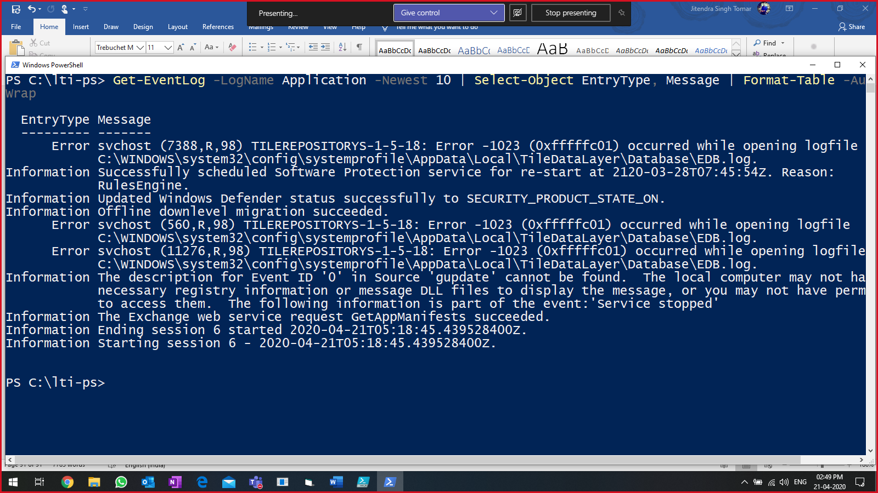

Basic commands:

pwd

Set-Location C:\lti-ps

Get-ChildItem

Move-Item -Path .\1st-get-date.ps1 -Destination .\testDir

Copy-Item -Path C:\lti-ps\*.ps1 -Destination C:\lti-ps\testDir

Task:

1. Create a script, which when clicked opens Outlook, notepad, Google Chrome.
2. List the logical disks information in GBs

WMI objects

* CIM
  + Common information model.
  + A standard given by distributed mgmt task force (DMTF)
  + Provides a common definition of managing network, systems, application, service etc…
* WMI
  + Windows management instrumentation
  + WMI is Microsoft implementation of CIM.
  + CIM + hardware + software
  + Everything is based on CLASSES
  + Cmdlet: get-wmiobject

Cmdlets:

* Get-WmiObject -Class win32_operatingsystem
* Get-WmiObject -Class win32_bios
* Get-WmiObject -Class win32_battery
* Get-WmiObject -Class win32_logicaldisk 🡪 task (b)

|  |
| --- |
| To get top 10 highest CPU utilization services:  Get-Process `  | select -Unique `  | Select-Object Processname, CPU `  | Sort-Object CPU -Descending `  | select -First 10 |

Mathematical operations:

[math]::Sqrt(25)

[math]::PI

[math]::Round(18.26)

[math]::Floor()

[math]::Ceiling()

Hash table:

@{key=value; key1=value1;key2=value2…}

@{label= “CPU(in2digits)” ; exp= “”} OR @{l= “CPU(in2digits)” ; e= “”}

|  |
| --- |
| To get top 10 processes in round off format:  Get-Process `  | select -Unique `  | Select-Object Processname,@{l="CPU”;e={[math]::round( ($_.CPU),2) }} `  | Sort-Object CPU -Descending `  | select -First 10 |

Microsoft documentation: <https://docs.microsoft.com/en-us/powershell/scripting/getting-started/getting-started-with-windows-powershell?view=powershell-5.1>

|  |
| --- |
| **Task: display below values:**  Name : "OS-name"  IP address : <IP>  C Drive size : <val> Total in GBs  C Drive size : <val> free in GBs  domain name : <domain-name> |

Operators:

* = 🡪 ‘-eq’
* != 🡪 ‘-ne’
* ‘>’ 🡪 ‘-gt’
* ‘<’ 🡪 ‘-lt’
* ‘>=’ 🡪 ‘-ge’
* ‘<=’ 🡪 ‘-le’

Task: to fetch the name of a service from user, display the status (running or stopped) & then ask user to start the service if it is stopped:

|  |
| --- |
| # to list the status of a service,  # and ask user to start the service  cls  #fetch the service name from user  $name = Read-Host "Enter service name"  #store the service info in a variable  $svc = Get-Service -Name $name  #store service NAME in a variable  $n = $svc.name  #store service status in a variable  $s = $svc.Status  #display all together  write-host "Service name $n is $s"  if($s -eq "stopped"){  $ans = read-host "Do u want to start the service (Y | N)"  if(($ans -eq "y") -or ($ans -eq "yes")){  Get-Service -Name $name | start-service  }else{  Write-Host "Fine, if u dont want to start the service"  }  }  else{  Write-Host "service already running"  } |

Interactive script to start a service & display its final result:

|  |
| --- |
| # to list the status of a service,  # and ask user to start the service  cls  #fetch the service name from user  $name = Read-Host "Enter service name"  #store the service info in a variable  $svc = Get-Service -Name $name  #store service NAME in a variable  $n = $svc.name  #store service status in a variable  $s = $svc.Status  #display all together  write-host "Service name $n is $s"  if($s -eq "stopped"){  $ans = read-host "Do u want to start the service (Y | N)"  if(($ans -eq "y") -or ($ans -eq "yes")){  Get-Service -Name $name | start-service  $cs = Get-Service -Name $name  if($cs.Status -eq "running"){  Write-Host "Service is running"  }else{  Write-Host "still not running"  }  }else{  Write-Host "Fine, if u dont want to start the service"  }  }  else{  Write-Host "service already running"  } |

Create a “Microsoft.PowerShell_profile.ps1” file, which gets loaded every time you start the terminal.

New-Item -ItemType File $PROFILE -Force 🡪 PS console

* “New-item” = create something (file or directory)
* “-itemtype file” = creating a text file
* “$PROFILE” = below value is stored in this variable [C:\Users\Jeetu\Documents\WindowsPowerShell\Microsoft.PowerShell_profile.ps1]
* “-Force” = create FORCEFULLY.

For PS ISE

* $profile
* C:\Users\Jeetu\Documents\WindowsPowerShell\Microsoft.PowerShellISE_profile.ps1

If the above file does not exist, then create it:

* New-Item -ItemType File $profile -Force

Powershell Functions

Syntax:

|  |
| --- |
| Function <function-name>  {  …  …  }  <function-name> |

To get the service info using functions:

|  |
| --- |
| #declare the function  function get-svcstatus{  cls  $n = Read-Host "enter service name"  Get-Service -Name $n  }  #call the function  get-svcstatus |

To display the status of a service using function & passing service name as parameter:

|  |
| --- |
| function get-svcstatus{  param($svc)  $ans = Get-Service -Name $svc  Write-Host "Service $svc is: "$ans.status  }  get-svcstatus -svc mpssvc |

Create function and load it in the memory, when PS console is triggered/opened:

|  |
| --- |
| Create a script & store it in any place [*C:\lti-ps\testDir\function-1.ps1*]  function get-svcstatus{  param($svc)  $ans = Get-Service -Name $svc  Write-Host "Service $svc is: "$ans.status  }  Call the function from the prompt by passing the parameter:  get-svcstatus -svc bits  if you want, the same script must be called every time you start the PS console:   * Notepad.exe $PROFILE   Import-Module C:\lti-ps\testDir\function-1.ps1 |

To get logical disk information:

|  |
| --- |
| function get-diskinfo{  cls  Get-WmiObject -Class win32_logicaldisk `  | Select-Object DeviceID, DriveType,`  FreeSpace, `  Size  }  get-diskinfo |

Converting & displaying the disk info in GBs format:

|  |
| --- |
| function get-diskinfo{  cls  Get-WmiObject -Class win32_logicaldisk `  | Select-Object DeviceID, DriveType,`  @{l="Size";e={[math]::Round($_.size/1GB,2)}}, `  @{l="FreeSpace";e={[math]::Round($_.size/1GB,2)}}  }  get-diskinfo |

Get the info of other devices in the network:

[method-1]

|  |
| --- |
| function get-diskinfo{  cls  Get-WmiObject -Class win32_logicaldisk -ComputerName cli `  | Select-Object DeviceID, DriveType,`  @{l="Size";e={[math]::Round($_.size/1GB,2)}}, `  @{l="FreeSpace";e={[math]::Round($_.size/1GB,2)}}  }  get-diskinfo |

[method-2]

|  |
| --- |
| function get-diskinfo{  cls  Get-WmiObject -Class win32_logicaldisk -ComputerName $newcomp `  | Select-Object DeviceID, DriveType,`  @{l="Size";e={[math]::Round($_.size/1GB,2)}}, `  @{l="FreeSpace";e={[math]::Round($_.size/1GB,2)}}  }  #create a text file & write computernames in it  #notepad.exe comp.txt  #fetch the values in a variable  $newcomp = Get-Content .\comp.txt  #call the function  get-diskinfo |

To get the logs for remote system:

|  |
| --- |
| Get-EventLog -LogName Application -Newest 5 -ComputerName dc `  | Select-Object EntryType, Message | ft -AutoSize -Wrap |

To get the output in the colour mode:

|  |
| --- |
| $name = Get-Service -Name winrm  cls  if($name.Status -eq "Running"){  Write-Host $name.name" is running" -ForegroundColor Black -BackgroundColor Green  }else{  Write-Host $name.name" is stopped" -ForegroundColor white -BackgroundColor Red  } |

**TASK: display ALL SERVICES (running in green & stopped in red)**

Sending variable values using pipeline in advance functions:

|  |
| --- |
| function get-eventdata{  [cmdletbinding()]  param(  [Parameter(Mandatory=$true,  ValueFromPipeline=$true  )]  [string]$com  )  cls  #Write-Host "$com function executed"  Get-EventLog -LogName Application -ComputerName $com -Newest 5  }  $com | get-eventdata |

Active directory mgmt using PowerShell: